# A REPORT

## On

**WEB DEVEOPMENT**

*Submitted*

*In partial fulfillment*

*For the award of the Degree of*

|  |  |
| --- | --- |
| Submitted By: | Submitted To: |

Sai Vishwanath Dhyanahitha School of Professional Studies

## Department of Computer Science and Engineering

**Candidate’s Declaration**

I, hereby declare that the project report "IN Design (Interior Designer Site)" is an original work done in the Department of Computer Science and Engineering, GITAM Institute of Technology, GITAM (Deemed to be University) submitted in partial fulfillment of the requirements for the award of the certificate of internship. The work has not been submitted to any other college or University for the award of any degree or diploma.

**Name and Signature of Candidate Counter Signed by**

**KB Sai Vishwanath**

**221710302025**

**CSE**

# ACKNOWLEDGEMENT

My project would not have been successful without the help of several people, I would like to thank the personalities who were part of my project in numerous ways, those who gave me outstanding support from the birth of the project.

I am extremely thankful to our honorable Pro-Vice-Chancellor, **Prof. N. Siva Prasad** for providing necessary infrastructure and resources for the accomplishment of my project.

I am highly indebted to **Prof. N. Seetharamaiah**, Principal, School of Technology, for his support during the tenure of the project.

I am very much obliged to our beloved **Prof. S. Phani Kumar**, Head of the Department of Computer Science & Engineering for providing the opportunity to undertake this project and encouragement in the completion of this project.

I hereby wish to express my deep sense of gratitude to **Mr. Anil Kumar**, for the esteemed guidance, moral support and invaluable advice provided by him for the success of the project.

I am also thankful to all the staff and mentors of the Dhyanahitha School of Professional Studies who have cooperated in making my project a success. I would like to thank my parents and friends who extended their help, encouragement and moral support either directly or indirectly in my project work.

**Sincerely,**

**K B Sai Vishwanath**

**(221710302025)**

**ABSTRACT**

**Table of Content**

|  |  |  |  |
| --- | --- | --- | --- |
|  | **Title** | | **Page No.** |
|  | List of Tables…………………………………………………….. | |  |
|  | List of Figures…………………………………………………… | | 6-7 |
| 1. | Introduction………………………………………………………   * 1. Front End ……………………………………………...   2. Back End………………………………………………. | | 9 |
| 2. | Web Development……………………………………………….. | | 10-12 |
|  | 2.1 | Web Site………………………………………………... | 10 |
|  | 2.2 | Web Page………………………………………………. | 11 |
|  | 2.3 Web Browser…………………………………………. | | 11 |
|  | 2.4 Mobile Web Browser…………………………………. | | 12 |
| 3. | The Steps to Create a Web site…………………………………… | | 13-24 |
|  | 3.1 | UI development | 14-19 |
|  | 3.1.1 HTML | | 13 |
|  | 3.1.2 CSS | | 14 |
|  | 3.1.3 Bootstrap | | 17 |
|  | 3.2 | Scripting | 19 |
|  | 3.2.1 Server side scripting | | 19 |
|  | 3.2.2 Server side scripting languages | | 19 |
|  | 3.2.3 Client side scripting | | 20 |
|  | 3.3 | Database | 22 |
|  | 3.4 | SQL | 22 |
|  | 3.5 | Queries | 23 |
| 4. | Scripting Languages……………………………………………… | | 23-27 |
|  | 4.1 | JavaScript |  |
|  | 4.2 | Node JS |  |
|  | 4.3 | JQuery |  |
|  | 4.4 | AJAX |  |
|  | 4.5 | JSON |  |
| 5. | Software Requirement Specification (SRS)………………….… | | 28 |
|  | 5.1 | Hardware Requirement |  |
|  | 5.2 | Software Requirement |  |
|  | 5.3 Software Installations | |  |

|  |  |  |  |
| --- | --- | --- | --- |
|  |  | 5.3.1 Installation of VS Code |  |
|  |  | 5.3.2 Installation of Node JS |  |
| 6. | UML Diagrams……………………………….. | | 33 |
|  | 6.1 | Introduction |  |
|  | 6.2 | Class Diagram |  |
|  | 6.3 | Sequence Diagram |  |
|  | 6.4 | Use Case Diagram |  |
| 7. | Project………………………………………………………. | | 34-38 |
|  | 7.1 Name | |  |
|  | 7.2 Project Details | |  |
|  | 7.3 Technology Used | |  |
|  | 7.4 Technical Details | |  |
| 8. | Implementation…………………………………………………… | | 39 |
|  | 8.1 Wireframes | |  |
|  | 8.1.1 What are wireframes? | |  |
|  | 8.1.2 Wireframe Diagrams | |  |
|  | 8.2 Validations | |  |
|  | 8.2.1 What are validations? | |  |
|  | 8.2.2 Validation Pages | |  |
|  | 8.3 Front end Screenshots and codes | |  |
|  | 8.4 Back end Screenshots and codes | |  |
| 9 | Maintenance……………………………………………………… | |  |
| 10 | Future scope and future enhancement…………………………… | | 40 |
| 11. | Conclusion………………………………………………………. | | 41 |
|  | Bibliography | |  |

**List of Figures**

Figure 2.1 Architecture of Web Browsers

Figure 3.1.1 Steps to create a website

Figure 3.1.2 Form without CSS

Figure 3.1.3 Form with CSS

Figure 3.2.1 Programming language popularity

Figure 3.2.2 Scripting process

Figure 4.1 Important parts of Node JS

Figure 5.3.1 Setup of Visual Studio Code

Figure 5.3.2 Home Page of Nodejs.org

Figure 5.3.3 Setup Page of Nodejs.org

Figure 6.1 Class Diagram

Figure 6.2 Sequence diagram

Figure 6.3 Use Case Diagram

Figure 8.1.1 Home Page Wireframe

Figure 8.1.2 Feedback Page Wireframe

Figure 8.1.3 Contact Page Wireframe

Figure 8.2.1 Validation Test Case 1

Figure 8.2.2 Validation Test Case 2

Figure 8.2.3 Validation Test Case 3

Figure 8.3.1 Home page Screen Shot 1

Figure 8.3.2 Home page Screen Shot 2

Figure 8.3.3 Home page Screen Shot 3

Figure 8.3.4 Home page Screen Shot 4

Figure 8.3.5 Home page Screen Shot 5

Figure 8.3.6 Home page Screen Shot 6

Figure 8.3.7 Home page Screen Shot 7

Figure 8.3.7 Feedback page Screen Shot 1

Figure 8.3.8 Feedback page Screen Shot 2

Figure 8.3.9 Contact us page Screen Shot 1

Figure 8.3.10 Contact us page Screen Shot 2

Figure 8.3.11 Contact us page Screen Shot 3

Figure 8.3.12 Contact us page Screen Shot 4

Figure 8.4.1 Create Appointment Page screen shot 1

Figure 8.4.2 Create Appointment Page screen shot 2

Figure 8.4.3 Create Appointment Page screenshot 3

Figure 8.4.4 Success Alert After receiving Input

Figure 8.4.5 Error Alert if the data is not is inserted into table

Figure 8.4.6 Created User status in command prompt.

Figure 8.4.7 Select Query and data insertion in the table

Figure 8.4.8 Status of user before update command

Figure 8.4.9 Update command and Status of user after update command

Figure 8.4.10 Check Appointment page Screenshot.

Figure 8.4.11 Phone number found and status is complete alert

Figure 8.4.12 Phone number found and status is incomplete

Figure 8.4.13 Phone number not found alert

Figure 8.4.14 Command prompt return values after inputting phone numbers

**CHAPTER-1**

### **INTRODUCTION**

The industry definition of a Full Stack Developer is an engineer who can work on different levels of an application stack. The term stack refers to the combination of components and tools that make up the application. The components could be in the front-end or the back-end of the system.

The main objective of full stack engineer is to keep every part of the system running smoothly. A Full Stack Developer can perform tasks ranging from resizing an image or text in a webpage to patching the kernel.

**Full stack development:** It refers to the development of both front end(client side) and back end(server side) portions of web application.

**Full stack web Developers:** Full stack web developers have the ability to design complete web application and websites. They work on the frontend, backend, database and debugging of web application or websites.

* 1. **FRONT-END**

Front-end web development, also known as client-side development is the practice of producing HTML, CSS and JavaScript for a website or Web Application so that a user can see and interact with them directly. The challenge associated with front end development is that the tools and techniques used to create the front end of a website change constantly and so the developer needs to constantly be aware of how the field is developing.

The objective of designing a site is to ensure that when the users open up the site they see the information in a format that is easy to read and relevant. This is further complicated by the fact that users now use a large variety of devices with varying screen sizes and resolutions thus forcing the designer to take into consideration these aspects when designing the site. They need to ensure that their site comes up correctly in different browsers (cross-browser), different operating systems (cross-platform) and different devices (cross-device), which requires careful planning on the side of the developer.

Front end development manages everything that users visually see first in their browser or application. Front end developers are responsible for the look and feel of a site. It is the visible part of website or web application which is responsible for user experience. The user directly interacts with the front end portion of the web application or website.

* 1. **BACK-END**

Back end development refers to the server side of an application and everything that communicates between the database and the browser. It is responsible for managing the database through queries and APIs by client-side commands.

Back end development refers to the server side of development where you are primarily focused on how the site works. Making updates and changes in addition to monitoring functionality of the site will be your primary responsibility. This type of web development usually consists of three parts: a server, an application, and a database. Code written by back end developers is what communicates the database information to the browser. Anything you can’t see easily with the eye such as databases and servers is the work of a back end developer. Back end developer positions are often called programmers or web developers.

**CHAPTER-2**

### **WEB-DEVELOPMENT**

**Web development** is a broad term for the work involved in developing a [web site](https://en.wikipedia.org/wiki/Web_site) for the [Internet](https://en.wikipedia.org/wiki/Internet) ([World Wide Web](https://en.wikipedia.org/wiki/World_Wide_Web)) or an [intranet](https://en.wikipedia.org/wiki/Intranet) (a private network). Web development can range from developing the simplest static single page of [plain text](https://en.wikipedia.org/wiki/Plain_text) to the most complex web-based [internet applications](https://en.wikipedia.org/wiki/Internet_application), [electronic businesses,](https://en.wikipedia.org/wiki/Electronic_business) and [social network services](https://en.wikipedia.org/wiki/Social_network_service). A more comprehensive list of tasks to which web development commonly refers, may include [web](https://en.wikipedia.org/wiki/Web_engineering) [engineering,](https://en.wikipedia.org/wiki/Web_engineering) [web design,](https://en.wikipedia.org/wiki/Web_design) [web content development](https://en.wikipedia.org/wiki/Web_content_development), client liaison, [client-side](https://en.wikipedia.org/wiki/Client-side_scripting)/side scripting, [web server](https://en.wikipedia.org/wiki/Web_server) and [network security](https://en.wikipedia.org/wiki/Network_security) configuration, and [e-commerce](https://en.wikipedia.org/wiki/E-commerce) development. Among web professionals, "web development" usually refers to the main non-design aspects of building web sites: writing [markup](https://en.wikipedia.org/wiki/Markup_language) and [coding.](https://en.wikipedia.org/wiki/Computer_programming) Most recently Web development has come to mean the creation of [content management systems](https://en.wikipedia.org/wiki/Content_management_system) or CMS. These CMS can be made from scratch, proprietary or open source. In broad terms the CMS acts as middleware between the database and the user through the browser. A principle benefit of a CMS is that it allows non-technical people to make changes to their web site without having technical knowledge.

For larger organizations and businesses, web development teams can consist of hundreds of people ([web developers](https://en.wikipedia.org/wiki/Web_developer)) and follow standard methods like [Agile methodologies](https://en.wikipedia.org/wiki/Agile_software_development) while developing websites. Smaller organizations may only require a single permanent or contracting developer, or secondary assignment to related job positions such as a [graphic](https://en.wikipedia.org/wiki/Graphic_designer) [designer](https://en.wikipedia.org/wiki/Graphic_designer) or [information systems](https://en.wikipedia.org/wiki/Information_systems) technician. Web development may be a collaborative effort between departments rather than the domain of a designated department. There are three kind of web developer specialization: front-end developer, back-end developer, and full-stack developer.

### **WEB-SITE**

A **website** is a collection of related [web pages,](https://en.wikipedia.org/wiki/Web_page) including [multimedia](https://en.wikipedia.org/wiki/Multimedia) content, typically identified with a common [domain name,](https://en.wikipedia.org/wiki/Domain_name) and published on at least one [web server](https://en.wikipedia.org/wiki/Web_server). A website may be accessible via a public [Internet Protocol](https://en.wikipedia.org/wiki/Internet_Protocol) (IP) network, such as the [Internet,](https://en.wikipedia.org/wiki/Internet) or a private [local area network](https://en.wikipedia.org/wiki/Local_area_network) (LAN), by referencing a [uniform resource locator](https://en.wikipedia.org/wiki/URL) (URL) that identifies the site.

Websites have many functions and can be used in various fashions; a website can be a [personal website,](https://en.wikipedia.org/wiki/Personal_website) a commercial website for a company, a [government website](https://en.wikipedia.org/wiki/E-Government) or a [non-profit](https://en.wikipedia.org/wiki/Nonprofit_organization) [organization](https://en.wikipedia.org/wiki/Nonprofit_organization) website. Websites are typically dedicated to a particular topic or purpose, ranging from entertainment and [social networking](https://en.wikipedia.org/wiki/Social_networking) to providing news and education. All publicly accessible websites collectively constitute the [World Wide Web](https://en.wikipedia.org/wiki/World_Wide_Web), while private websites, such as a company's website for its employees, and are typically a part of an [intranet.](https://en.wikipedia.org/wiki/Intranet)

Web pages, which are the [building blocks](https://en.wikipedia.org/wiki/Building_block) of websites, are [documents](https://en.wikipedia.org/wiki/Document), typically composed in [plain text](https://en.wikipedia.org/wiki/Plain_text) interspersed with formatting instructions of Hypertext Markup Language ([HTML,](https://en.wikipedia.org/wiki/HTML) [XHTML](https://en.wikipedia.org/wiki/XHTML)). They may incorporate elements from other websites with

Suitable [markup anchors.](https://en.wikipedia.org/wiki/HTML_anchor) Web pages are accessed and transported with the [Hypertext Transfer](https://en.wikipedia.org/wiki/Hypertext_Transfer_Protocol) [Protocol](https://en.wikipedia.org/wiki/Hypertext_Transfer_Protocol) (HTTP), which may optionally employ encryption ([HTTP Secure,](https://en.wikipedia.org/wiki/HTTP_Secure) HTTPS) to provide security and privacy for the user. The user's application, often a [web browser](https://en.wikipedia.org/wiki/Web_browser), renders the page content according to its HTML markup instructions onto a [display terminal](https://en.wikipedia.org/wiki/Computer_monitor).

[Hyperlinking](https://en.wikipedia.org/wiki/Hyperlink) between web pages conveys to the reader the [site structure](https://en.wikipedia.org/wiki/Site_map) and guides the navigation of the site, which often starts with a [home page](https://en.wikipedia.org/wiki/Home_page) containing a directory of the site [web content.](https://en.wikipedia.org/wiki/Web_content) Some websites require user registration or [subscription](https://en.wikipedia.org/wiki/Subscription) to access content. Examples of [subscription websites](https://en.wikipedia.org/wiki/Paywall) include many business sites, news websites, [academic](https://en.wikipedia.org/wiki/Academic_journal) [journal](https://en.wikipedia.org/wiki/Academic_journal) websites, gaming websites, file-sharing websites, [message boards](https://en.wikipedia.org/wiki/Internet_forum), web-based [email](https://en.wikipedia.org/wiki/Email), [social networking](https://en.wikipedia.org/wiki/Social_networking) websites, websites providing real-time [stock market](https://en.wikipedia.org/wiki/Stock_market) data, as well as sites providing various other services. As of 2016 [end users](https://en.wikipedia.org/wiki/End_user) can access websites on a range of devices, including [desktop](https://en.wikipedia.org/wiki/Desktop_computer) and [laptop computers](https://en.wikipedia.org/wiki/Laptop), [tablet computers](https://en.wikipedia.org/wiki/Tablet_computer), [smartphones](https://en.wikipedia.org/wiki/Smartphone) and [smart](https://en.wikipedia.org/wiki/Smart_TV) [TVs.](https://en.wikipedia.org/wiki/Smart_TV)

A web site consists of web pages which are interconnected to each other and contain various data and functionalities.

### **WEB-PAGE**

A **web page**, or **webpage**, is a document that is suitable for the [World Wide Web](https://en.wikipedia.org/wiki/World_Wide_Web) and [web browsers.](https://en.wikipedia.org/wiki/Web_browser) A web browser displays a web page on a [monitor](https://en.wikipedia.org/wiki/Computer_display) or [mobile device.](https://en.wikipedia.org/wiki/Mobile_device) The web page is what displays, but the term also refers to a [computer file](https://en.wikipedia.org/wiki/Computer_file), usually written in [HTML](https://en.wikipedia.org/wiki/HTML) or comparable [markup language.](https://en.wikipedia.org/wiki/Markup_language) Web browsers coordinate the various [web resource](https://en.wikipedia.org/wiki/Web_resource) elements for the written web page, such as [style sheets,](https://en.wikipedia.org/wiki/Cascading_Style_Sheets) [scripts,](https://en.wikipedia.org/wiki/Client-side_scripting) and [images](https://en.wikipedia.org/wiki/Image), to present the web page.

Typical web pages provide [hypertext](https://en.wikipedia.org/wiki/Hypertext) that includes a [navigation bar](https://en.wikipedia.org/wiki/Navigation_bar) or a [sidebar menu](https://en.wikipedia.org/wiki/Sidebar_%28computing%29) to other web pages via [hyperlinks](https://en.wikipedia.org/wiki/Hyperlink), often referred to as links.

On a network, a web browser can retrieve a web page from a remote [web server.](https://en.wikipedia.org/wiki/Web_server) On a higher level, the web server may restrict access to only a private network such as a corporate [intranet](https://en.wikipedia.org/wiki/Intranet) or it provides access to the World Wide Web. On a lower level, the web browser uses the [Hypertext Transfer Protocol](https://en.wikipedia.org/wiki/Hypertext_Transfer_Protocol) (HTTP) to make such requests.

A [static web page](https://en.wikipedia.org/wiki/Static_web_page) is delivered exactly as stored, as [web content](https://en.wikipedia.org/wiki/Web_content) in the web server's [file](https://en.wikipedia.org/wiki/File_system) [system,](https://en.wikipedia.org/wiki/File_system) while a [dynamic web page](https://en.wikipedia.org/wiki/Dynamic_web_page) is generated by a [web application](https://en.wikipedia.org/wiki/Web_application) that is driven by [server-](https://en.wikipedia.org/wiki/Server-side_scripting) [side software](https://en.wikipedia.org/wiki/Server-side_scripting) or client-side scripting. Dynamic website pages help the browser (the [client](https://en.wikipedia.org/wiki/Client_%28computing%29)) to enhance the web page through user input to the server.

**2.3. WEB BROWSER**

A web browser is a software application for accessing information on the World Wide Web. When a user requests a web page from a particular website, the web browser retrieves the necessary content from a web server and then displays the page on a screen. As a client/server model, the browser is the client run on a computer or mobile device that contacts the Web server and requests information. The web server sends the information back to the browser which displays the results on the Internet-enabled device that supports a browser.

Web browsers are used on a range of devices, including desktops, laptops, tablets, and smartphones. In 2019, an estimated 4.3 billion people used a browser.The most used browser is Google Chrome, with a 64% global market share on all devices, followed by Safari with 18%.

**2.4. MOBILE WEB BROWSER**

There are a number of browsers that are designed to access the Web using a mobile device. A mobile browser, also called a micro browser, is optimized to display Web content on smaller mobile device screens and to perform efficiently on these computing devices, which have far less computing power and memory capacity as desktop or laptop. Mobile browsers are typically "stripped down" versions of Web browsers and offer fewer features in order to run well on mobile devices.

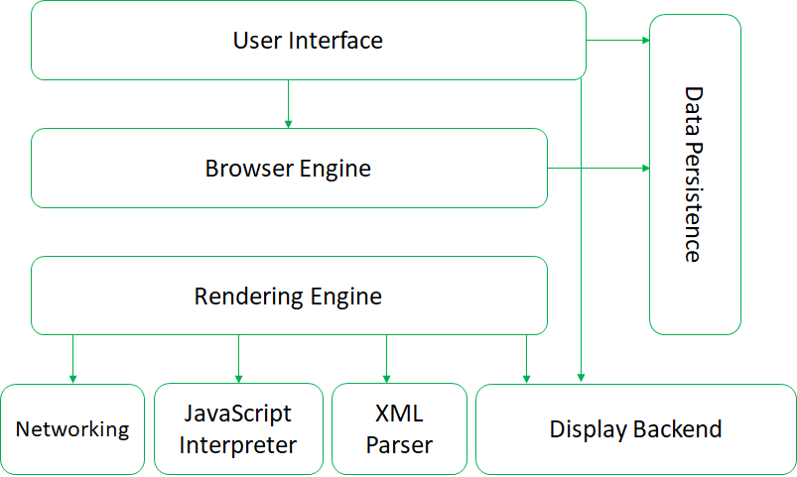

**FIGUREURE 2.1 ARCHITECTURE OF WEB BROWSERS**

**CHAPTER-3**

### **THE STEPS TO CREATE A WEB SITE**

Creating a web site requires multiple steps which includes the following:

* Creating a UI(User interface)
* Scripting(Both at server end and client end)
* Creating a backend or the database

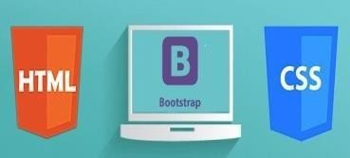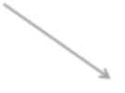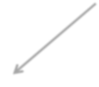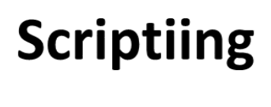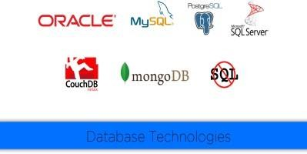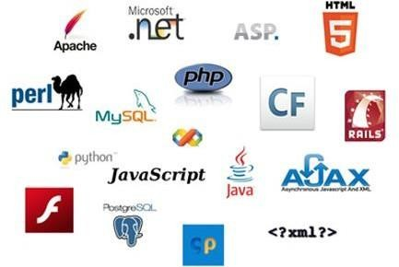

**Web Site**

**UI**

**Data Base**

**Figure 3.1.1 Steps to create a website**

### **UI DEVELOPMENT**

Technologies that are mostly used to develop a User Interface are:

* + - HTML
* CSS
  + - Bootstrap

### **. HTML**

**Hypertext Markup Language** (**HTML**) is the standard [markup language](https://en.wikipedia.org/wiki/Markup_language) for creating [web pages](https://en.wikipedia.org/wiki/Web_page) and [web applications](https://en.wikipedia.org/wiki/Web_application). With [Cascading Style Sheets](https://en.wikipedia.org/wiki/Cascading_Style_Sheets) (CSS) and [JavaScript](https://en.wikipedia.org/wiki/JavaScript) it forms a triad of cornerstone technologies for the [World Wide Web](https://en.wikipedia.org/wiki/World_Wide_Web). [Web browsers](https://en.wikipedia.org/wiki/Web_browser) receive HTML documents from a [webserver](https://en.wikipedia.org/wiki/Webserver) or from local storage and render them into multimedia web pages. HTML describes the structure of a web page [semantically](https://en.wikipedia.org/wiki/Semantic) and originally included cues for the appearance of the document.

[HTML elements](https://en.wikipedia.org/wiki/HTML_element) are the building blocks of HTML pages. With HTML constructs, [images](https://en.wikipedia.org/wiki/Img_%28HTML_element%29) and other objects, such as [interactive forms,](https://en.wikipedia.org/wiki/Fieldset) may be embedded into the rendered page. It provides a means to create [structured documents](https://en.wikipedia.org/wiki/Structured_document) by denoting structural [semantics](https://en.wikipedia.org/wiki/Semantics) for text such as headings, paragraphs, lists, [links](https://en.wikipedia.org/wiki/Hyperlink), quotes and other items. HTML elements are delineated by tags, written using [angle brackets](https://en.wikipedia.org/wiki/Bracket#Angle_brackets). Tags such as <img /> and <input /> introduce content into the page directly. Others such as <p>...</p> surround and provide information about document text and may include other tags as sub-elements. Browsers do not display the HTML tags, but use them to interpret the content of the page.

HTML can embed programs written in a [scripting language](https://en.wikipedia.org/wiki/Scripting_language) such as [JavaScript](https://en.wikipedia.org/wiki/JavaScript) which affect the behavior and content of web pages. Inclusion of CSS defines the look and layout of content. The [World Wide Web Consortium](https://en.wikipedia.org/wiki/World_Wide_Web_Consortium) (W3C), maintainer of both the HTML and the CSS standards, has encouraged the use of CSS over explicit presentational HTML since 1997.

HTML markup consists of several key components, including those called tags (and their attributes), character-based data types, character references and entity references. HTML tags most commonly come in pairs like <h1> and </h1>, although some represent empty elements and so are unpaired, for example <img>. The first tag in such a pair is the start tag, and the second is the end tag (they are also called opening tags and closing tags).

Another important component is the HTM[L document type declaration,](https://en.wikipedia.org/wiki/Document_type_declaration) which triggers [standards mode](https://en.wikipedia.org/wiki/Standards_mode) rendering.

The following is an example of the classic [Hello world program,](https://en.wikipedia.org/wiki/Hello_world_program) a common test employed for comparing [programming languages,](https://en.wikipedia.org/wiki/Programming_language) [scripting languages](https://en.wikipedia.org/wiki/Scripting_language) and [markup languages](https://en.wikipedia.org/wiki/Markup_language). This example is made using 9 [lines of code](https://en.wikipedia.org/wiki/Lines_of_code):

### **General Syntax of HTML**

<!DOCTYPE html>

<html>

<head>

<title>This is a title</title>

</head>

<body>

<p>Hello world!</p>

</body>

</html>

The text between <html> and </html> describes the web page, and the text between <body> and </body> is the visible page content. The markup text "<title>This is a title</title>" defines the browser page title.

The Document Type Declaration <!DOCTYPE html> is for HTML5. If a declaration is not included, various browsers will revert to "[quirks mode](https://en.wikipedia.org/wiki/Quirks_mode)" for rendering.

### **. CSS**

**Cascading Style Sheets** (**CSS**) is a [style sheet language](https://en.wikipedia.org/wiki/Style_sheet_language) used for describing the [presentation](https://en.wikipedia.org/wiki/Presentation_semantics) of a document written in a [markup language.](https://en.wikipedia.org/wiki/Markup_language) Although most often used to set the visual style of [web pages](https://en.wikipedia.org/wiki/Web_page) and user interfaces written in [HTML](https://en.wikipedia.org/wiki/HTML) and [XHTML](https://en.wikipedia.org/wiki/XHTML), the languagecan be applied to any [XML](https://en.wikipedia.org/wiki/XML) document, including [plain XML](https://en.wikipedia.org/wiki/Plain_Old_XML), [SVG](https://en.wikipedia.org/wiki/Scalable_Vector_Graphics) and [XUL](https://en.wikipedia.org/wiki/XUL), and is applicable to rendering in [speech,](https://en.wikipedia.org/wiki/Speech_synthesis) or on other media. Along with HTML and [JavaScript](https://en.wikipedia.org/wiki/JavaScript), CSS is a cornerstone technology used by most websites to create visually engaging webpages, user interfaces for [web applications,](https://en.wikipedia.org/wiki/Web_applications) and user interfaces for many mobile applications.

CSS is designed primarily to enable the separation of presentation and content, including aspects such as the [layout](https://en.wikipedia.org/wiki/Page_layout), [colors](https://en.wikipedia.org/wiki/Color), and [fonts](https://en.wikipedia.org/wiki/Typeface). This separation can improve content [accessibility,](https://en.wikipedia.org/wiki/Accessibility) provide more flexibility and control in the specification of presentation characteristics, enable multiple HTML pages to share formatting by specifying the relevant CSS in a separate .css file, and reduce complexity and repetition in the structural content.

Separation of formatting and content makes it possible to present the same markup page in different styles for different rendering methods, such as on-screen, in print, by voice (via speech-based browser or [screen reader](https://en.wikipedia.org/wiki/Screen_reader)), and on [Braille-based](https://en.wikipedia.org/wiki/Braille_display) tactile devices. It can also display the web page differently depending on the screen size or viewing device. Readers can also specify a different style sheet, such as a CSS file stored on their own computer, to override the one the author specified.

Changes to the [graphic design](https://en.wikipedia.org/wiki/Graphic_design) of a document (or hundreds of documents) can be applied quickly and easily, by editing a few lines in the CSS file they use, rather than by changing markup in the documents.

The CSS specification describes a priority scheme to determine which style rules apply if more than one rule matches against a particular element. In this so-called cascade, priorities (or weights) are calculated and assigned to rules, so that the results are predictable.

The CSS specifications are maintained by the [World Wide Web Consortium](https://en.wikipedia.org/wiki/World_Wide_Web_Consortium) (W3C). Internet media type ([MIME type](https://en.wikipedia.org/wiki/MIME_media_type)) text/css is registered for use with CSS by [RFC 2318](https://tools.ietf.org/html/rfc2318) (March 1998). The W3C operates a free [CSS validation service](https://en.wikipedia.org/wiki/W3C_Markup_Validation_Service#CSS_validation) for CSS documents.

#### Types of CSS:

* **Inline CSS:**

In this CSS is applied in between the tags

* **Internal CSS:**

Eg: <tag style=”styling”>Hello World</tag>

In this the css code is defined inside the style tag in the head section of the HTML page.

#### General Syntax:

<html>

<head>

<style>

<! -- CSS STYLING -- >

</style>

</head>

</html>

**External CSS:**

In this the CSS code is written on another page and is linked to the HTML page. It is advantageous to use this type of styling as we can use the same file to style various HTML pages.

External CSS uses the extension .css and is applied using the following syntax

<html>

<head>

<link relation=”stylesheet” type=”css” href=”url to the page”>

</head>

</html>

All the CSS style types are important but can be used in different situations.

* Inline CSS is used when only small changes are to be done to the HTML tag and the changes are to be reflected only to that specific tag
* Internal CSS is used when the individual HTML pages have to be designed differently. This also slows the page load system if the internal styling is long.
* External CSS files are maintained to design multiple pages and use common styles over various pages. It is useful as it helps in managing the resources in an easy manner.

*Both HTML and CSS are used to create a UI but CSS behaves like a makeup on the face of an actress which makes her look even more beautiful than she is in reality.*

And here is the difference:

##### Before using CSS in HTML page:

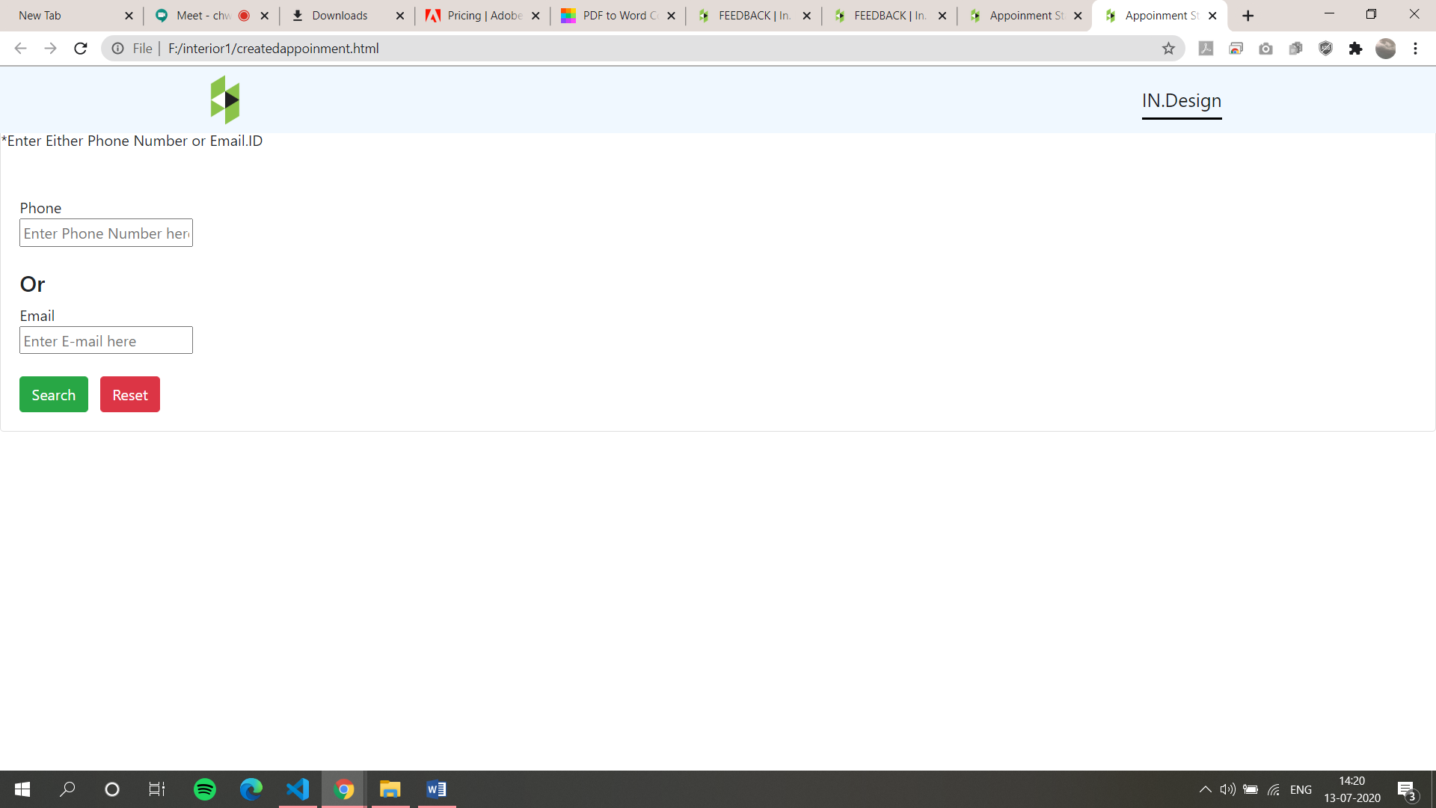

##### Figure 3.1.2 Before using CSS in HTML page:

##### 

##### After using CSS in HTML Page:

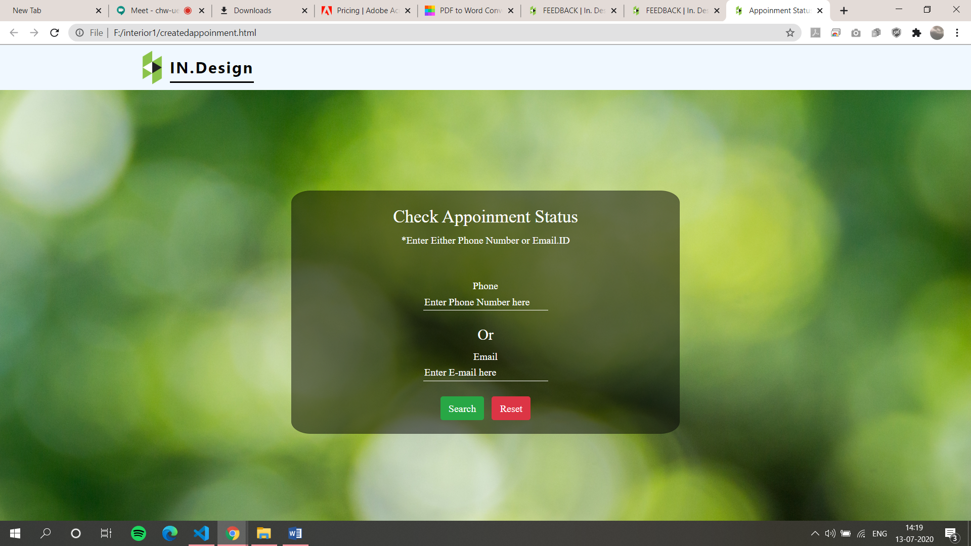

##### Figure 3.1.3 Before using CSS in HTML page:

### **BOOTSTRAP**

**Bootstrap** is a [free and open-source](https://en.wikipedia.org/wiki/Free_and_open-source_software) front-end [web framework](https://en.wikipedia.org/wiki/Web_framework) for designing [websites](https://en.wikipedia.org/wiki/Website) and [web applications.](https://en.wikipedia.org/wiki/Web_application) It contains [HTML](https://en.wikipedia.org/wiki/HTML)- and [CSS](https://en.wikipedia.org/wiki/CSS)-based design templates for [typography](https://en.wikipedia.org/wiki/Typography), forms, buttons, navigation and other interface components, as well as optional [JavaScript](https://en.wikipedia.org/wiki/JavaScript) extensions. Unlike many web frameworks, it concerns itself with [front-end development](https://en.wikipedia.org/wiki/Front-end_web_development) only.

Bootstrap is the second most-starred project on [GitHub](https://en.wikipedia.org/wiki/GitHub), with more than 107,000 stars and 48,000 forks.

Bootstrap, originally named Twitter Blueprint, was developed by Mark Otto and Jacob Thornton at [Twitter](https://en.wikipedia.org/wiki/Twitter) as a framework to encourage consistency across internal tools. Before Bootstrap, various libraries were used for interface development, which led to inconsistencies and a high maintenance burden. According to [twitter](https://en.wikipedia.org/wiki/Twitter) developer Mark Otto:

“A super small group of developers and I got together to design and build a new internal tool and saw an opportunity to do something more. Through that process, we saw ourselves build something much more substantial than another internal tool. Months later, we ended up with an early version of Bootstrap as a way to document and share common design patterns and assets within the company.”

After a few months of development by a small group, many developers at Twitter began to contribute to the project as a part of Hack Week, a [hackathon](https://en.wikipedia.org/wiki/Hackathon)-style week for the Twitter development team. It was renamed from Twitter Blueprint to Bootstrap, and released as an

open source project on August 19, 2011. It has continued to be maintained by Mark Otto, Jacob Thornton, and a small group of core developers, as well as a large community of contributors.

On January 31, 2012, Bootstrap 2 was released, which added a twelve-column [responsive](https://en.wikipedia.org/wiki/Responsive_web_design) grid layout system, inbuilt support for Glyphicons, several new components, as well as changes to many of the existing components.

On August 19, 2013, Bootstrap 3 was released, which redesigned components to use [flat design,](https://en.wikipedia.org/wiki/Flat_design) and a [mobile first](https://en.wikipedia.org/wiki/Responsive_web_design#Mobile_first.2C_unobtrusive_JavaScript.2C_and_progressive_enhancement) approach.

On October 29, 2014, Mark Otto announced that Bootstrap 4 was in development. The first alpha version of Bootstrap 4 was released on August 19, 2015.

Bootstrap 3 supports the latest versions of the [Google Chrome,](https://en.wikipedia.org/wiki/Google_Chrome) [Firefox](https://en.wikipedia.org/wiki/Firefox), [Internet](https://en.wikipedia.org/wiki/Internet_Explorer) [Explorer](https://en.wikipedia.org/wiki/Internet_Explorer), [Opera,](https://en.wikipedia.org/wiki/Opera_%28web_browser%29) and [Safari](https://en.wikipedia.org/wiki/Safari_%28web_browser%29) (except on Windows). It additionally supports back to [IE8](https://en.wikipedia.org/wiki/Internet_Explorer_8) and the latest [Firefox](https://en.wikipedia.org/wiki/Firefox) Extended Support Release (ESR).

Since 2.0, Bootstrap supports [responsive web design](https://en.wikipedia.org/wiki/Responsive_Web_Design). This means the layout of web pages adjusts dynamically, taking into account the characteristics of the device used (desktop, tablet, mobile phone).

Starting with version 3.0, Bootstrap adopted a [mobile-first design](https://en.wikipedia.org/wiki/Mobile-first_design) philosophy, emphasizing responsive design by default.

The version 4.0 alpha release added [Sass](https://en.wikipedia.org/wiki/Sass_%28stylesheet_language%29) and [flexbox](https://en.wikipedia.org/wiki/CSS_Flex_Box_Layout) support.

### **Installing and linking bootstrap to the HTML page**

* Install bootstrap from <https://getbootstrap.com/>
* Copy the bootstrap.min.css file to your CSS folder and link it to the HTML page in the similar manner to how any other CSS file is linked.
* Link the bootstrap.min.js file which is present in the JS folder of the bootstrap. It can be linked using script tag.

Eg: <script src=”url to bootstrap.min.js”></script>

* Now use bootstrap classes to reduce the work of designing which was earlier done through CSS.

### **SCRIPTING**

There are two scripting methodologies.

1. Server side scripting: This scripting is done at the server end
2. Client side scripting: This scripting is done at the client end or the browser.

### **. SERVER SIDE SCRIPTING**

**Server-side scripting** is a technique used in [web development](https://en.wikipedia.org/wiki/Web_development) which involves employing [scripts](https://en.wikipedia.org/wiki/Scripting_language) on a web server which produce a response customized for each user’s (client’s) request to the website. The alternative is for the web server itself to deliver a [static](https://en.wikipedia.org/wiki/Static_web_page) [web page.](https://en.wikipedia.org/wiki/Static_web_page) Scripts can be written in any of a number of server-side scripting languages that are available (see below). Server-side scripting is distinguished from [client-side scripting](https://en.wikipedia.org/wiki/Client-side_scripting) where embedded scripts, such as [JavaScript](https://en.wikipedia.org/wiki/JavaScript), are run client-side in a [web browser](https://en.wikipedia.org/wiki/Web_browser), but both techniques are often used together.

Server-side scripting is often used to provide a customized interface for the user. These scripts may assemble client characteristics for use in customizing the response based on those characteristics, the user’s requirements, access rights, etc. Server-side scripting also enables the website owner to hide the source code that generates the interface, whereas with client-side scripting, the user has access to all the code received by the client. A down-side to the use of server-side scripting is that the client needs to make further requests over the network to the server in order to show new information to the user via the web browser. These requests can slow down the experience for the user, place more load on the server, and prevent use of the application when the user is disconnected from the server.

When the server serves data in a commonly used manner, for example according to the [HTTP](https://en.wikipedia.org/wiki/Hypertext_Transfer_Protocol) or [FTP protocols](https://en.wikipedia.org/wiki/File_Transfer_Protocol), users may have their choice of a number of client programs (most modern web browsers can request and receive data using both of those protocols). In the case of more specialized applications, programmers may write their own server, client, and communications protocol that can only be used with one another.

Programs that run on a user’s local computer without ever sending or receiving data over a network are not considered clients, and so the operations of such programs would not be considered client-side operations.

### **Server Side scripting Languages**

There are several languages that can be used for server-side programming:

* + - PHP
    - ASP.NET (C# OR Visual Basic)
    - C++
    - Java and JSP
    - Python
    - Ruby on Rails and so on.

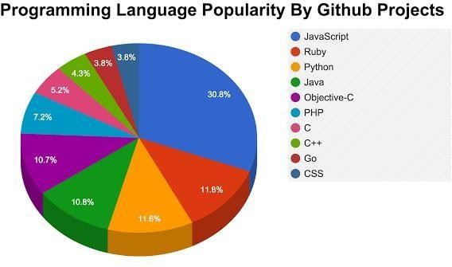

**Figure 3.2.1 Programming Language Popularity By GitHub Projects**

### **CLIENT SIDE SCRIPTING**

Client-side scripting is changing interface behaviors within a specific web page in response to mouse or keyboard actions, or at specified timing events. In this case, the dynamic behavior occurs within the [presentation.](https://en.wikipedia.org/wiki/Look_and_feel) The client-side content is generated on the user's local computer system.

Such web pages use presentation technology called [rich interfaced pages.](https://en.wikipedia.org/wiki/Rich_Internet_application#Methods_and_techniques) Client-side scripting languages like [JavaScript](https://en.wikipedia.org/wiki/JavaScript) or [ActionScript](https://en.wikipedia.org/wiki/ActionScript), used for [Dynamic HTML](https://en.wikipedia.org/wiki/Dynamic_HTML) (DHTML) and [Flash](https://en.wikipedia.org/wiki/Adobe_Flash) technologies respectively, are frequently used to orchestrate media types (sound, animations, changing text, etc.) of the presentation. Client-side scripting also allows the use of

[Remote scripting,](https://en.wikipedia.org/wiki/Remote_scripting) a technique by which the DHTML page requests additional information from a server, using a [hidden frame,](https://en.wikipedia.org/wiki/HTML_element#Frames) [XML Http Requests](https://en.wikipedia.org/wiki/XMLHttpRequest), or a [Web service](https://en.wikipedia.org/wiki/Web_service).

The first widespread use of JavaScript was in 1997, when the language was standardized as [ECMAScript](https://en.wikipedia.org/wiki/ECMAScript) and implemented in [Netscape 3.](https://en.wikipedia.org/wiki/Netscape)

Example:

The client-side content is generated on the client's computer. The web browser retrieves a page from the server, then processes the code embedded in the page (typically written in [JavaScript](https://en.wikipedia.org/wiki/JavaScript)) and displays the retrieved page's content to the user.

The most popularly used client side scripting languages is **Java Script**. Flow of request from browser to server:

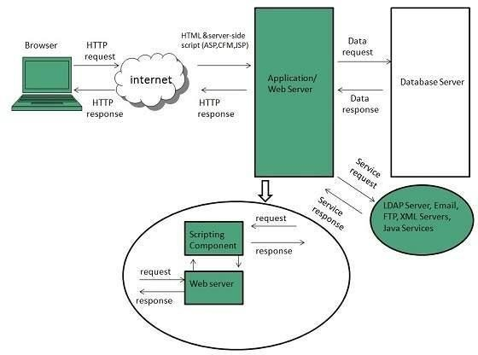

**Figure 3.2.2 Scripting Process**

### 

### 3.3 **DATABASE**

A **database** is an organized collection of [data.](https://en.wikipedia.org/wiki/Data_%28computing%29) It is the collection of [schemas, tables](https://en.wikipedia.org/wiki/Database_schema), [queries,](https://en.wikipedia.org/wiki/Query_language) reports, [views](https://en.wikipedia.org/wiki/View_%28SQL%29), and other objects. The data are typically organized to model aspects of reality in a way that supports [processes](https://en.wikipedia.org/wiki/Process_%28computing%29) requiring information, such as modelling the availability of rooms in hotels in a way that supports finding a hotel with vacancies.

A **database management system** (**DBMS**) is a [computer software](https://en.wikipedia.org/wiki/Computer_software) application that interacts with the user, other applications, and the database itself to capture and analyze data. A general-purpose DBMS is designed to allow the definition, creation, querying, update, and administration of databases. Well-known DBMSs include [MySQL, PostgreSQL,](https://en.wikipedia.org/wiki/MySQL) [MongoDB](https://en.wikipedia.org/wiki/MongoDB), [MariaDB,](https://en.wikipedia.org/wiki/MariaDB) [Microsoft SQL Server,](https://en.wikipedia.org/wiki/Microsoft_SQL_Server) [Oracle](https://en.wikipedia.org/wiki/Oracle_Database), [Sybase,](https://en.wikipedia.org/wiki/Sybase) [SAP HANA, Mem SQL](https://en.wikipedia.org/wiki/SAP_HANA) and [IBM DB2.](https://en.wikipedia.org/wiki/IBM_DB2) A database is not generally [portable](https://en.wikipedia.org/wiki/Software_portability) across different DBMSs, but different DBMS can interoperate by using [standards](https://en.wikipedia.org/wiki/Technical_standard) such as [SQL](https://en.wikipedia.org/wiki/SQL) and [ODBC](https://en.wikipedia.org/wiki/ODBC) or [JDBC](https://en.wikipedia.org/wiki/JDBC) to allow a single application to work with more than one DBMS. Database management systems are often classified according to the [database model](https://en.wikipedia.org/wiki/Database_model) that they support; the most popular database systems since the 1980s have all supported the [relational model](https://en.wikipedia.org/wiki/Relational_model) as represented by the [SQL](https://en.wikipedia.org/wiki/SQL) language. Sometimes a DBMS is loosely referred to as a "database".

### **SQL**

Originally based upon [relational algebra](https://en.wikipedia.org/wiki/Relational_algebra) and [tuple relational calculus](https://en.wikipedia.org/wiki/Tuple_relational_calculus), SQL consists of a [data definition language](https://en.wikipedia.org/wiki/Data_definition_language), [data manipulation language](https://en.wikipedia.org/wiki/Data_manipulation_language), and [data control language](https://en.wikipedia.org/wiki/Data_control_language). The scope of SQL includes data insert, query, update and delete, [schema](https://en.wikipedia.org/wiki/Database_schema) creation and modification, and data access control. Although SQL is often described as, and to a great extent is, a [declarative](https://en.wikipedia.org/wiki/Declarative_programming) [language](https://en.wikipedia.org/wiki/Declarative_programming) ([4GL](https://en.wikipedia.org/wiki/4GL)), it also includes [procedural](https://en.wikipedia.org/wiki/Procedural_programming) elements.

SQL was one of the first commercial languages for [Edgar F. Codd](https://en.wikipedia.org/wiki/Edgar_F._Codd)'s[relational model](https://en.wikipedia.org/wiki/Relational_model), as described in his influential 1970 paper, "A Relational Model of Data for Large Shared Data Banks." Despite not entirely adhering to [the relational model as described by Codd,](https://en.wikipedia.org/wiki/Codd%27s_12_rules) it became the most widely used database language.

SQL became a [standard](https://en.wikipedia.org/wiki/Technical_standard) of the [American National Standards Institute](https://en.wikipedia.org/wiki/American_National_Standards_Institute) (ANSI) in 1986, and of the [International Organization for Standardization](https://en.wikipedia.org/wiki/International_Organization_for_Standardization) (ISO) in 1987. Since then, the standard has been revised to include a larger set of features. Despite the existence of such standards, most SQL code is not completely portable among different database systems without adjustments.

### **QUERIES**

The most common operation in SQL, the query, makes use of the declarative [SELECT](https://en.wikipedia.org/wiki/Select_%28SQL%29) statement. SELECT retrieves data from one or more [tables,](https://en.wikipedia.org/wiki/Table_%28database%29) or expressions. Standard SELECT statements have no persistent effects on the database. Some non-standard implementations of SELECT can have persistent effects, such as the SELECT INTO syntax provided in some databases.

Queries allow the user to describe desired data, leaving the [database management](https://en.wikipedia.org/wiki/Database_management_system) [system (DBMS)](https://en.wikipedia.org/wiki/Database_management_system) to carry out [planning,](https://en.wikipedia.org/wiki/Query_plan) [optimizing,](https://en.wikipedia.org/wiki/Query_optimizer) and performing the physical operations necessary to produce that result as it chooses.

A query includes a list of columns to include in the final result, normally immediately following the SELECT keyword. An asterisk ("*") can be used to specify that the query should return all columns of the queried tables. SELECT is the most complex statement in SQL, with optional keywords and clauses that include:

* + - The [FROM](https://en.wikipedia.org/wiki/From_%28SQL%29) clause, which indicates the table(s) to retrieve data from. The FROM clause can include optional [JOIN](https://en.wikipedia.org/wiki/Join_%28SQL%29) sub clauses to specify the rules for joining tables.
    - The [WHERE](https://en.wikipedia.org/wiki/Where_%28SQL%29) clause includes a comparison predicate, which restricts the rows returned by the query. The WHERE clause eliminates all rows from the result set where the comparison predicate does not evaluate to True.
    - The GROUP BY clause projects rows having common values into a smaller set of rows. GROUP BY is often used in conjunction with SQL aggregation functions or to eliminate duplicate rows from a result set. The WHERE clause is applied before the GROUP BY clause.
    - The [HAVING](https://en.wikipedia.org/wiki/Having_%28SQL%29) clause includes a predicate used to filter rows resulting from the GROUP BY clause. Because it acts on the results of the GROUP BY clause, aggregation functions can be used in the HAVING clause predicate.
    - The [ORDER BY](https://en.wikipedia.org/wiki/Order_by_%28SQL%29) clause identifies which column[s] to use to sort the resulting data, and in which direction to sort them (ascending or descending). Without an ORDER BY clause, the order of rows returned by an SQL query is undefined.
    - The DISTINCT keyword eliminates duplicate data.

**CHAPTER-4**

### **SCRIPTING LANGUAGES**

### **4.1 JAVA SCRIPT**

**JavaScript**, often abbreviated as "JS", is a [high-level](https://en.wikipedia.org/wiki/High-level_programming_language), [dynamic,](https://en.wikipedia.org/wiki/Dynamic_programming_language) [untyped](https://en.wikipedia.org/wiki/Untyped_language), and [interpreted](https://en.wikipedia.org/wiki/Interpreted_language) run-time [language.](https://en.wikipedia.org/wiki/Programming_language) It has been standardized in the [ECMAScript](https://en.wikipedia.org/wiki/ECMAScript) language specification. Alongside [HTML](https://en.wikipedia.org/wiki/HTML) and [CSS,](https://en.wikipedia.org/wiki/CSS) JavaScript is one of the three core technologies of [World Wide Web content production](https://en.wikipedia.org/wiki/World_Wide_Web); the majority of [websites](https://en.wikipedia.org/wiki/Website) employ it, and all modern [Web](https://en.wikipedia.org/wiki/Web_browser) [browsers](https://en.wikipedia.org/wiki/Web_browser) support it without the need for [plug-ins.](https://en.wikipedia.org/wiki/Browser_extension) JavaScript is [prototype-based](https://en.wikipedia.org/wiki/Prototype-based_programming) with [first-class](https://en.wikipedia.org/wiki/First-class_function) [functions,](https://en.wikipedia.org/wiki/First-class_function) making it a [multi-paradigm](https://en.wikipedia.org/wiki/Multi-paradigm) language, supporting [object-oriented](https://en.wikipedia.org/wiki/Object-oriented_programming), [imperative](https://en.wikipedia.org/wiki/Imperative_programming), and [functional programming styles.](https://en.wikipedia.org/wiki/Functional_programming) It has an [API](https://en.wikipedia.org/wiki/Application_programming_interface) for working with text, [arrays](https://en.wikipedia.org/wiki/Array_data_type), dates and [regular](https://en.wikipedia.org/wiki/Regular_expression) [expressions](https://en.wikipedia.org/wiki/Regular_expression), but does not include any [I/O,](https://en.wikipedia.org/wiki/Input/output) such as networking, storage, or graphics facilities, relying for these upon the host environment in which it is embedded.

Although there are strong outward similarities between JavaScript and Java, including language name, [syntax](https://en.wikipedia.org/wiki/Syntax_%28programming_languages%29), and respective [standard libraries,](https://en.wikipedia.org/wiki/Standard_library) the two are distinct languages and differ greatly in their design. JavaScript was influenced by programming languages such as [self](https://en.wikipedia.org/wiki/Self_%28programming_language%29) and [Scheme.](https://en.wikipedia.org/wiki/Scheme_%28programming_language%29)

JavaScript is also used in environments that are not Web-based, such as [PDF](https://en.wikipedia.org/wiki/Portable_Document_Format) documents, [site-specific browsers,](https://en.wikipedia.org/wiki/Site-specific_browser) and [desktop widgets.](https://en.wikipedia.org/wiki/Desktop_widget) Newer and faster JavaScript [virtual](https://en.wikipedia.org/wiki/Virtual_machine) [machines](https://en.wikipedia.org/wiki/Virtual_machine) (VMs) and platforms built upon them have also increased the popularity of JavaScript for [server-side Web applications](https://en.wikipedia.org/wiki/Server-side). On the [client side](https://en.wikipedia.org/wiki/Client_side), developers have traditionally implemented JavaScript as an [interpreted](https://en.wikipedia.org/wiki/Interpreter_%28computing%29) language, but more recent browsers perform [just-in-time](https://en.wikipedia.org/wiki/Just-in-time_compilation) [compilation](https://en.wikipedia.org/wiki/Just-in-time_compilation). Programmers also use JavaScript in [video-game development](https://en.wikipedia.org/wiki/Video_game_development), in crafting desktop and mobile applications, and in server-side [network programming](https://en.wikipedia.org/wiki/Computer_network_programming) with [run-time environments](https://en.wikipedia.org/wiki/Runtime_system) such as [Node.js.](https://en.wikipedia.org/wiki/Node.js)

**4.2 NODE JS**

Node.js was developed by Ryan Dahl in 2009 and its latest version is v0.10.36. Node.js is a platform built on [Chrome's JavaScript runtime](https://code.google.com/p/v8/) for easily building fast and scalable network applications. Node.js uses an event-driven, non-blocking I/O model that makes it lightweight and efficient, perfect for data-intensive real-time applications that run across distributed devices.

Node.js is an open source, cross-platform runtime environment for developing server-side and networking applications. Node.js applications are written in JavaScript, and can be run within the Node.js runtime on OS X, Microsoft Windows, and Linux.

Node.js also provides a rich library of various JavaScript modules which simplifies the development of web applications using Node.js to a great extent.

## Features of Node.js

Following are some of the important features that make Node.js the first choice of software architects.

* **Asynchronous and Event Driven** − All APIs of Node.js library are asynchronous, that is, non-blocking. It essentially means a Node.js based server never waits for an API to return data. The server moves to the next API after calling it and a notification mechanism of Events of Node.js helps the server to get a response from the previous API call.
* **Very Fast** − Being built on Google Chrome's V8 JavaScript Engine, Node.js library is very fast in code execution.
* **Single Threaded but Highly Scalable** − Node.js uses a single threaded model with event looping. Event mechanism helps the server to respond in a non-blocking way and makes the server highly scalable as opposed to traditional servers which create limited threads to handle requests. Node.js uses a single threaded program and the same program can provide service to a much larger number of requests than traditional servers like Apache HTTP Server.
* **No Buffering** − Node.js applications never buffer any data. These applications simply output the data in chunks.
* **License** − Node.js is released under the [MIT license](https://raw.githubusercontent.com/joyent/node/v0.12.0/LICENSE).

## Who Uses Node.js?

Following is the link on GitHub wiki containing an exhaustive list of projects, application and companies which are using Node.js. This list includes eBay, General Electric, Go Daddy, Microsoft, PayPal, Uber, Wikipins, Yahoo!, and Yammer to name a few.

[Projects, Applications, and Companies Using Node](https://github.com/joyent/node/wiki/projects,-applications,-and-companies-using-node)

## Concepts

The following diagram depicts some important parts of Node.js which we will discuss in detail in the subsequent chapters.

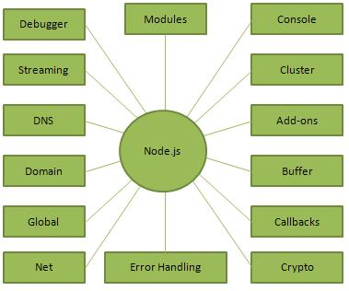

**Figure 4.1) Important parts of Node JS**

## Where to use Node JS

Following are the areas where Node.js is proving itself as a perfect technology partner.

* I/O bound Applications
* Data Streaming Applications
* Data Intensive Real-time Applications (DIRT)
* JSON APIs based Applications
* Single Page Applications

### **4.3 JQUERY**

**JQuery** is a [cross-platform](https://en.wikipedia.org/wiki/Cross-platform) [JavaScript library](https://en.wikipedia.org/wiki/JavaScript_library) designed to simplify the [client-side](https://en.wikipedia.org/wiki/Client-side_scripting) [scripting](https://en.wikipedia.org/wiki/Client-side_scripting) of [HTML.](https://en.wikipedia.org/wiki/HTML) It is [free, open-source software](https://en.wikipedia.org/wiki/Free_and_open_source_software) using the permissive [MIT license](https://en.wikipedia.org/wiki/MIT_license). [Web](https://en.wikipedia.org/wiki/World_Wide_Web) analysis indicates that it is the most widely deployed JavaScript library by a large margin.

jQuery's syntax is designed to make it easier to navigate a document, select [DOM](https://en.wikipedia.org/wiki/Document_Object_Model) elements, create [animations](https://en.wikipedia.org/wiki/Animation), handle [events,](https://en.wikipedia.org/wiki/Event_%28computing%29) and develop [Ajax](https://en.wikipedia.org/wiki/Ajax_%28programming%29) applications. jQuery also provides capabilities for developers to create [plug-ins](https://en.wikipedia.org/wiki/Plug-in_%28computing%29) on top of the JavaScript library. This enables developers to create [abstractions](https://en.wikipedia.org/wiki/Abstraction_%28computer_science%29) for low-level interaction and animation, advanced effects and high-level, themeable widgets. The modular approach to the jQuery library allows the creation of powerful [dynamic web pages](https://en.wikipedia.org/wiki/Dynamic_web_page) and Web applications.

The set of [jQuery core features](https://en.wikipedia.org/wiki/JQuery#Features)—DOM element selections, traversal and manipulation—enabled by its selector engine (named "Sizzle" from v1.3), created a new "programming style", fusing algorithms and DOM data structures. This style influenced the architecture of other [JavaScript frameworks](https://en.wikipedia.org/wiki/Comparison_of_JavaScript_frameworks) like [YUI v3](https://en.wikipedia.org/wiki/YUI_Library) and [Dojo](https://en.wikipedia.org/wiki/Dojo_Toolkit), later stimulating the creation of the standard Selectors API.

[Microsoft](https://en.wikipedia.org/wiki/Microsoft) and [Nokia](https://en.wikipedia.org/wiki/Nokia) bundle jQuery on their platforms. Microsoft includes it with [Visual Studio](https://en.wikipedia.org/wiki/Microsoft_Visual_Studio) for use within Microsoft's [ASP.NET AJAX](https://en.wikipedia.org/wiki/ASP.NET_AJAX) and [ASP.NET MVC](https://en.wikipedia.org/wiki/ASP.NET_MVC) frameworks while Nokia has integrated it into the Web Run-Time widget development platform.

### **AJAX**

**Ajax** (also **AJAX** short for "asynchronous [JavaScript](https://en.wikipedia.org/wiki/JavaScript) and [XML](https://en.wikipedia.org/wiki/XML)") is a set of [Web](https://en.wikipedia.org/wiki/Web_development) [development](https://en.wikipedia.org/wiki/Web_development) techniques using many Web technologies on the [client side](https://en.wikipedia.org/wiki/Client_side) to create [asynchronous Web applications](https://en.wikipedia.org/wiki/Asynchronous_I/O). With Ajax, Web applications can send data to and retrieve from a [server](https://en.wikipedia.org/wiki/Web_server) asynchronously (in the background) without interfering with the display and behavior of the existing page. By decoupling the data interchange layer from the presentation layer, Ajax allows for Web pages, and by extension Web applications, to change content dynamically without the need to reload the entire page. In practice, modern implementations commonly substitute [JSON](https://en.wikipedia.org/wiki/JSON) for XML due to the advantages of being native to JavaScript.

Ajax is not a single technology, but rather a group of technologies. [HTML](https://en.wikipedia.org/wiki/Hypertext_Markup_Language) and [CSS](https://en.wikipedia.org/wiki/Cascading_Style_Sheets) can be used in combination to mark up and style information. The [DOM](https://en.wikipedia.org/wiki/Document_Object_Model) is accessed with JavaScript to dynamically display – and allow the user to interact with – the information presented. JavaScript and the [XML Http Request](https://en.wikipedia.org/wiki/XMLHttpRequest) object provide a method for exchanging data asynchronously between browser and server to avoid full page reloads.

### **JSON**

[In computing,](https://en.wikipedia.org/wiki/Computing) **JavaScript Object Notation** or **JSON** (/ˈdʒeɪsən/***JAY****-sən*), is an [open-](https://en.wikipedia.org/wiki/Open_standard) [standard](https://en.wikipedia.org/wiki/Open_standard) [file format](https://en.wikipedia.org/wiki/Open_standard) that uses [human-readable](https://en.wikipedia.org/wiki/Human-readable_medium) text to transmit data objects consisting of [attribute–value pairs](https://en.wikipedia.org/wiki/Attribute%E2%80%93value_pair) and [array data types](https://en.wikipedia.org/wiki/Array_data_type) (or any other [serializable](https://en.wikipedia.org/wiki/Serialization) value). It is a very common data format used for [asynchronous](https://en.wikipedia.org/wiki/Asynchronous_I/O) browser/server communication, including as a replacement for [XML](https://en.wikipedia.org/wiki/XML) in some [AJAX](https://en.wikipedia.org/wiki/Ajax_%28programming%29)-style systems.

JSON is [a language-independent](https://en.wikipedia.org/wiki/Language-independent_specification) data format. It was derived from [JavaScript](https://en.wikipedia.org/wiki/JavaScript), but as of 2017 many [programming languages](https://en.wikipedia.org/wiki/Programming_language) include code to generate and [parse](https://en.wikipedia.org/wiki/Parsing) JSON-format data. The official Internet [media type](https://en.wikipedia.org/wiki/Media_type) for JSON is application/json. JSON filenames use the extension

.json.

[Douglas Crock ford](https://en.wikipedia.org/wiki/Douglas_Crockford) originally specified the JSON format in the early 2000s; two competing standards, [RFC 7159](https://tools.ietf.org/html/rfc7159) and [ECMA-404](https://www.ecma-international.org/publications/standards/Ecma-404.htm), defined it in 2013. The ECMA standard describes only the allowed syntax, whereas the RFC covers some security and interoperability considerations.[[3]](https://en.wikipedia.org/wiki/JSON#cite_note-3)

A restricted profile of JSON, known as **I-JSON** (short for "Internet JSON"), seeks to overcome some of the interoperability problems with JSON. It is defined in [RFC 7493](https://tools.ietf.org/html/rfc7493).

**Chapter-5**

### 

### **SOFTWARE REQUIREMENT SPECIFICATION**

**5.1 Hardware Requirements**

The selection of hardware is very important in the existence and proper working of any software. When selecting hardware, the size and requirements are also important.

|  |  |
| --- | --- |
| Processor | Intel CORE i3 |
| RAM | **4.0 GB** |
| Hard Disk Drive | **500 GB** |

**5.2.** **Software Requirements**

|  |  |
| --- | --- |
| **Number** | **Description** |
| 1 | Any Windows OS |
| 2 | HTML/Css/Ajax/JavaScript/  Bootstrap. |
| 3 | Visual Studio Code |
| 4 | Node js |
| 5 | MySQL |
| 6 | Postman |

**5.3 Software Installations**

**5.3.1 Installation of Visual Studio Code:**

Windows (a development environment) Visual Studio Code (a.k.a.VS Code) is a lightweight developer tool (or code editor).

1. Download and run Visual Studio Code installer from <http://code.visualstudio.com/Download>.

2. in the following window, check

a. “Add to PATH (available after restart)” and

b. “Run Code after installation”.

c. You can decide on the rest of the options according to your preferences.

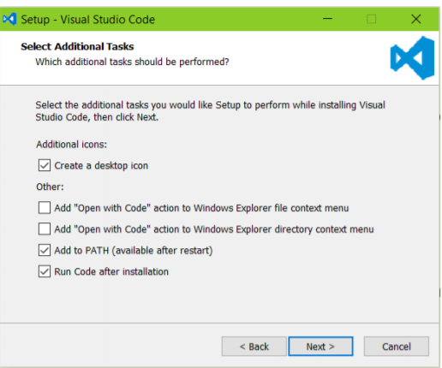

**Figure 5.3.1) Setup Of Visual Studio Code**

If Visual Studio Code is added to the PATH, you can type > code folder name (don’t type the > it represents the prompt) in the Command Prompt to launch Visual Studio Code.

3. To maximize your web development productivity, you should install Mohamed Abusaid’s HTML Snippets extension. You install the extension by launching VS Code, opening up the Command Palette (Control + Shift + P) and entering ext install html-snippets in it, then pressing ENTER. This will give you access to rich language support for HTML markup in VS Code including full HTML tags, colorization, snippets, quick info, etc.

4. To benefit from the HTML Snippets extension, type part of a snippet, press ENTER, and see the snippet unfold. Snippets are named as tag names, without brace

**5.3.3 Installation of Node JS:**

**1.) Download the Windows installer from**[Nodejs.org](http://nodejs.org/download/)**.**

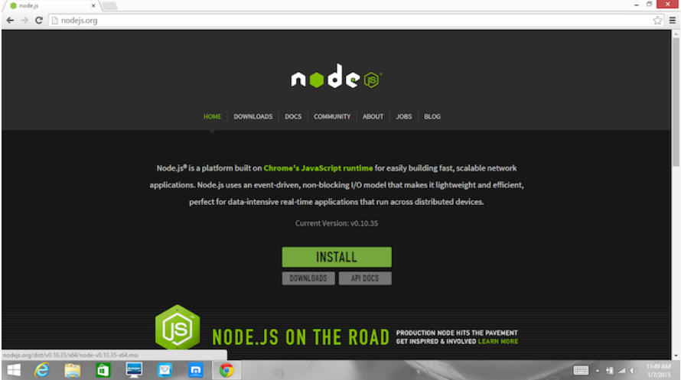

**Figure 5.3.2) Home Page of Nodejs.org**

**2.) Run the installer** (the .msi file you downloaded in the previous step.

3.) **Follow the prompts in the installer** (Accept the license agreement, click the NEXT button a bunch of times and accept the default installation settings).

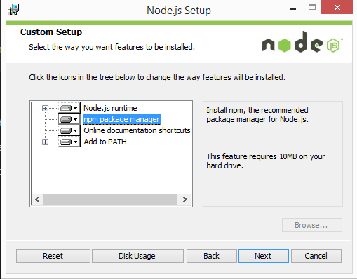

**Figure 5.3.3) Setup Page of Nodejs.org**

**3).Restart your computer.** You won’t be able to run Node.js until you restart your computer.

**Chapter-6**

### **UML DIAGRAM**

### **6.1.1 INTRODUCTION OF UML**

A UML diagram is a diagram based on the UML (Unified Modelling Language) with the purpose of visually representing a system along with its main actors, roles, actions, artifacts or classes, in order to better understand, alter, maintain, or document information about the system. UML is an acronym that stands for Unified Modelling Language. Simply put, UML is a modern approach to modelling and documenting software. In fact, it’s one of the most popular business process modelling techniques. It is based on diagrammatic representations of software components. As the old proverb says: “a picture is worth a thousand words”. By using visual representations, we are able to better understand possible flaws or errors in software or business processes.

UML was created as a result of the chaos revolving around software development and documentation. In the 1990s, there were several different ways to represent and document software systems. The need arose for a more unified way to visually represent those systems and 8 as a result, in 1994-1996, the UML was developed by three software engineers working at Rational Software. It was later adopted as the standard in 1997 and has remained the standard ever since, receiving only a few updates.

Mainly, UML has been used as a general-purpose modelling language in the field of software engineering. However, it has now found its way into the documentation of several business processes or workflows. For example, activity diagrams, a type of UML diagram, can be used as a replacement for flowcharts. They provide both a more standardized way of modelling workflows as well as a wider range of features to improve readability and efficacy.

UML itself finds different uses in software development and business process documentation: UML diagrams, in this case, are used to communicate different aspects and characteristics of a system. However, this is only a top-level view of the system and will most probably not include all the necessary details to execute the project until the very end.

Forward Design – The design of the sketch is done before coding the application. This is done to get a better view of the system or workflow that you are trying to create. Many design issues or flaws can be revealed, thus improving the overall project health and wellbeing.

Backward Design – After writing the code, the UML diagrams are drawn as a form of documentation for the different activities, roles, actors, and workflows.

In such a case, the UML diagram serves as a complete design that requires solely the actual implementation of the system or software. Often, this is done by using CASE tools (Computer Aided Software Engineering Tools). The main drawback of using CASE tools is that they require a certain level of expertise, user training as well as management and staff commitment.

UML is not a stand-alone programming language like Java, C++ or Python, however, with the right tools, it can turn into a pseudo programming language. In order to achieve this, the whole system needs to be documented in different UML diagrams and, by using the right software, the diagrams can be directly translated into code. This method can only be beneficial if the time it takes to draw the diagrams would take less time than writing the actual code.

Despite UML having been created for modelling software systems, it has found several adoptions in business fields or non-software systems.

There are several types of UML diagrams and each one of them serves a different purpose regardless of whether it is being designed before the implementation or after (as part of documentation).

The two most broad categories that encompass all other types are Behavioral UML diagram and Structural UML diagram. As the name suggests, some UML diagrams try to analyses and depict the structure of a system or process, whereas other describe the behavior of the system, its actors, and its building components. The different types are broken down as follows:

* Use Case Diagram
* Class Diagram
* Sequence Diagram
* Activity Diagram
* State chart Diagram

**Building blocks of UML:**

The vocabulary of the UML encompasses three kinds of building blocks:

* Things
* Relationships
* Diagrams

Things are the abstractions that are first-class citizens in a model;

Relationships tie these things together;

Diagrams group interesting collections of things.

**Things in UML**

There are four kinds of things in the UML:

* Structural things
* Behavioral things
* Grouping things
* Annotation things

Structural things are the nouns of UML models. The structural things used in the project design are:

First, a class is a description of a set of objects that share the same attributes, operations, relationships and semantics.

|  |
| --- |
| Window |
| Origin  Size |
| open() close() move() display() |
|  |

class

Second, a use case is a description of set of sequence of actions that a system performs that yields an observable result of value to particular actor.

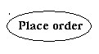

Use Case

Third, a node is a physical element that exists at runtime and represents a computational resource, generally having at least some memory and often processing capability.

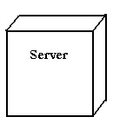

Nodes

Behavioral things are the dynamic parts of UML models. The behavioral thing used is:

**Interaction**

An interaction is a behavior that comprises a set of messages exchanged among a set of objects within a particular context to accomplish a specific purpose. An interaction involves a number of other elements, including messages, action sequences (the behavior invoked by a message, and links (the connection between objects).

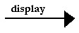

Messages

**Relationships in UML**

There are four kinds of relationships in the UML:

* Dependency
* Association
* Generalization
* Realization

A ***Dependency*** is a semantic relationship between two things in which a change to one thing may affect the semantics of the other thing (the dependent thing).

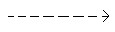

Dependencies

An ***Association*** is a structural relationship that describes a set links, a link being a connection among objects. Aggregation is a special kind of association, representing a structural relationship between a whole and its parts.



Association

A ***Generalization*** is a specialization/ generalization relationship in which objects of the specialized element (the child) are substitutable for objects of the generalized element (the parent).

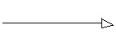

Generalization

A ***Realization*** is a semantic relationship between classifiers, where in one classifier specifies a contract that another classifier guarantees to carry out.

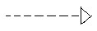

Realization

**6.1.2 Class Diagram:**

In software engineering, a class diagram in the Unified Modelling Language (UML) is a type of static structure diagram that describes the structure of a system by showing the system's classes, their attributes, operations (or methods), and the relationships among objects. The class diagram is the main building block of object-oriented modelling. It is used for general conceptual modelling of the structure of the application, and for detailed modelling translating the models into programming code. Class diagrams can also be used for data modelling. The classes in a class diagram represent both the main elements, interactions in the application, and the classes to be programmed.

### 

**Figure 6.1) Class Diagram**

**­­­­**

**6.1.3 Sequence Diagram:**

A sequence diagram shows object interactions arranged in time sequence. It depicts the objects and classes involved in the scenario and the sequence of messages exchanged between the objects needed to carry out the functionality of the scenario. Sequence diagrams are typically associated with use case realizations in the Logical View of the system under development. Sequence diagrams are sometimes called event diagrams or event scenarios.

### 

**Figure 6.2) Sequence diagram**

**6.1.4 Use Case Diagram**:

A use case diagram at its simplest is a representation of a user's interaction with the system that shows the relationship between the user and the different use cases in which the user is involved. A use case diagram can identify the different types of users of a system and the different use cases and will often be accompanied by other types of diagrams as well. The use cases are represented by either circles or ellipses.

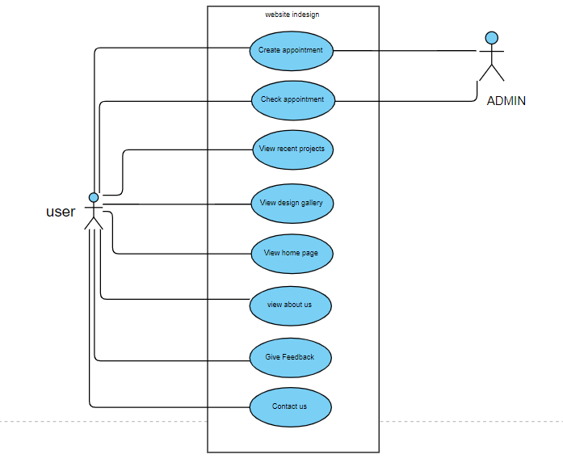­

**Figure 6.3) Use Case Diagram**

**CHAPTER-7**

### **PROJECT**

**7.1 NAME:**

Interior Designer Website

**7.2 Project Details:**

**Interior design** is the art and science of enhancing the interior of a building to achieve a healthier and more aesthetically pleasing environment for the people using the space. An **interior designer** is someone who plans, researches, coordinates, and manages such enhancement projects. Interior design is a multifaceted profession that includes conceptual development, space planning, site inspections, programming, research and communicating with the stakeholders of a project, construction management, and execution of the design. The following website is useful in showcasing the work done and the details of the interior design company called “IN Design” through design gallery and about us page .It also acts like a bridge between the user and interior designer where the user can communicate with the company, giving feedback to the company, creating appointment with the company and checking his appointment status. The following page also showcases the recent projects of the company where the user can know the projects done by the company till date.

##### 7.3 Technologies Used:

* + - HTML
    - CSS
    - Bootstrap
    - Node JS
    - Java Script
    - J query
    - AJAX

**Server:** Web Server

**Database:** My Sql 8

**Operating System:** Any Windows Operating system

**Wire framing tool:** Ms Paint

##### Team Size: 4

* 1. **TECHNICAL DETAILS:**
* Front end is designed using HTML, CSS and Bootstrap. Ajax used to perform behind the screen requests and JavaScript used to perform client side scripting
* Backend is based on Node JS + My Sql based RDB (Relational Data Base) model.
* The SQL queries are run using the CI SQL library functions
* Backend online host includes a centralized database resident on the server, the script uses SQL query to connect to the database on user’s request for transaction of data.
* The forms are made using the HTML, Bootstrap for designing and Node JS, SQL for back-end
* JavaScript, AJAX and JQuery used for client side scripting and Node JS for the server side development

**Chapter 8**

**IMPLEMENTATION**

**8.1 WIRE FRAMES**

**8.1.1) What is wireframe?**

Wireframes are simple black and white layouts that outline the specific size and placement of page elements, site features, conversion areas and navigation for your website.

* Wireframes are simple black and white layouts that outline the specific size and placement of page elements, site features, conversion areas and navigation for your website.
* They are devoid of colour, font choices, logos or any real design elements that take away from purely focusing on a site’s structure.
* We often say that they are much like your home’s blueprint, where you can easily see the structural placement of your plumbing, electrical and other structural elements without any interior design treatments.

**8.1.2) Wireframes**

**Home page wireframe:**

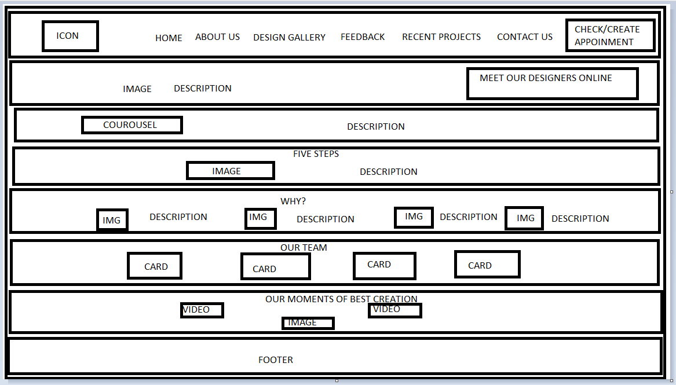

**Figure 8.1.1) Home Page Wireframe**

**Feedback page wireframe:**

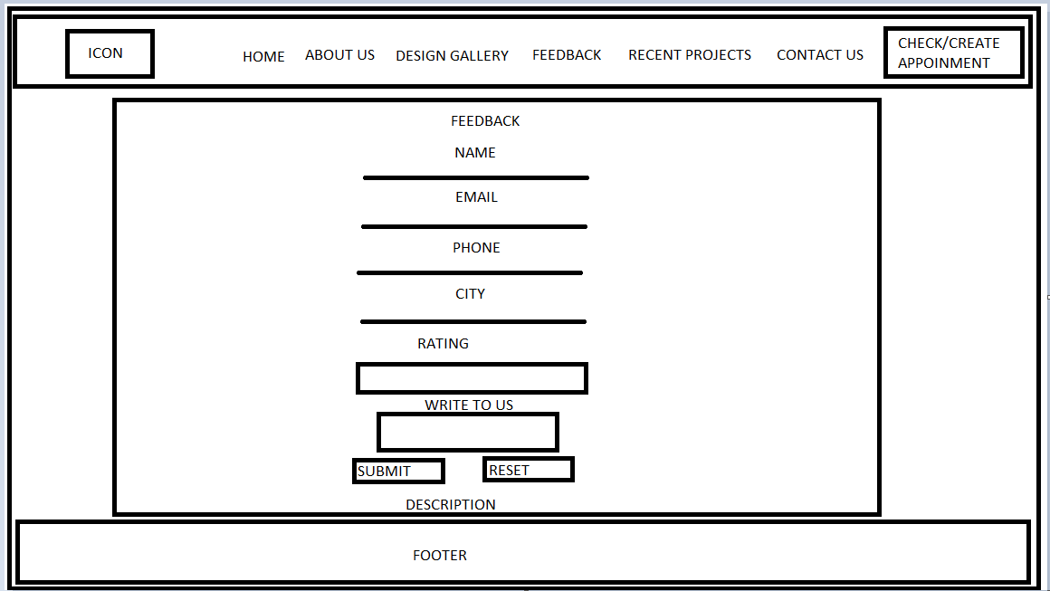

**Figure 8.1.2) Feedback Page Wireframe**

**Contact us page wireframe:**

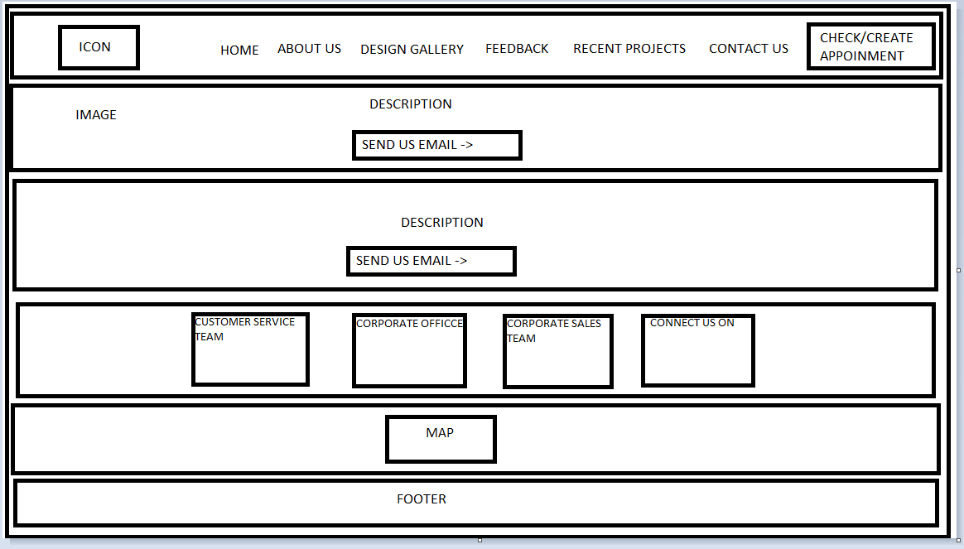 **Figure 8.1.3) Contact Page Wireframe**

**8.2 VALIDATIONS**

**8.2.1) What are Validations?**

Form validation normally used to occur at the server, after the client had entered all the necessary data and then pressed the Submit button. If the data entered by a client was incorrect or was simply missing, the server would have to send all the data back to the client and request that the form be resubmitted with correct information. This was really a lengthy process which used to put a lot of burden on the server.

JavaScript provides a way to validate form's data on the client's computer before sending it to the web server. Form validation generally performs two functions.

* **Basic Validation** − First of all, the form must be checked to make sure all the mandatory fields are filled in. It would require just a loop through each field in the form and check for data.
* **Data Format Validation** − Secondly, the data that is entered must be checked for correct form and value. Your code must include appropriate logic to test correctness of data.

**8.2.2) Validation pages:**

**Feedback Page:**

Feedback page has several validation fields like Name, Email, Phone number, City , Rate your experience where the following fields are mandatory and they are also validated if the user is giving correct input or not.

Test case 1:

If the user leaves the input fields black then following is returned.

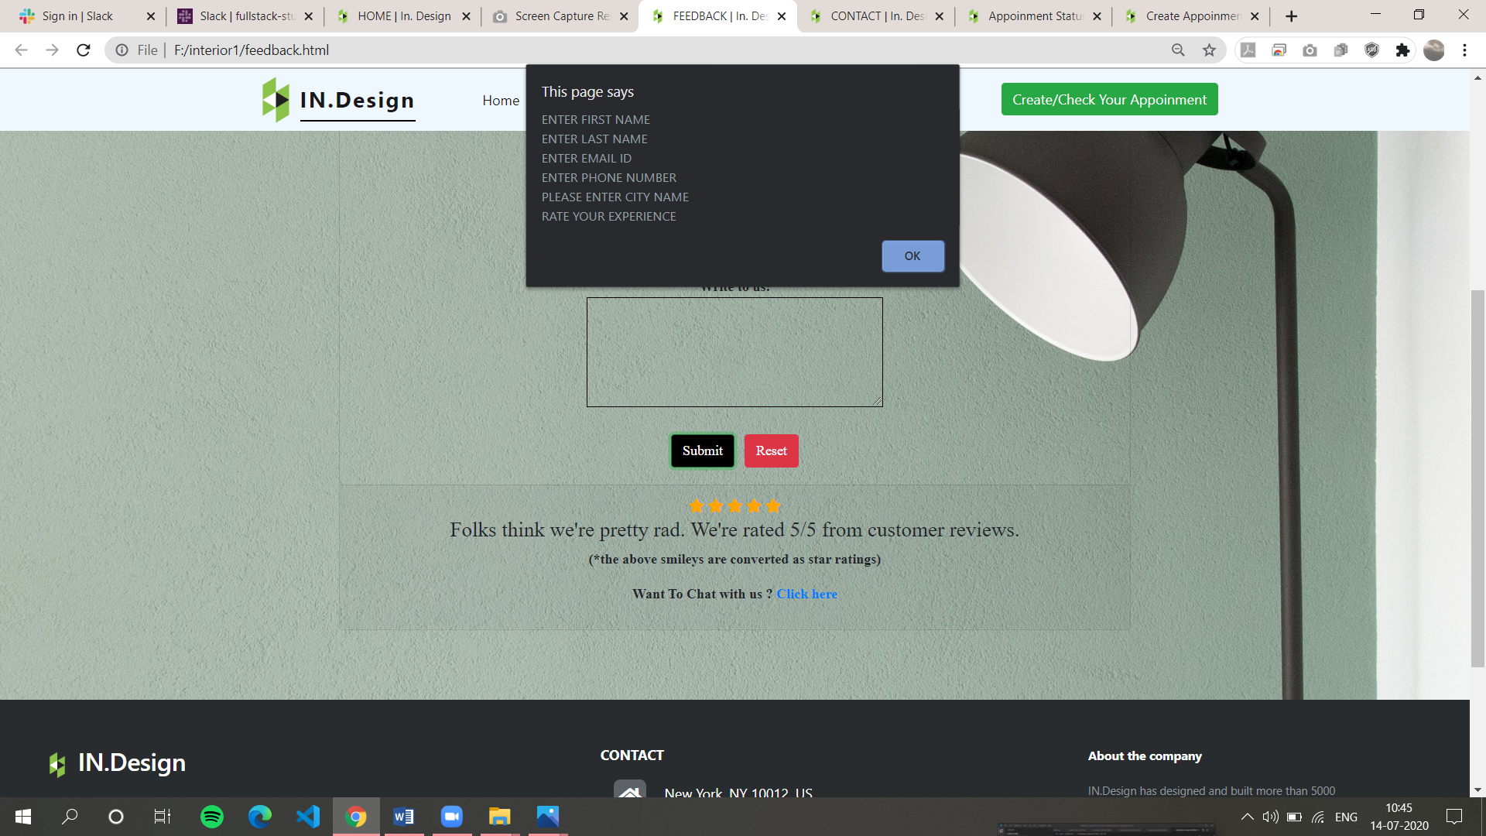

**Figure 8.2.1) Validation Test Case 1**

Test case 2:

If the user input wrong format of name or any input field then following is returned.

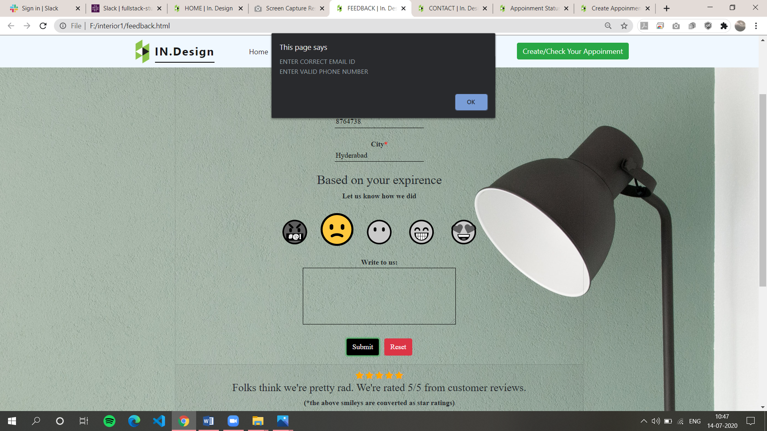

**Figure 8.2.2) Validation Test Case 2**

Test case 3:

If the user input is correct then the user input is stored in the data base and the success message is displayed.

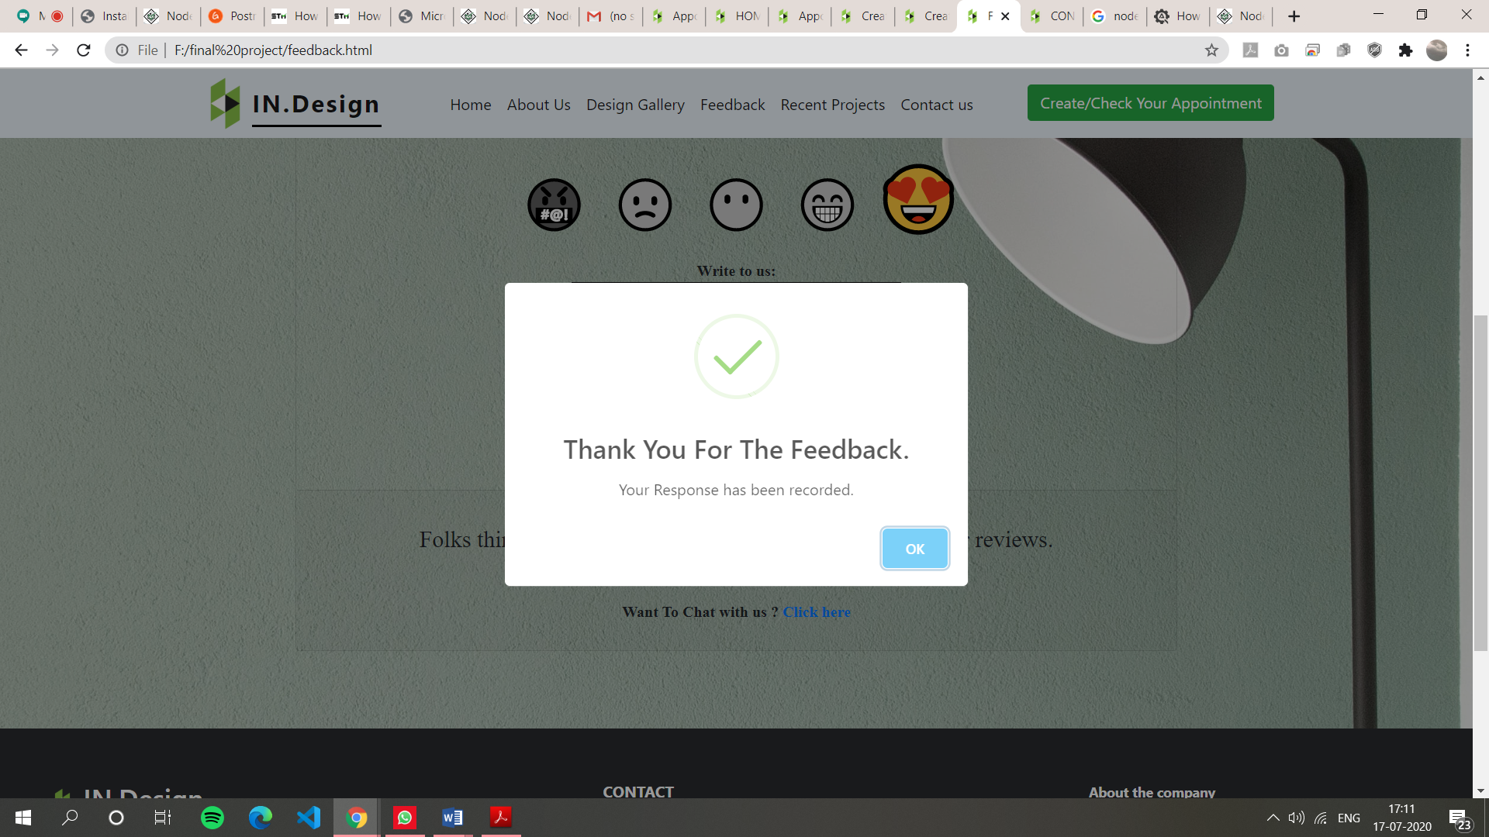

**Figure 8.2.3) Validation Test Case 3**

**Script for the following validation:**

function myFun() {

var result = "";

result += validateFName();

result += validateLName();

result += validateEmail();

result += validatePhoneno();

result += City();

result += Validatesmiley();

if (result == "") {

window.alert("Your Response has been recorded.Thank You For The Feedback.");

return true;

} else {

window.alert(result);

return false;

}

}

function validateFName() {

var regn = /^[a-zA-Z\s]*$/;

var name = document.getElementById("fn").value;

if (name == "") return "ENTER FIRST NAME\n";

if (regn.test(name)) return "";

else return "INVALID NAME\n";

}

function validateLName() {

var regl = /^[a-zA-Z\s]*$/;

var name1 = document.getElementById("ln").value;

if (name1 == "") return "ENTER LAST NAME\n";

if (regl.test(name1)) return "";

else return "INVALID NAME\n";

}

function Validatesmiley() {

var group = document.myForm.myradio;

for (var i = 0; i < group.length; i++) {

if (group[i].checked) return "";

}

if (i == group.length) return "RATE YOUR EXPERIENCE";

}

function validateEmail() {

var reg1 = /^[a-zA-z0-9._-]{6,25}[@][a-z]{3,15}[.][a-z]{2,6}$/;

var uid = document.getElementById("em").value;

if (uid == "") return "ENTER EMAIL ID\n";

if (reg1.test(uid)) return "";

else return "ENTER CORRECT EMAIL ID\n";

}

function validatePhoneno() {

var num = /^[6-9][0-9]{9}$/;

var psd = document.getElementById("phone").value;

if (psd == "") {

return "ENTER PHONE NUMBER\n";

}

if (num.test(psd)) return "";

else return "ENTER VALID PHONE NUMBER\n";

}

function City() {

var city = document.getElementById("cit").value;

var regc = /^[a-zA-Z\s]*$/;

if (city == "") return "PLEASE ENTER CITY NAME\n";

if (regc.test(city)) return "";

else return "INVALID CITY NAME\n";

}

function res() {

document.getElementById("myForm").reset();

}

**8.3 FRONT END SCREENSHOTS AND CODE**

**Home page:**

In the Home Page the user can find all the details about the company and we can navigate to any page like about us , design gallery , contact us etc.

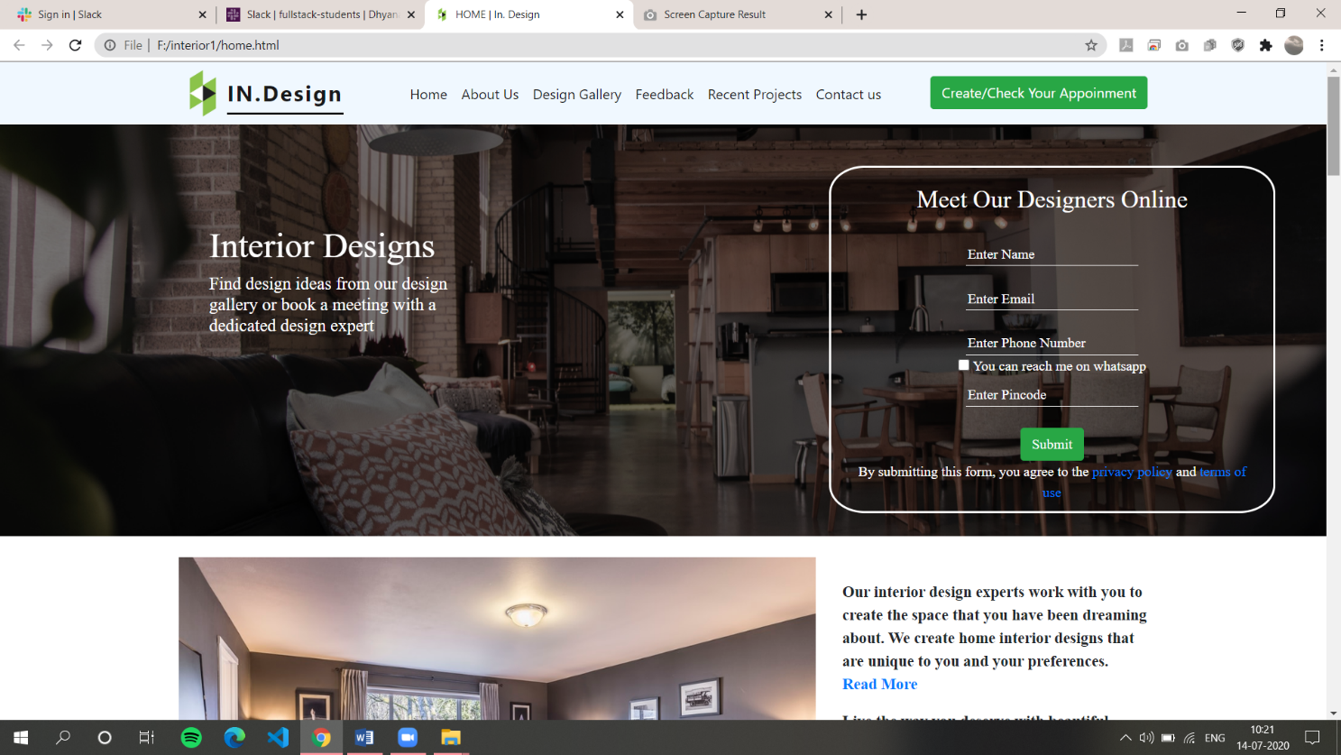

**Figure 8.3.1) Home page Screen Shot 1**

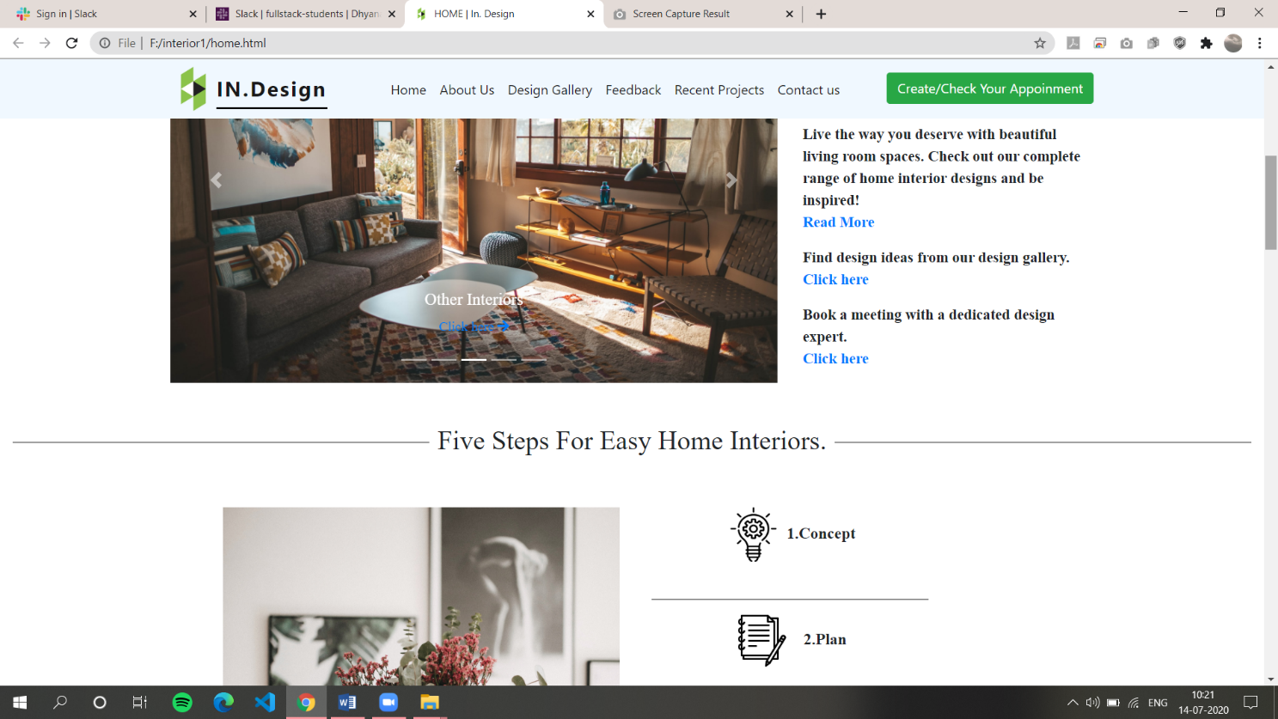

**Figure 8.3.2) Home page Screen Shot 2**

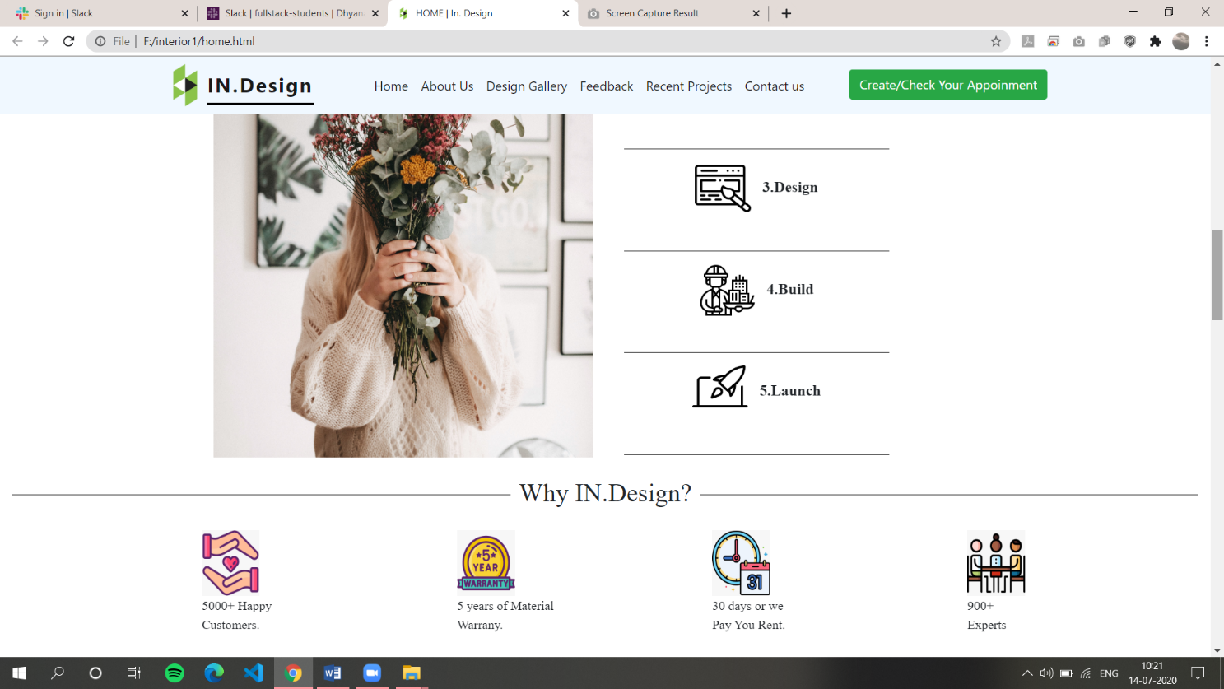

**Figure 8.3.3) Home page Screen Shot 3**

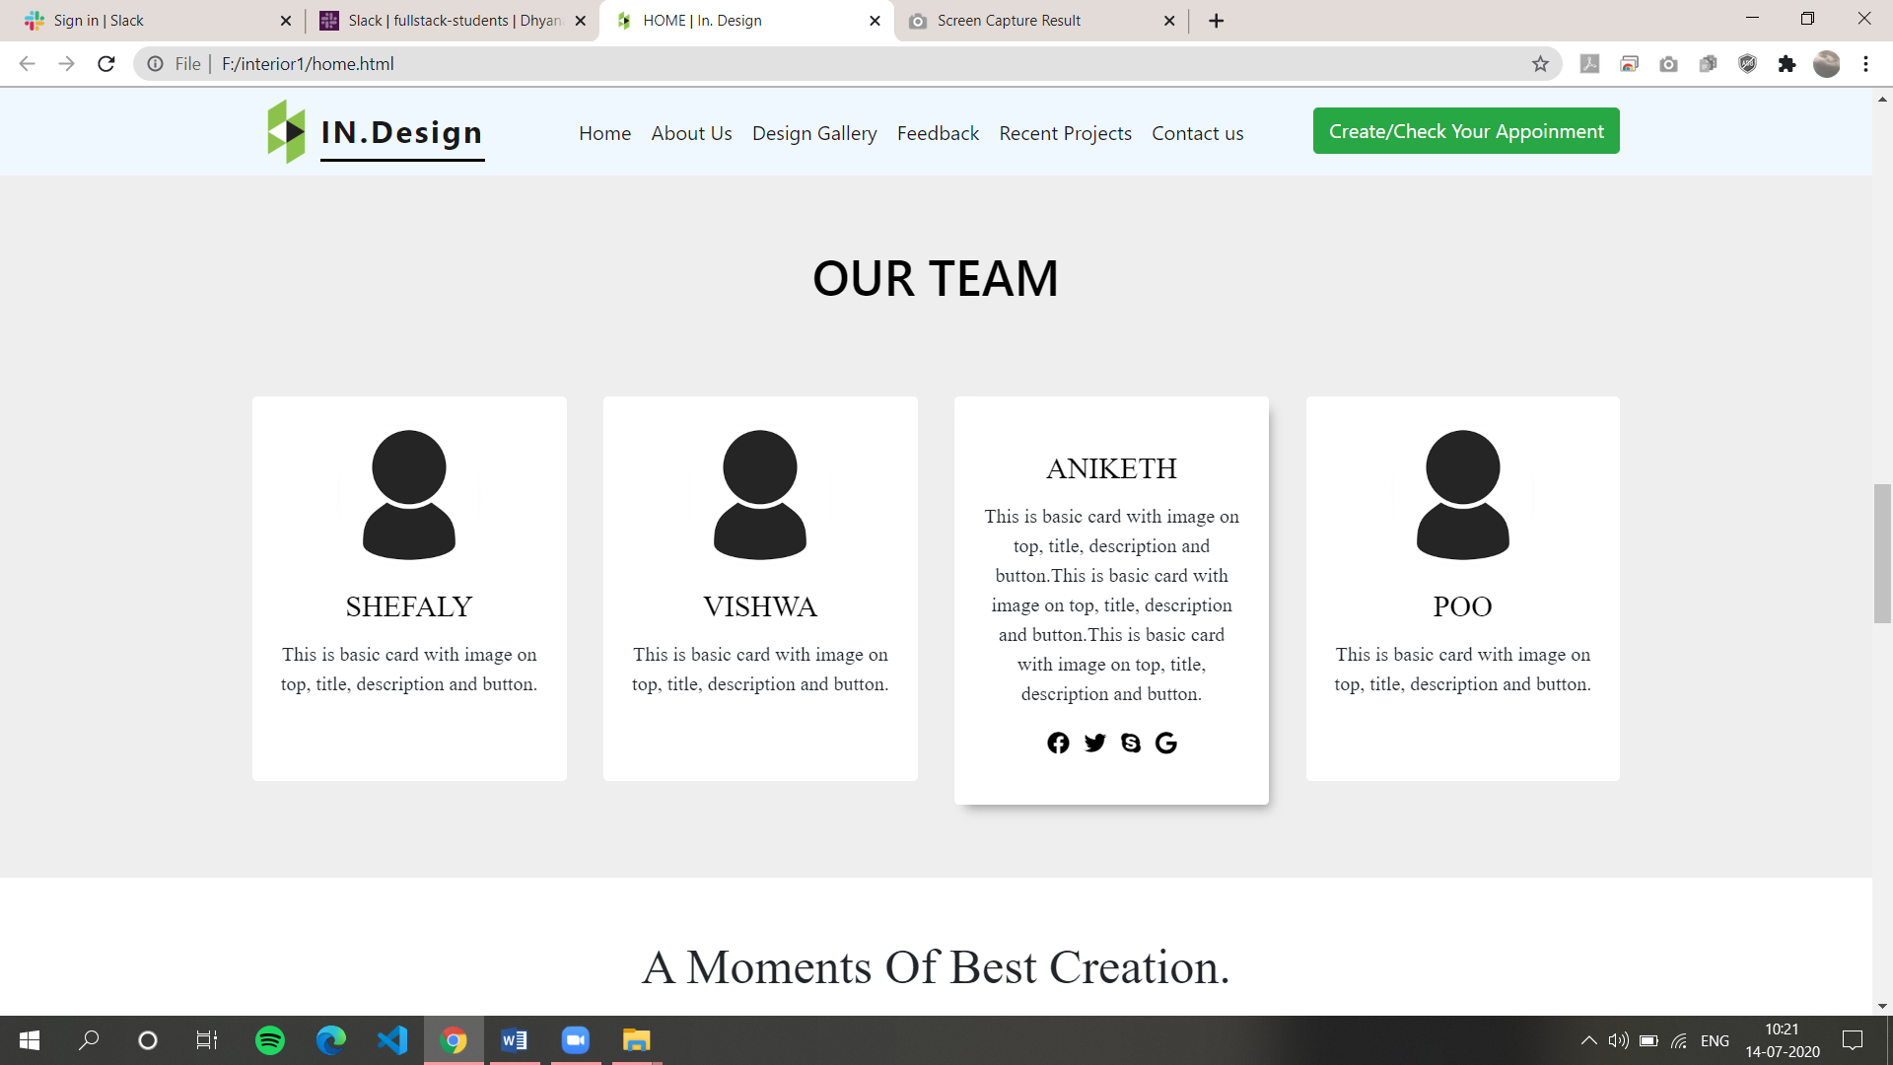

**Figure 8.3.4) Home page Screen Shot 4**

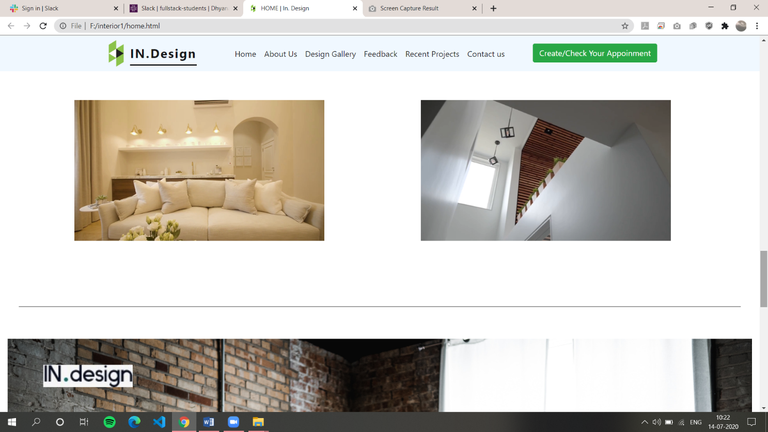

**Figure 8.3.5) Home page Screen Shot 5**



**Figure 8.3.6) Home page Screen Shot 6**

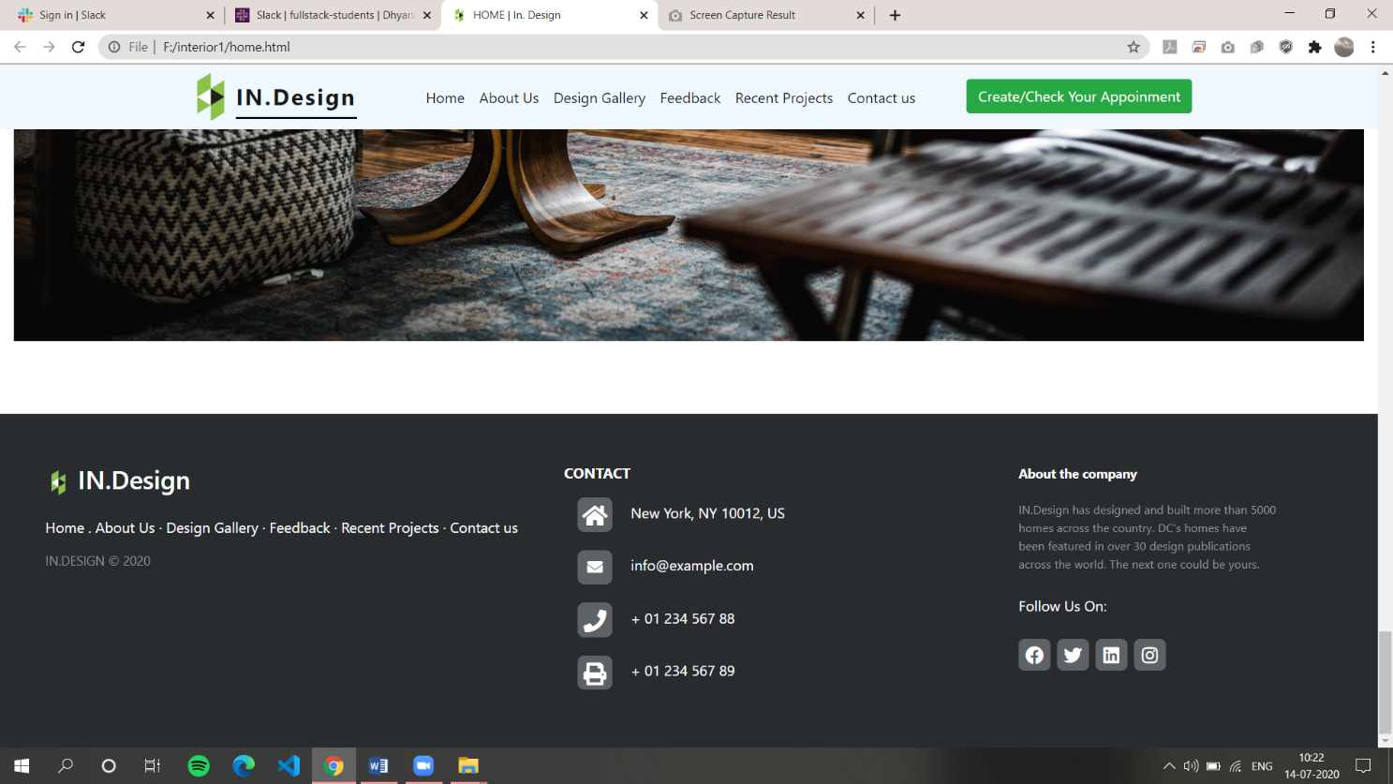

**Figure 8.3.7) Home page Screen Shot 7**

**HTML Code for Home Page:**

<!DOCTYPE html>

<head>

  <title>HOME | In. Design</title>

  <link rel="shortcut icon" href="image/icons8.png" />

  <link rel="StyleSheet" href="home.css" />

  <script src="bootstrap/js/jquery.min.js"></script>

  <script src="https://unpkg.com/sweetalert/dist/sweetalert.min.js"></script>

  <meta name="viewport" content="width=device-width, initial-scale=1" />

  <link

    rel="stylesheet"

    href="https://pro.fontawesome.com/releases/v5.10.0/css/all.css"

    integrity="sha384-AYmEC3Yw5cVb3ZcuHtOA93w35dYTsvhLPVnYs9eStHfGJvOvKxVfELGroGkvsg+p"

    crossorigin="anonymous"

  />

  <link

    rel="stylesheet"

    href="bootstrap/css/bootstrap.min.css" />

<script src="https://cdnjs.cloudflare.com/ajax/libs/jquery/3.2.1/jquery.min.js"></script>

  <script

    src="https://cdn.jsdelivr.net/npm/popper.js@1.16.0/dist/umd/popper.min.js"

    integrity="sha384-Q6E9RHvbIyZFJoft+2mJbHaEWldlvI9IOYy5n3zV9zzTtmI3UksdQRVvoxMfooAo"

    crossorigin="anonymous"

  ></script>

  <script

    src="https://stackpath.bootstrapcdn.com/bootstrap/4.5.0/js/bootstrap.min.js"

    integrity="sha384-OgVRvuATP1z7JjHLkuOU7Xw704+h835Lr+6QL9UvYjZE3Ipu6Tp75j7Bh/kR0JKI"

    crossorigin="anonymous"

  ></script>

  </head>

<body>

<div class="bg-img">

    <nav

      class="navbar navbar-expand-lg navbar-light fixed-top"

      style="background-color: aliceblue;"

    >

      <div class="container">

        <img src="image/icons8.png" height="5%" width="5%">

        <a class="navbar-brand" href="#" style="border-bottom: 2px solid black;">IN.Design</a>

        <button

          class="navbar-toggler"

          type="button"

          data-toggle="collapse"

          data-target="#navbarSupportedContent"

          aria-controls="navbarSupportedContent"

          aria-expanded="false"

          aria-label="Toggle navigation"

        >

          <span class="navbar-toggler-icon"></span>

        </button>

        <div class="collapse navbar-collapse" id="navbarSupportedContent">

          <ul class="navbar-nav ml-auto">

            <li class="nav-item active">

              <a class="nav-link active" href="home.html" target="_self">Home</a>

            </li>

            <li class="nav-item active">

              <a class="nav-link" href="aboutus.html"  target="_self">About Us</a>

            </li>

            <li class="nav-item active">

              <a class="nav-link" href="designgallery.html"  target="_blank">Design Gallery</a>

            </li>

            <li class="nav-item active">

              <a class="nav-link" href="feedback.html"  target="_self">Feedback</a>

            </li>

            <li class="nav-item active">

              <a class="nav-link" href="recentprojects.html"  target="_self">Recent Projects</a>

            </li>

            <li class="nav-item active">

              <a class="nav-link" href="contactus.html"  target="_self">Contact us</a>

            </li>

            &nbsp; &nbsp; &nbsp; &nbsp; &nbsp; &nbsp;

            <li class="nav-item active">

              <a href="checkestimate.html" target="_blank"><button type="button" class="btn btn-success">

              Create/Check Your Appointment

              </button></a>

            </li>

          </ul>

        </div>

      </div>

    </nav>

    <div class="container">

      <div class="row">

        <div class="col-md-4">

          <div class="header1">

            <h1 id="heading">Interior Designs</h1>

            <h5 id="matter">

              Find design ideas from our design gallery or book a meeting with a

              dedicated design expert

            </h5>

          </div>

        </div>

        <div class="col-md-8">

          <div class="card" id="centered">

            <div class="card-body">

              <h3>Meet Our Designers Online</h3>

              <br />

              <input type="text" id="un" placeholder="Enter Name" /><br />

              <span id="s1"></span><br>

              <input type="text" id="em" placeholder="Enter Email" /><br />

              <span id="s2"></span><br>

              <input type="text" id="pn" placeholder="Enter Phone Number" /><br /><br>

              <input type="text" id="pin1" placeholder="Enter Pincode" /><br /><br />

              <button type="button" class="btn btn-success" id="bt" >

                Submit</button

              ><br />

              <p>

                By submitting this form, you agree to the

                <a href="#">privacy policy</a> and

                <a href="#">terms of use</a>

              </p>

            </div>

          </div>

        </div>

      </div>

    </div>

  </div>

  <br />

  <div class="container" id="cor">

    <div class="row">

      <div class="col-md-8">

        <div

          id="carouselExampleIndicators"

          class="carousel slide"

          data-ride="carousel">

          <ol class="carousel-indicators">

            <li

              data-target="#carouselExampleIndicators"

              data-slide-to="0"

              class="active"

            ></li>

            <li data-target="#carouselExampleIndicators" data-slide-to="1"></li>

            <li data-target="#carouselExampleIndicators" data-slide-to="2"></li>

            <li data-target="#carouselExampleIndicators" data-slide-to="3"></li>

            <li data-target="#carouselExampleIndicators" data-slide-to="4"></li>

          </ol>

          <div class="carousel-inner">

            <div class="carousel-item active">

              <img class="d-block w-100" src="image/homepage/corousel1/kitchen1.jpg" alt="First slide" />

              <div class="carousel-caption d-none d-md-block">

                <h5>Modular Kitchens</h5>

                <p>

                  <a href="#"

                    >Click here&nbsp;<i

                      class="fa fa-arrow-right"

                      aria-hidden="true"

                    ></i

                  ></a>

                </p>

              </div>

            </div>

            <div class="carousel-item">

              <img class="d-block w-100" src="image/homepage/corousel1/bed1.jpg" alt="Second slide" />

              <div class="carousel-caption d-none d-md-block">

                <h5>Bedrooms</h5>

                <p>

                  <a href="#"

                    >Click here&nbsp;<i

                      class="fa fa-arrow-right"

                      aria-hidden="true"

                    ></i

                  ></a>

                </p>

              </div>

            </div>

            <div class="carousel-item">

              <img class="d-block w-100" src="image/homepage/corousel1/home4.jpg" alt="Third slide" />

              <div class="carousel-caption d-none d-md-block">

                <h5>Other Interiors</h5>

                <p>

                  <a href="#"

                    >Click here&nbsp;<i

                      class="fa fa-arrow-right"

                      aria-hidden="true"

                    ></i

                  ></a>

                </p>

              </div>

            </div>

            <div class="carousel-item">

              <img class="d-block w-100" src="image/homepage/corousel1/image4.jpg" alt="Fourth slide" />

              <div class="carousel-caption d-none d-md-block">

                <h5>Artificial Plants</h5>

                <p>

                  <a href="#"

                    >Click here&nbsp;<i

                      class="fa fa-arrow-right"

                      aria-hidden="true"

                    ></i

                  ></a>

                </p>

              </div>

            </div>

            <div class="carousel-item">

              <img class="d-block w-100" src="image/homepage/corousel1/image5.jpg" alt="fifth slide" />

              <div class="carousel-caption d-none d-md-block">

                <h5>Magnificent Designs</h5>

                <p>

                  <a href="#"

                    >Click here&nbsp;<i

                      class="fa fa-arrow-right"

                      aria-hidden="true"

                    ></i

                  ></a>

                </p>

              </div>

            </div>

          </div>

          <a

            class="carousel-control-prev"

            href="#carouselExampleIndicators"

            role="button"

            data-slide="prev"

            id="prev"

          >

            <span class="carousel-control-prev-icon" aria-hidden="true"></span>

            <span class="sr-only">Previous</span>

          </a>

          <a

            class="carousel-control-next"

            href="#carouselExampleIndicators"

            role="button"

            data-slide="next"

          >

            <span class="carousel-control-next-icon" aria-hidden="true"></span>

            <span class="sr-only">Next</span>

          </a>

        </div>

      </div>

      <div class="col-md-4" id="p1">

        <br />

        <p>

          Our interior design experts work with you to create the space that you

          have been dreaming about. We create home interior designs that are

          unique to you and your preferences.<br />

          <a href="aboutus.html">Read More</a>

        </p>

        <p>

          Live the way you deserve with beautiful living room spaces. Check out

          our complete range of home interior designs and be inspired!<br />

          <a href="aboutus.html">Read More</a>

        </p>

        <p>

          Find design ideas from our design gallery.<br />

          <a href="designgallery.html">Click here</a>

        </p>

        <p>

          Book a meeting with a dedicated design expert.<br />

          <a href="step1.html">Click here</a>

        </p>

      </div>

    </div>

  </div>

   <div class="container-fluid" id="one">

    <div>

      <br><br><h2><span>

        Five Steps For Easy Home Interiors.</span></h2>

    </div><br><br>

    <div class="row">

     <div class="col-md-2">

     </div>

       <div class="col-md-4">

        <img src="image/homepage/fivesteps/flowergirl.jpg" width="100%" height="95%">

      </div><br>

    <div class="col-md-3">

               <img src="image/homepage/fivesteps/innovation.png " width="20%" height="10%">&nbsp;1.Concept <br><br><hr>

               <img src="image/homepage/fivesteps/study.png"width="20%" height="10%">&nbsp;&nbsp;&nbsp;2.Plan <br><br><hr>

              <img src="image/homepage/fivesteps/content.png"width="20%" height="10%">&nbsp;&nbsp;&nbsp;3.Design  <br><br><hr>

              <img src="image/homepage/fivesteps/construction.png"width="20%" height="10%">&nbsp;&nbsp;&nbsp;4.Build <br><br><hr>

               <img src="image/homepage/fivesteps/speed.png"width="20%" height="10%">&nbsp;&nbsp;&nbsp;5.Launch <br><br><hr>

            </div>

     <div class="col-md-3">

     </div>

    </div>

   </div>

  <!--WHO WE ARE STARTS HERE-->

<div class="container-fluid" id="two">

  <div>

    <h2><span>Why IN.Design?</span></h2>

  </div><br>

  <div class="row" id="bommal">

 <div class="col-xs-12 col-sm-6 col-md-3">

      <img src="image/homepage/why/handmade.jpeg" width="25%" height="60%"><br><p> 5000+ Happy <BR> Customers.</p>

    </div>

    <div class="col-xs-12 col-sm-6 col-md-3">

      <img src="image/homepage/why/5yw.jpeg" width="25%" height="60%"><br><p>  5 years of Material<BR> Warrany.</p>

    </div>

    <div class="col-xs-12 col-sm-6 col-md-3">

      <img src="image/homepage/why/appoinment.jpeg" width="25%" height="60%"><br><p >30 days or we<BR> Pay You Rent.</p>

    </div>

    <div class="col-xs-12 col-sm-6 col-md-3">

      <img src="image/homepage/why/interview.png" width="25%" height="60%"><br><p> 900+ <BR> Experts</p>

    </div>

  </div>

</div><br> <br>

  </div>

  <section id="team" class="pb-5">

    <div class="container">

      <h5 class="section-title h1">OUR TEAM</h5><br>

      <div class="row">

        <!-- Team member  1-->

        <div class="col-xs-12 col-sm-6 col-md-3">

          <div class="image-flip">

            <div class="mainflip flip-0">

              <div class="frontside">

                <div class="card">

                  <div class="card-body text-center">

                    <p>

                      <img

                        class="img-fluid"

                        src="image/homepage/29.png"

                        alt="card image"

                      />

                    </p>

                    <h4 class="card-title">SHEFALY</h4>

                    <p class="card-text">

                    </p>

                  </div>

                </div>

              </div>

              <div class="backside">

                <div class="card">

                  <div class="card-body text-center mt-4">

                    <h4 class="card-title">SHEFALY KASAM</h4>

                    <p class="card-text">

                      Working on front and validations of subpages

                    </p>

                    <ul class="list-inline">

                      <li class="list-inline-item">

                        <a

                          class="social-icon text-xs-center"

                          target="_blank"

                          href="#"

                        >

                          <i class="fab fa-facebook"></i>

                        </a>

                      </li>

                      <li class="list-inline-item">

                        <a

                          class="social-icon text-xs-center"

                          target="_blank"

                          href="#"

                        >

                          <i class="fab fa-twitter"></i>

                        </a>

                      </li>

                      <li class="list-inline-item">

                        <a

                          class="social-icon text-xs-center"

                          target="_blank"

                          href="#"

                        >

                          <i class="fab fa-skype"></i>

                        </a>

                      </li>

                      <li class="list-inline-item">

                        <a

                          class="social-icon text-xs-center"

                          target="_blank"

                          href="#"

                        >

                          <i class="fab fa-google"></i>

                        </a>

                      </li>

                    </ul>

                  </div>

                </div>

              </div>

            </div>

          </div>

        </div>

        <!-- ./Team member 1 end here -->

        <!-- Team member 2 start -->

        <div class="col-xs-12 col-sm-6 col-md-3">

          <div

            class="image-flip"

            ontouchstart="this.classList.toggle('hover');"

          >

            <div class="mainflip">

              <div class="frontside">

                <div class="card">

                  <div class="card-body text-center">

                    <p>

                      <img

                        class="img-fluid"

                        src="image/homepage/29.png"

                        alt="card image"

                      />

                    </p>

                    <h4 class="card-title">VISHWA</h4>

                    <p class="card-text">

                    </p>

                  </div>

                </div>

              </div>

              <div class="backside">

                <div class="card">

                  <div class="card-body text-center mt-4">

                    <h4 class="card-title">VISHWANATH</h4>

                    <p class="card-text">

                      Working on front end and back end.

                    </p>

                    <ul class="list-inline">

                      <li class="list-inline-item">

                        <a

                          class="social-icon text-xs-center"

                          target="_blank"

                          href="#"

                        >

                          <i class="fab fa-facebook"></i>

                        </a>

                      </li>

                      <li class="list-inline-item">

                        <a

                          class="social-icon text-xs-center"

                          target="_blank"

                          href="#"

                        >

                          <i class="fab fa-twitter"></i>

                        </a>

                      </li>

                      <li class="list-inline-item">

                        <a

                          class="social-icon text-xs-center"

                          target="_blank"

                          href="#"

                        >

                          <i class="fab fa-skype"></i>

                        </a>

                      </li>

                      <li class="list-inline-item">

                        <a

                          class="social-icon text-xs-center"

                          target="_blank"

                          href="#"

                        >

                          <i class="fab fa-google"></i>

                        </a>

                      </li>

                    </ul>

                  </div>

                </div>

              </div>

            </div>

          </div>

        </div>

        <!-- ./Team member 2 end here-->

<!-- Team member 3 start here ->

<div class="col-xs-12 col-sm-6 col-md-3">

          <div

            class="image-flip"

            ontouchstart="this.classList.toggle('hover');"

          >

            <div class="mainflip">

              <div class="frontside">

                <div class="card">

                  <div class="card-body text-center">

                    <p>

                      <img

                        class="img-fluid"

                        src="image/homepage/29.png"

                        alt="card image"

                      />

                    </p>

                    <h4 class="card-title">ANI</h4>

                  </div>

                </div>

              </div>

              <div class="backside">

                <div class="card">

                  <div class="card-body text-center mt-4">

                    <h4 class="card-title">ANIKETH REDDY</h4>

                    <p class="card-text">

                      Working on font part operations and back end.

                    </p>

                    <ul class="list-inline">

                      <li class="list-inline-item">

                        <a class="social-icon text-xs-center" target="_blank">

                          <i class="fab fa-facebook"></i>

                        </a>

                      </li>

                      <li class="list-inline-item">

                        <a class="social-icon text-xs-center" target="_blank">

                          <i class="fab fa-twitter"></i>

                        </a>

                      </li>

                      <li class="list-inline-item">

                        <a class="social-icon text-xs-center" target="_blank">

                          <i class="fab fa-skype"></i>

                        </a>

                      </li>

                      <li class="list-inline-item">

                        <a class="social-icon text-xs-center" target="_blank">

                          <i class="fab fa-google"></i>

                        </a>

                      </li>

                    </ul>

                  </div>

                </div>

              </div>

            </div>

          </div>

        </div>

        <!-- ./Team member 3 end here-->

       <!-- Team member 4 start here -->

          <div class="col-xs-12 col-sm-6 col-md-3">

            <div

              class="image-flip"

              ontouchstart="this.classList.toggle('hover');"

            >

              <div class="mainflip">

                <div class="frontside">

                  <div class="card">

                    <div class="card-body text-center">

                      <p>

                        <img

                          class="img-fluid"

                          src="image/homepage/29.png"

                          alt="card image"

                        />

                      </p>

                      <h4 class="card-title">POOJITHA</h4>

                      <p class="card-text">

                      </p>

                     </div>

                  </div>

                </div>

                <div class="backside">

                  <div class="card">

                    <div class="card-body text-center mt-4">

                      <h4 class="card-title">POOJITHA</h4>

                      <p class="card-text">

                        working on front end and validation

                      </p>

                      <ul class="list-inline">

                        <li class="list-inline-item">

                          <a class="social-icon text-xs-center" target="_blank">

                            <i class="fab fa-facebook"></i>

                          </a>

                        </li>

                        <li class="list-inline-item">

                          <a class="social-icon text-xs-center" target="_blank">

                            <i class="fab fa-twitter"></i>

                          </a>

                        </li>

                        <li class="list-inline-item">

                          <a class="social-icon text-xs-center" target="_blank">

                            <i class="fab fa-skype"></i>

                          </a>

                        </li>

                        <li class="list-inline-item">

                          <a class="social-icon text-xs-center" target="_blank">

                            <i class="fab fa-google"></i>

                          </a>

                        </li>

                      </ul>

                    </div>

                  </div>

                </div>

              </div>

            </div>

          </div>

          <!-- ./Team member 4 end here-->

      </div>

    </div>

  </section><br><br>

 <div class="container-fluid" >

   <h1 style="text-align: center; text-transform: capitalize; font-family: 'Times New Roman', Times, serif;">A Moments of Best Creation.</h1>

   <div class="row" id="vd">

     <div class="col-md-6">

      <video  width="500" height="500"    controls="false" autoplay="autoplay" muted="true"  contenteditable="true">

        <source src="Video/Video1.mp4" type="video/mp4">

        Your browser does not support the video tag.

      </video>

     </div>

     <div class="col-md-6">

      <video  width="500" height="500" controls="false" autoplay="autoplay" muted="true"  contenteditable="true">

        <source src="Video/second.mp4" type="video/mp4">

        Your browser does not support the video tag.

      </video>

     </div>

   </div>

 </div><hr><br><br>

<div class="container-fluid" id="belowi">

  <img src="image/homepage/book3.jpg" class="img-fluid" alt="Responsive image">

  <a href="checkestimate.html" target="_self"><button type="button" class="btn btn-success" id="below-button">Create/Check Appointment&nbsp;<i class="fa fa-arrow-right" aria-hidden="true"></i></button></a>

</div>

</div>

<!--FOOTER START HERE-->

  <footer class="footer-distributed">

    <div class="footer-left">

      <h3 class="fothead"> <img src="image/icons8.png" height="5%" width="5%"> IN.Design</h3>

 <p class="footer-links">

        <a href="home.html">Home</a>

        . <a href="aboutus.html">About Us</a>

        ·

        <a href="designgallery.html" target="_blank">Design Gallery</a>

        ·

        <a href="feedback.html">Feedback</a>

        ·

        <a href="recentprojects.html">Recent Projects</a>

        ·

        <a href="contactus.html">Contact us</a>

      </p>

      <p class="footer-company-name">IN.DESIGN &copy; 2020</p>

    </div>

<div class="footer-center">

      <h6 class="text-uppercase font-weight-bold" style="color: white;">

        Contact

      </h6>

      <p><i class="fas fa-home mr-3"></i> Hyderabad, HY 10012, INDIA</p>

      <br />

      <p><i class="fas fa-envelope mr-3"></i> info@example.com</p>

      <br />

      <p><i class="fas fa-phone mr-3"></i> + 01 234 567 88</p>

      <br />

      <p><i class="fas fa-print mr-3"></i> + 01 234 567 89</p>

    </div>

 <div class="footer-right">

      <p class="footer-company-about">

        <span>About the company</span>

        IN.Design has designed and built more than 5000 homes across the

        country. DC’s homes have been featured in over 30 design publications

        across the world. The next one could be yours.

      </p><br>

      <span style="color: white;">Follow Us On:</span>

      <div class="footer-icons">

        <a href="#"><i class="fab fa-facebook"></i></a>

        <a href="#"><i class="fab fa-twitter"></i></a>

        <a href="#"><i class="fab fa-linkedin"></i></a>

        <a href="#"><i class="fab fa-instagram"></i></a>

      </div>

    </div>

   </footer>

   </body>

**CSS Code for home page:**

.navbar-light .navbar-brand {

color: #fff;

font-size: 25px;

font-weight: bold;

letter-spacing: 2px;

}

.navbar-light .navbar-nav .active > .nav-link,

.navbar-light .navbar-nav .nav-link.active,

.navbar-light .navbar-nav .nav-link.show,

.navbar-light .navbar-nav .show > .nav-link {

color: #fff;

}

.navbar-light .navbar-nav .nav-link {

color: #fff;

}

.navbar-toggler {

background: #fff;

}

.navbar-nav {

text-align: center;

}

.nav-link {

padding: 0.2rem 1rem;

}

.nav-link.active,

.nav-link:focus {

color: #fff;

}

.navbar-toggler {

padding: 1px 5px;

font-size: 18px;

line-height: 0.3;

}

.navbar-light .navbar-nav .nav-link:focus,

.navbar-light .navbar-nav .nav-link:hover {

color: #fff;

}

.nav-item:hover {

background-color: grey;

border-radius: 8px;

transition: 0.5s;

}

::placeholder {

color: white;

}

input[type="text"] {

color: white;

outline: none;

background-color: transparent;

border: transparent;

border-bottom: 1px solid white;

}

.bg-img {

/* The image used */

background-image: linear-gradient(rgba(0, 0, 0, 0.5), rgba(0, 0, 0, 0.5)),

url("image/homepage/homeimage.jpg");

/* Center and scale the image nicely */

background-position: center;

background-repeat: no-repeat;

background-size: cover;

margin-top: 3%;

/* Needed to position the navbar */

}

#centered {

margin-left: 50%;

margin-top: 10%;

width: 70%;

height: 80%;

background-color: rgba(0, 0, 0, 0);

color: white;

text-align: center;

border: 2px solid white;

border-radius: 8%;

font-family: "Times New Roman", Times, serif;

}

.header1 {

margin-left: 10%;

margin-top: 40%;

color: white;

font-family: "Times New Roman", Times, serif;

text-shadow: black;

}

@media (max-width: 880px) {

#matter {

display: none;

}

#centered {

margin-left: auto;

height: auto;

}

}

.footer-distributed {

background-color: #292c2f;

box-shadow: 0 1px 1px 0 rgba(0, 0, 0, 0.12);

box-sizing: border-box;

width: 100%;

text-align: left;

padding: 55px 50px;

margin-top: 80px;

}

.footer-distributed .footer-left,

.footer-distributed .footer-center,

.footer-distributed .footer-right {

display: inline-block;

vertical-align: top;

}

.footer-distributed .footer-left {

width: 40%;

}

.footer-distributed h3 {

color: #ffffff;

font: normal 36px;

margin: 0;

}

.footer-distributed h3 span {

color: #5383d3;

}

.foothead {

color: #fff;

font-size: 25px;

border-bottom: 2px solid black;

font-weight: bold;

letter-spacing: 2px;

margin-left: 3%;

margin-top: 3%;

}

.footer-distributed .footer-links {

color: #ffffff;

margin: 20px 0 12px;

padding: 0;

}

.footer-distributed .footer-links a {

display: inline-block;

line-height: 1.8;

text-decoration: none;

color: inherit;

}

.footer-distributed .footer-company-name {

color: #8f9296;

font-size: 14px;

font-weight: normal;

margin: 0;

}

.footer-distributed .footer-center {

width: 35%;

}

.footer-distributed .footer-center i {

background-color: #70757abd;

color: #ffffff;

font-size: 25px;

width: 38px;

height: 38px;

border-radius: 20%;

text-align: center;

line-height: 42px;

margin: 10px 15px;

vertical-align: middle;

}

.footer-distributed .footer-center i:hover {

background-color: white;

color: black;

}

.footer-distributed .footer-center i.fa-envelope {

font-size: 17px;

line-height: 38px;

}

.footer-distributed .footer-center p {

display: inline-block;

color: #ffffff;

vertical-align: middle;

margin: 0;

}

.footer-distributed .footer-center p span {

display: block;

font-weight: normal;

font-size: 14px;

line-height: 2;

}

.footer-distributed .footer-center p a {

color: #5383d3;

text-decoration: none;

}

.footer-distributed .footer-right {

width: 20%;

}

.footer-distributed .footer-company-about {

line-height: 20px;

color: #92999f;

font-size: 13px;

font-weight: normal;

margin: 0;

}

.footer-distributed .footer-company-about span {

display: block;

color: #ffffff;

font-size: 14px;

font-weight: bold;

margin-bottom: 20px;

}

.footer-distributed .footer-icons {

margin-top: 25px;

}

.footer-distributed .footer-icons a {

display: inline-block;

width: 35px;

height: 35px;

cursor: pointer;

background-color: #70757abd;

border-radius: 20%;

font-size: 20px;

color: #ffffff;

text-align: center;

line-height: 35px;

margin-right: 3px;

margin-bottom: 5px;

}

.footer-distributed .footer-icons a:hover {

background-color: white;

color: black;

}

@media (max-width: 880px) {

.footer-distributed {

font: bold 14px sans-serif;

}

.footer-distributed .footer-left,

.footer-distributed .footer-center,

.footer-distributed .footer-right {

display: block;

width: 100%;

margin-bottom: 40px;

text-align: center;

}

.footer-distributed .footer-center i {

margin-left: 0;

}

.main {

line-height: normal;

font-size: auto;

}

}

#cor {

font-family: "Times New Roman", Times, serif;

}

#team {

background: #eee !important;

}

.btn-primary:hover,

.btn-primary:focus {

background-color: #108d6f;

border-color: #108d6f;

box-shadow: none;

outline: none;

}

.btn-primary {

color: #fff;

background-color: #007b5e;

border-color: #007b5e;

}

section {

padding: 60px 0;

}

section .section-title {

text-align: center;

color: black;

margin-bottom: 50px;

text-transform: uppercase;

}

#team .card {

border: none;

background: white;

font-family: "Times New Roman", Times, serif;

}

.image-flip:hover .backside,

.image-flip.hover .backside {

-webkit-transform: rotateY(0deg);

-moz-transform: rotateY(0deg);

-o-transform: rotateY(0deg);

-ms-transform: rotateY(0deg);

transform: rotateY(0deg);

border-radius: 0.25rem;

}

.image-flip:hover .frontside,

.image-flip.hover .frontside {

-webkit-transform: rotateY(180deg);

-moz-transform: rotateY(180deg);

-o-transform: rotateY(180deg);

transform: rotateY(180deg);

}

.mainflip {

-webkit-transition: 1s;

-webkit-transform-style: preserve-3d;

-ms-transition: 1s;

-moz-transition: 1s;

-moz-transform-style: preserve-3d;

-ms-transform-style: preserve-3d;

transition: 1s;

transform-style: preserve-3d;

position: relative;

}

.frontside {

position: relative;

z-index: 2;

margin-bottom: 30px;

}

.backside {

position: absolute;

top: 0;

left: 0;

background: white;

-webkit-transform: rotateY(-180deg);

-moz-transform: rotateY(-180deg);

-o-transform: rotateY(-180deg);

-ms-transform: rotateY(-180deg);

transform: rotateY(-180deg);

-webkit-box-shadow: 5px 7px 9px -4px rgb(158, 158, 158);

-moz-box-shadow: 5px 7px 9px -4px rgb(158, 158, 158);

box-shadow: 5px 7px 9px -4px rgb(158, 158, 158);

}

.frontside,

.backside {

-webkit-backface-visibility: hidden;

-moz-backface-visibility: hidden;

-ms-backface-visibility: hidden;

backface-visibility: hidden;

-webkit-transition: 1s;

-webkit-transform-style: preserve-3d;

-moz-transition: 1s;

-moz-transform-style: preserve-3d;

-o-transition: 1s;

-o-transform-style: preserve-3d;

-ms-transition: 1s;

-ms-transform-style: preserve-3d;

transition: 1s;

transform-style: preserve-3d;

}

.frontside .card,

.backside .card {

min-height: 312px;

}

.backside .card a {

font-size: 18px;

color: black !important;

}

.frontside .card .card-title,

.backside .card .card-title {

color: black !important;

font-family: "Times New Roman", Times, serif;

}

.frontside .card .card-body img {

width: 120px;

height: 120px;

border-radius: 50%;

font-family: "Times New Roman", Times, serif;

}

#two h2 {

width: 100%;

text-align: center;

border-bottom: 1px solid #000;

line-height: 0.1em;

margin: 10px 0 20px;

}

#two {

width: 100%;

font-family: "Times New Roman", Times, serif;

}

#two h2 span {

background: #fff;

padding: 0 10px;

}

ul li {

display: inline-block;

text-decoration: none;

}

#bommal {

margin-left: 15%;

}

#one {

width: 100%;

font-family: "Times New Roman", Times, serif;

font-weight: bold;

font-size: larger;

text-align: center;

}

#one h2 {

width: 100%;

text-align: center;

border-bottom: 1px solid #000;

line-height: 0.1em;

margin: 10px 0 20px;

}

#one h2 span {

background: #fff;

padding: 0 10px;

}

#steps {

font-size: large;

}

#belowi {

position: relative;

width: 100%;

}

#belowi img {

width: 100%;

height: auto;

}

#belowi .btn {

position: absolute;

top: 60%;

left: 50%;

transform: translate(-50%, -50%);

-ms-transform: translate(-50%, -50%);

color: white;

font-size: 16px;

padding: 12px 24px;

border: none;

cursor: pointer;

border-radius: 5px;

text-align: center;

}

#belowi .btn:hover {

background-color: black;

}

#p1 {

font-size: large;

font-weight: bold;

}

[contenteditable] {

outline: 0px solid transparent;

}

#vd {

margin-left: 8%;

}

hr {

width: 95%;

height: 2%;

background-color: black;

border: none;

}

**Feedback page:**

Here the user can give feedback regarding their experience with the company.

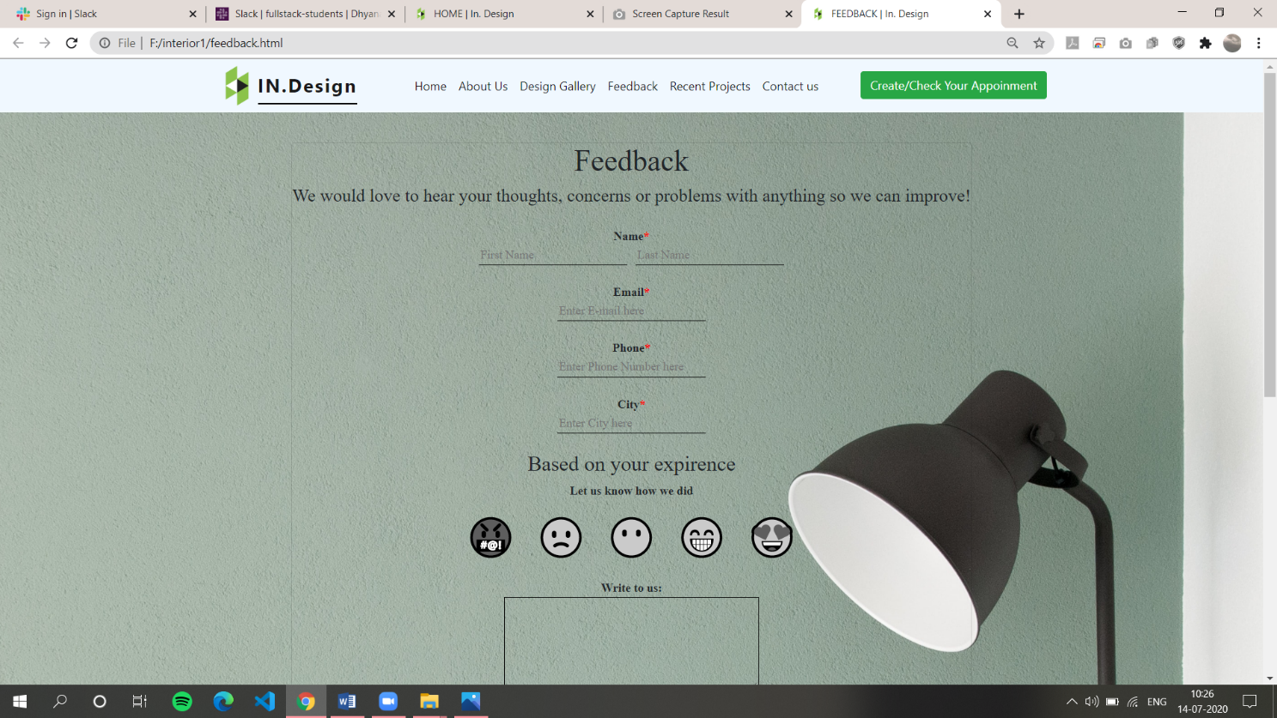

**Figure 8.3.7) Feedback page Screen Shot 1**

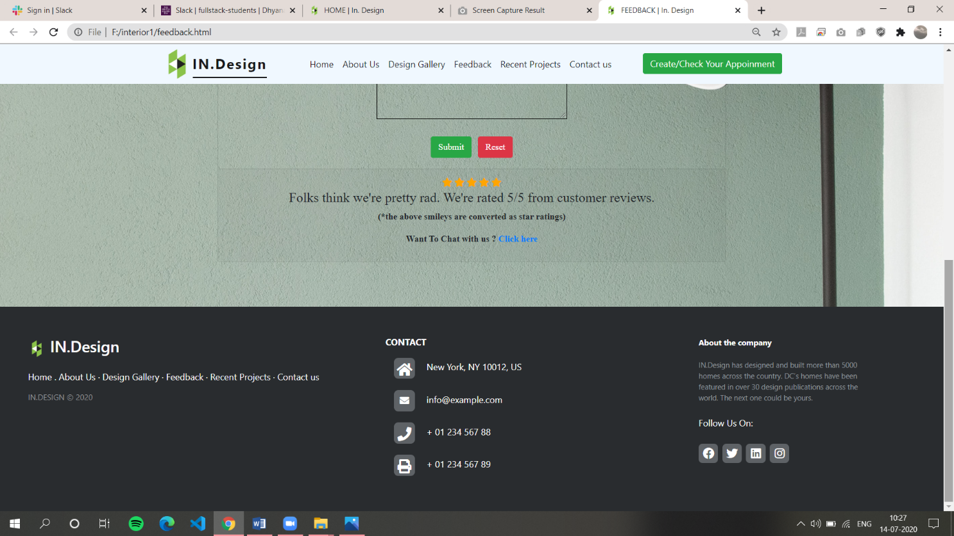

**Figure 8.3.8) Feedback page Screen Shot 2**

**HTML Code for Feedback page:**

<!DOCTYPE html>

<head>

  <title>FEEDBACK | In. Design</title>

  <link rel="shortcut icon" href="image/icons8.png" />

  <link rel="StyleSheet" href="feedback.css" />

  <script src="bootstrap/js/jquery.min.js"></script>

  <meta name="viewport" content="width=device-width, initial-scale=1" />

  <link

    rel="stylesheet"

    href="https://pro.fontawesome.com/releases/v5.10.0/css/all.css"

    integrity="sha384-AYmEC3Yw5cVb3ZcuHtOA93w35dYTsvhLPVnYs9eStHfGJvOvKxVfELGroGkvsg+p"

    crossorigin="anonymous"

  />

  <link rel="stylesheet" href="bootstrap/css/bootstrap.min.css" />

  <script src="https://cdnjs.cloudflare.com/ajax/libs/jquery/3.2.1/jquery.min.js"></script>

  <script

    src="https://cdn.jsdelivr.net/npm/popper.js@1.16.0/dist/umd/popper.min.js"

    integrity="sha384-Q6E9RHvbIyZFJoft+2mJbHaEWldlvI9IOYy5n3zV9zzTtmI3UksdQRVvoxMfooAo"

    crossorigin="anonymous"

  ></script>

</head>

<body>

  <nav

    class="navbar navbar-expand-lg navbar-light fixed-top"

    style="background-color: aliceblue;"

  >

    <div class="container">

      <img src="image/icons8.png" height="5%" width="5%" />

      <a class="navbar-brand" href="#" style="border-bottom: 2px solid black;"

        >IN.Design</a

      >

      <button

        class="navbar-toggler"

        type="button"

        data-toggle="collapse"

        data-target="#navbarSupportedContent"

        aria-controls="navbarSupportedContent"

        aria-expanded="false"

        aria-label="Toggle navigation"

      >

        <span class="navbar-toggler-icon"></span>

      </button>

      <div class="collapse navbar-collapse" id="navbarSupportedContent">

        <ul class="navbar-nav ml-auto">

          <li class="nav-item active">

            <a class="nav-link active" href="home.html">Home</a>

          </li>

          <li class="nav-item active">

            <a class="nav-link" href="aboutus.html">About Us</a>

          </li>

          <li class="nav-item active">

            <a class="nav-link" href="designgallery.html" target="_blank">Design Gallery</a>

          </li>

          <li class="nav-item active">

            <a class="nav-link" href="feedback.html">Feedback</a>

          </li>

          <li class="nav-item active">

            <a class="nav-link" href="recentprojects.html">Recent Projects</a>

          </li>

          <li class="nav-item active">

            <a class="nav-link" href="contactus.html">Contact us</a>

          </li>

          &nbsp; &nbsp; &nbsp; &nbsp; &nbsp; &nbsp;

          <li class="nav-item active">

            <a href="checkestimate.html" target="_blank"><button type="button" class="btn btn-success">

              Create/Check Your Appointment

            </button></a>

          </li>

        </ul>

      </div>

    </div>

  </nav>

  <div class="container" id="card1">

    <div class="card">

      <div class="card-head">

        <h1>Feedback</h1>

        <h4>

          We would love to hear your thoughts, concerns or problems with

          anything so we can improve!

        </h4>

      </div>

      <div class="card-body">

        <form id="myForm" name="myForm">

          Name<span style="color: red;">*</span><br />

          <input type="text" id="fn" placeholder="First Name" />&nbsp;&nbsp;

          <input type="text" id="ln" placeholder="Last Name" /><br /><br />

          Email<span style="color: red;">*</span><br />

          <input

            type="text"

            id="em"

            placeholder="Enter E-mail here"

          /><br /><br />

          Phone<span style="color: red;">*</span><br />

          <input

            type="text"

            id="phone"

            placeholder="Enter Phone Number here"

          /><br /><br />

          City<span style="color: red;">*</span><br />

          <input

            type="text"

            id="cit"

            placeholder="Enter City here"

          /><br /><br />

          <div class="app">

            <h3>Based on your expirence</h3>

            <p>Let us know how we did</p>

            <div class="item">

              <label for="1" class="radio-inline">

                <input

                  class="radio"

                  type="radio"

                  id="1"

                  name="myradio"

                  value="1"

                />

                <span>🤬</span>

              </label>

            </div>

            <div class="item">

              <label for="2" class="radio-inline">

                <input

                  class="radio"

                  type="radio"

                  id="2"

                  name="myradio"

                  value="2"

                />

                <span>🙁</span>

              </label>

            </div>

            <div class="item">

              <label for="3" class="radio-inline">

                <input

                  class="radio"

                  type="radio"

                  id="3"

                  name="myradio"

                  value="3"

                />

                <span>😶</span>

              </label>

            </div>

            <div class="item">

              <label for="4" class="radio-inline">

                <input

                  class="radio"

                  type="radio"

                  id="4"

                  name="myradio"

                  value="4"

                />

                <span>😁</span>

              </label>

            </div>

            <div class="item">

              <label for="5" class="radio-inline">

                <input

                  class="radio"

                  type="radio"

                  id="5"

                  name="myradio"

                  value="5"

                />

                <span>😍</span>

              </label>

            </div>

          </div>

          Write to us:<br />

          <textarea

            name="paragraph_text"

            id="area"

            cols="40"

            rows="5"

          ></textarea

          ><br /><br />

          <button

            type="button"

            id="bt"

            class="btn btn-success"

          >

            Submit</button

          >&nbsp;&nbsp;

          <button type="button" class="btn btn-danger" onclick="return res()">

            Reset

          </button>

        </form>

      </div>

      <div class="card-footer">

        <span class="fa fa-star checked"></span>

        <span class="fa fa-star checked"></span>

        <span class="fa fa-star checked"></span>

        <span class="fa fa-star checked"></span>

        <span class="fa fa-star checked"></span>

        <h4>

          Folks think we're pretty rad. We're rated 5/5 from customer reviews.

        </h4>

        <p>(*the above smileys are converted as star ratings)</p>

        <p>Want To Chat with us ? <a href="contactform.html" target="_blank">Click here</a></p>

      </div>

    </div>

  </div>

  <footer class="footer-distributed">

    <div class="footer-left">

      <h3 class="fothead">

        <img src="image/icons8.png" height="5%" width="5%" /> IN.Design

      </h3>

      <p class="footer-links">

        <a href="home.html">Home</a>

        . <a href="aboutus.html">About Us</a>

        ·

        <a href="designgallery.html" target="_blank">Design Gallery</a>

        ·

        <a href="feedback.html">Feedback</a>

        ·

        <a href="recentprojects.html">Recent Projects</a>

        ·

        <a href="contactus.html">Contact us</a>

      </p>

      <p class="footer-company-name">IN.DESIGN &copy; 2020</p>

    </div>

    <div class="footer-center">

      <h6 class="text-uppercase font-weight-bold" style="color: white;">

        Contact

      </h6>

      <p><i class="fas fa-home mr-3"></i> Hyderabad, HY 10012, INDIA</p>

      <br />

      <p><i class="fas fa-envelope mr-3"></i> info@example.com</p>

      <br />

      <p><i class="fas fa-phone mr-3"></i> + 01 234 567 88</p>

      <br />

      <p><i class="fas fa-print mr-3"></i> + 01 234 567 89</p>

    </div>

    <div class="footer-right">

      <p class="footer-company-about">

        <span>About the company</span>

        IN.Design has designed and built more than 5000 homes across the

        country. DC’s homes have been featured in over 30 design publications

        across the world. The next one could be yours.

      </p>

      <br />

      <span style="color: white;">Follow Us On:</span>

      <div class="footer-icons">

        <a href="#"><i class="fab fa-facebook"></i></a>

        <a href="#"><i class="fab fa-twitter"></i></a>

        <a href="#"><i class="fab fa-linkedin"></i></a>

        <a href="#"><i class="fab fa-instagram"></i></a>

      </div>

    </div>

  </footer>

</body>

  </html>

**CSS Code for Feedback page:**

.navbar-light .navbar-brand {

color: #fff;

font-size: 25px;

font-weight: bold;

letter-spacing: 2px;

}

.navbar-light .navbar-nav .active > .nav-link,

.navbar-light .navbar-nav .nav-link.active,

.navbar-light .navbar-nav .nav-link.show,

.navbar-light .navbar-nav .show > .nav-link {

color: #fff;

}

.navbar-light .navbar-nav .nav-link {

color: #fff;

}

.navbar-toggler {

background: #fff;

}

.navbar-nav {

text-align: center;

}

.nav-link {

padding: 0.2rem 1rem;

}

.nav-link.active,

.nav-link:focus {

color: #fff;

}

.navbar-toggler {

padding: 1px 5px;

font-size: 18px;

line-height: 0.3;

}

.navbar-light .navbar-nav .nav-link:focus,

.navbar-light .navbar-nav .nav-link:hover {

color: #fff;

}

.nav-item:hover {

background-color: grey;

border-radius: 8px;

transition: 0.5s;

}

.footer-distributed {

background-color: #292c2f;

box-shadow: 0 1px 1px 0 rgba(0, 0, 0, 0.12);

box-sizing: border-box;

width: 100%;

text-align: left;

padding: 55px 50px;

margin-top: 80px;

}

.footer-distributed .footer-left,

.footer-distributed .footer-center,

.footer-distributed .footer-right {

display: inline-block;

vertical-align: top;

}

.footer-distributed .footer-left {

width: 40%;

}

.footer-distributed h3 {

color: #ffffff;

font: normal 36px;

margin: 0;

}

.footer-distributed h3 span {

color: #5383d3;

}

.foothead {

color: #fff;

font-size: 25px;

border-bottom: 2px solid black;

font-weight: bold;

letter-spacing: 2px;

margin-left: 3%;

margin-top: 3%;

}

.footer-distributed .footer-links {

color: #ffffff;

margin: 20px 0 12px;

padding: 0;

}

.footer-distributed .footer-links a {

display: inline-block;

line-height: 1.8;

text-decoration: none;

color: inherit;

}

.footer-distributed .footer-company-name {

color: #8f9296;

font-size: 14px;

font-weight: normal;

margin: 0;

}

.footer-distributed .footer-center {

width: 35%;

}

.footer-distributed .footer-center i {

background-color: #70757abd;

color: #ffffff;

font-size: 25px;

width: 38px;

height: 38px;

border-radius: 20%;

text-align: center;

line-height: 42px;

margin: 10px 15px;

vertical-align: middle;

}

.footer-distributed .footer-center i:hover {

background-color: white;

color: black;

}

.footer-distributed .footer-center i.fa-envelope {

font-size: 17px;

line-height: 38px;

}

.footer-distributed .footer-center p {

display: inline-block;

color: #ffffff;

vertical-align: middle;

margin: 0;

}

.footer-distributed .footer-center p span {

display: block;

font-weight: normal;

font-size: 14px;

line-height: 2;

}

.footer-distributed .footer-center p a {

color: #5383d3;

text-decoration: none;

}

.footer-distributed .footer-right {

width: 20%;

}

.footer-distributed .footer-company-about {

line-height: 20px;

color: #92999f;

font-size: 13px;

font-weight: normal;

margin: 0;

}

.footer-distributed .footer-company-about span {

display: block;

color: #ffffff;

font-size: 14px;

font-weight: bold;

margin-bottom: 20px;

}

.footer-distributed .footer-icons {

margin-top: 25px;

}

.footer-distributed .footer-icons a {

display: inline-block;

width: 35px;

height: 35px;

cursor: pointer;

background-color: #70757abd;

border-radius: 20%;

font-size: 20px;

color: #ffffff;

text-align: center;

line-height: 35px;

margin-right: 3px;

margin-bottom: 5px;

}

.footer-distributed .footer-icons a:hover {

background-color: white;

color: black;

}

@media (max-width: 880px) {

.footer-distributed {

font: bold 14px sans-serif;

}

.footer-distributed .footer-left,

.footer-distributed .footer-center,

.footer-distributed .footer-right {

display: block;

width: 100%;

margin-bottom: 40px;

text-align: center;

}

.footer-distributed .footer-center i {

margin-left: 0;

}

.main {

line-height: normal;

font-size: auto;

}

}

#cor {

font-family: "Times New Roman", Times, serif;

}

input[type="text"] {

font-family: "Times New Roman", Times, serif;

color: black;

outline: none;

background-color: transparent;

border: transparent;

border-bottom: 1px solid black;

}

#area {

font-family: "Times New Roman", Times, serif;

color: black;

outline: none;

background-color: transparent;

border: transparent;

border: 1px solid black;

}

.card {

margin-top: 15%;

background-color: rgba(0, 0, 0, 0) !important;

font-family: "Times New Roman", Times, serif;

text-align: center;

border: 2px solid white;

border-radius: 3%;

font-weight: bold;

}

h1,

p {

margin: 0;

padding: 0;

line-height: 1.5;

}

.app {

width: 100%;

margin: 0 auto;

}

.container {

display: flex;

flex-wrap: wrap;

justify-content: center;

align-items: center;

}

.item {

width: 90px;

height: 90px;

display: flex;

justify-content: center;

align-items: center;

user-select: none;

}

.radio {

display: none;

}

.radio ~ span {

font-size: 3rem;

filter: grayscale(100);

cursor: pointer;

transition: 0.3s;

}

.radio:checked ~ span {

filter: grayscale(0);

font-size: 4rem;

}

.item {

border: none;

display: inline-block;

flex-direction: row;

justify-content: flex-start;

break-before: always;

}

.checked {

color: orange;

}

body {

background-image: url(image/feedback/light.jpg);

background-position: center;

background-repeat: no-repeat;

background-size: cover;

}

#bt:hover {

background-color: black;

}

**Contact us page:**

Here the user can get company’s contact details and address. He can also redirect to the contact form page where he can interact with company’s crew.



**Figure 8.3.9) Contact us page Screen Shot 1**

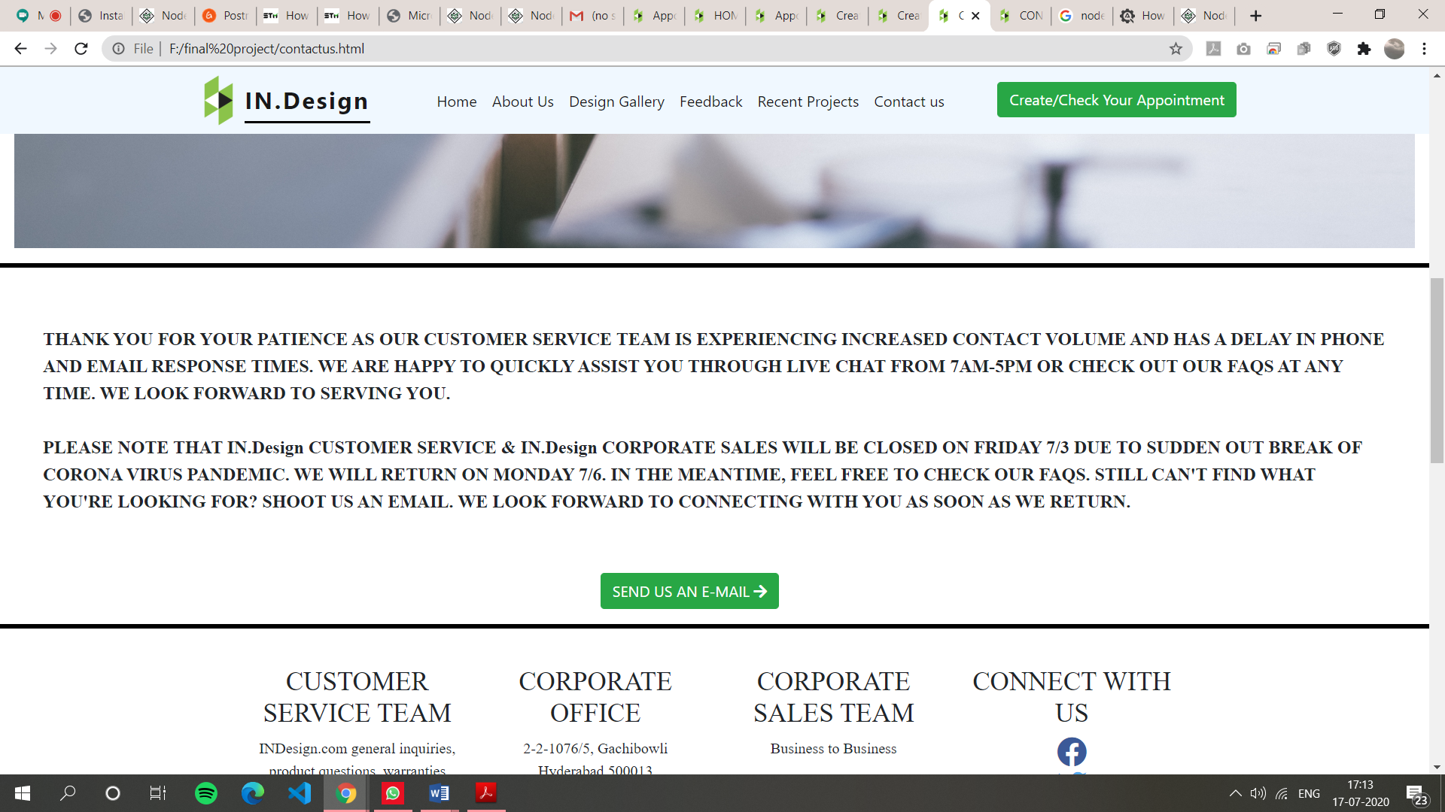

**Figure 8.3.10) Contact us page Screen Shot 2**

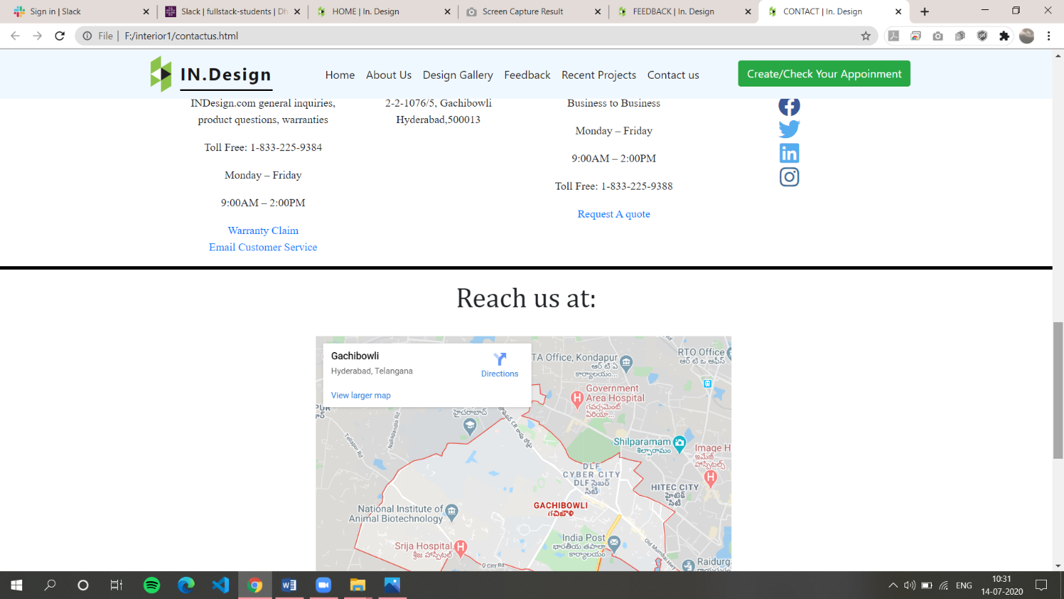

**Figure 8.3.11) Contact us page Screen Shot 3**

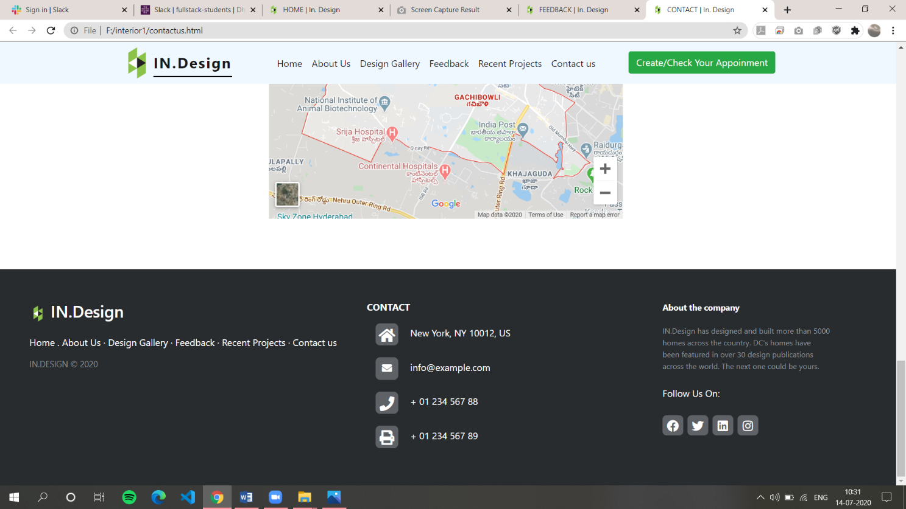

**Figure 8.3.12) Contact us page Screen Shot 4**

**HTML Code for Contact us page:**

<!DOCTYPE html>

<head>

  <title>CONTACT | In. Design</title>

  <link rel="shortcut icon" href="image/icons8.png" />

  <link rel="StyleSheet" href="contactus.css" />

  <meta name="viewport" content="width=device-width, initial-scale=1" />

  <link

    rel="stylesheet"

    href="https://pro.fontawesome.com/releases/v5.10.0/css/all.css"

    integrity="sha384-AYmEC3Yw5cVb3ZcuHtOA93w35dYTsvhLPVnYs9eStHfGJvOvKxVfELGroGkvsg+p"

    crossorigin="anonymous"

  />

  <link rel="stylesheet" href="bootstrap/css/bootstrap.min.css" />

  <script src="https://cdnjs.cloudflare.com/ajax/libs/jquery/3.2.1/jquery.min.js"></script>

  <script

    src="https://code.jquery.com/jquery-3.5.1.slim.min.js"

    integrity="sha384-DfXdz2htPH0lsSSs5nCTpuj/zy4C+OGpamoFVy38MVBnE+IbbVYUew+OrCXaRkfj"

    crossorigin="anonymous"

  ></script>

  <script

    src="https://cdn.jsdelivr.net/npm/popper.js@1.16.0/dist/umd/popper.min.js"

    integrity="sha384-Q6E9RHvbIyZFJoft+2mJbHaEWldlvI9IOYy5n3zV9zzTtmI3UksdQRVvoxMfooAo"

    crossorigin="anonymous"

  ></script>

  <script

    src="https://stackpath.bootstrapcdn.com/bootstrap/4.5.0/js/bootstrap.min.js"

    integrity="sha384-OgVRvuATP1z7JjHLkuOU7Xw704+h835Lr+6QL9UvYjZE3Ipu6Tp75j7Bh/kR0JKI"

    crossorigin="anonymous"

  ></script>

</head>

<body>

  <nav

    class="navbar navbar-expand-lg navbar-light fixed-top"

    style="background-color: aliceblue;"

  >

    <div class="container">

      <img src="image/icons8.png" height="5%" width="5%" />

      <a class="navbar-brand" href="#" style="border-bottom: 2px solid black;"

        >IN.Design</a

      >

      <button

        class="navbar-toggler"

        type="button"

        data-toggle="collapse"

        data-target="#navbarSupportedContent"

        aria-controls="navbarSupportedContent"

        aria-expanded="false"

        aria-label="Toggle navigation"

      >

        <span class="navbar-toggler-icon"></span>

      </button>

      <div class="collapse navbar-collapse" id="navbarSupportedContent">

        <ul class="navbar-nav ml-auto">

          <li class="nav-item active">

            <a class="nav-link active" href="home.html">Home</a>

          </li>

          <li class="nav-item active">

            <a class="nav-link" href="aboutus.html">About Us</a>

          </li>

          <li class="nav-item active">

            <a class="nav-link" href="designgallery.html" target="_self">Design Gallery</a>

          </li>

          <li class="nav-item active">

            <a class="nav-link" href="feedback.html">Feedback</a>

          </li>

          <li class="nav-item active">

            <a class="nav-link" href="recentprojects.html">Recent Projects</a>

          </li>

          <li class="nav-item active">

            <a class="nav-link" href="contactus.html">Contact us</a>

          </li>

          &nbsp; &nbsp; &nbsp; &nbsp; &nbsp; &nbsp;

          <li class="nav-item active">

            <a href="checkestimate.html" target="_blank"><button type="button" class="btn btn-success">

              Create/Check Your Appointment

            </button></a>

          </li>

        </ul>

      </div>

    </div>

  </nav>

  <div class="container-fluid" id="belowi">

    <h1 id="abc">CONTACT US</h1>

    <h1 id="ac" style="font-size: 40px; position: absolute; left: 25%; top: 30%;">CONTACT US</h1>

    <img

      src="image/contactus/gbimage.jpg"

      class="img-fluid"

      alt="Responsive image" style="background-color: rgba(0.5, 0.5, 0.5, 0.5);"

    />

      <a href="contactform.html" target="_blank" style="color: white;"

        ><button type="button" class="btn btn-success" id="below-button">SEND US AN E-MAIL&nbsp;<i class="fa fa-arrow-right" aria-hidden="true"></i></button>

       </a>

  </div>

  <hr class="new5" />

  <p id="p1">

    THANK YOU FOR YOUR PATIENCE AS OUR CUSTOMER SERVICE TEAM IS EXPERIENCING

    INCREASED CONTACT VOLUME AND HAS A DELAY IN PHONE AND EMAIL RESPONSE TIMES.

    WE ARE HAPPY TO QUICKLY ASSIST YOU THROUGH LIVE CHAT FROM 7AM-5PM OR CHECK

    OUT OUR FAQS AT ANY TIME. WE LOOK FORWARD TO SERVING YOU. <br /><br />PLEASE

    NOTE THAT IN.Design CUSTOMER SERVICE & IN.Design CORPORATE SALES WILL BE

    CLOSED ON FRIDAY 7/3 DUE TO SUDDEN OUT BREAK OF CORONA VIRUS PANDEMIC. WE

    WILL RETURN ON MONDAY 7/6. IN THE MEANTIME, FEEL FREE TO CHECK OUR FAQS.

    STILL CAN'T FIND WHAT YOU'RE LOOKING FOR? SHOOT US AN EMAIL. WE LOOK FORWARD

    TO CONNECTING WITH YOU AS SOON AS WE RETURN.

  </p>

  <a href="contactform.html" target="_blank"><button type="button" class="btn btn-success"  id="para-button">

    SEND US AN E-MAIL&nbsp;<i class="fa fa-arrow-right" aria-hidden="true"></i>

  </button></a>

  <hr class="new5" />

  <br />

  <div class="container-fluid" id="down">

    <div class="row">

      <div class="col-md-2"></div>

      <div class="col-md-2">

        <h3>CUSTOMER SERVICE TEAM</h3>

        <p>INDesign.com general inquiries, product questions, warranties</p>

        <p>Toll Free: 1-833-225-9384</p>

        <p>Monday – Friday</p>

        <p>9:00AM – 2:00PM</p>

        <a href="#">Warranty Claim</a><br />

        <a href="#">Email Customer Service</a>

      </div>

      <div class="col-md-2">

        <h3>CORPORATE OFFICE</h3>

        <p>2-2-1076/5, Gachibowli<br />Hyderabad,500013</p>

      </div>

      <div class="col-md-2">

        <h3>CORPORATE SALES TEAM</h3>

        <p>Business to Business</p>

        <p>Monday – Friday</p>

        <p>9:00AM – 2:00PM</p>

        <p>Toll Free: 1-833-225-9388</p>

        <a href="#">Request A quote</a><br />

      </div>

      <div class="col-md-2">

        <h3>CONNECT WITH US</h3>

        <a href="#"

          ><i class="fab fa-facebook fa-2x" style="color: #3b5998;"></i></a

        ><br />

        <a href="#"

          ><i class="fab fa-twitter fa-2x" style="color: #55acee;"></i></a

        ><br />

        <a href="#"

          ><i class="fab fa-linkedin fa-2x" style="color: #55acee;"></i></a

        ><br />

        <a href="#"

          ><i class="fab fa-instagram fa-2x" style="color: #3f729b;"></i></a

        ><br />

      </div>

      <div class="col-md-2"></div>

    </div>

  </div>

  <hr class="new5" />

  <h1

    style="

      text-align: center;

      font-family: Cambria, Cochin, Georgia, Times, 'Times New Roman', serif;

    "

  >

    Reach us at:

  </h1>

  <br />

  <iframe

    src="https://www.google.com/maps/embed?pb=!1m18!1m12!1m3!1d30450.629745775223!2d78.32222202306173!3d17.443973881095378!2m3!1f0!2f0!3f0!3m2!1i1024!2i768!4f13.1!3m3!1m2!1s0x3bcb93a276decedf%3A0x2c12e79e6f9344e2!2sGachibowli%2C%20Hyderabad%2C%20Telangana!5e0!3m2!1sen!2sin!4v1594205077663!5m2!1sen!2sin"

    width="600"

    height="450"

    frameborder="0"

    style="border: 0;"

    allowfullscreen=""

    aria-hidden="false"

    tabindex="0"

    id="map"

  ></iframe>

  <footer class="footer-distributed">

    <div class="footer-left">

      <h3 class="fothead">

        <img src="image/icons8.png" height="5%" width="5%" /> IN.Design

      </h3>

      <p class="footer-links">

        <a href="home.html">Home</a>

        . <a href="aboutus.html">About Us</a>

        ·

        <a href="designgallery.html" target="_blank">Design Gallery</a>

        ·

        <a href="feedback.html">Feedback</a>

        ·

        <a href="recentprojects.html">Recent Projects</a>

        ·

        <a href="contactus.html">Contact us</a>

      </p>

      <p class="footer-company-name">IN.DESIGN &copy; 2020</p>

    </div>

    <div class="footer-center">

      <h6 class="text-uppercase font-weight-bold" style="color: white;">

        Contact

      </h6>

      <p><i class="fas fa-home mr-3"></i>Hyderabad, HY 10012, INDIA</p>

      <br />

      <p><i class="fas fa-envelope mr-3"></i> info@example.com</p>

      <br />

      <p><i class="fas fa-phone mr-3"></i> + 01 234 567 88</p>

      <br />

      <p><i class="fas fa-print mr-3"></i> + 01 234 567 89</p>

    </div>

    <div class="footer-right">

      <p class="footer-company-about">

        <span>About the company</span>

        IN.Design has designed and built more than 5000 homes across the

        country. DC’s homes have been featured in over 30 design publications

        across the world. The next one could be yours.

      </p>

      <br />

      <span style="color: white;">Follow Us On:</span>

      <div class="footer-icons">

        <a href="#"><i class="fab fa-facebook"></i></a>

        <a href="#"><i class="fab fa-twitter"></i></a>

        <a href="#"><i class="fab fa-linkedin"></i></a>

        <a href="#"><i class="fab fa-instagram"></i></a>

      </div>

    </div>

  </footer>

</body>

**CSS Code for contact us page:**

#down {

  text-align: center;

  font-family: "Times New Roman", Times, serif;

}

#map {

  margin-left: 30%;

}

hr.new5 {

  border-top: 5px solid black;

}

#p1 {

  font-family: "Times New Roman", Times, serif;

  padding: 3%;

  font-size: larger;

  font-weight: bold;

}

#belowi {

  position: relative;

  width: 100%;

}

#belowi img {

  width: 100%;

  height: auto;

}

#belowi .btn {

  position: absolute;

  top: 60%;

  left: 50%;

  transform: translate(-50%, -50%);

  -ms-transform: translate(-50%, -50%);

  color: white;

  font-size: 16px;

  padding: 12px 24px;

  border: none;

  cursor: pointer;

  border-radius: 5px;

  text-align: center;

}

#para-button {

  margin-left: 42%;

}

#para-button:hover {

  background-color: black;

}

#belowi .btn:hover {

  background-color: black;

}

.navbar-light .navbar-brand {

  color: #fff;

  font-size: 25px;

  font-weight: bold;

  letter-spacing: 2px;

}

.navbar-light .navbar-nav .active > .nav-link,

.navbar-light .navbar-nav .nav-link.active,

.navbar-light .navbar-nav .nav-link.show,

.navbar-light .navbar-nav .show > .nav-link {

  color: #fff;

}

.navbar-light .navbar-nav .nav-link {

  color: #fff;

}

.navbar-toggler {

  background: #fff;

}

.navbar-nav {

  text-align: center;

}

.nav-link {

  padding: 0.2rem 1rem;

}

.nav-link.active,

.nav-link:focus {

  color: #fff;

}

.navbar-toggler {

  padding: 1px 5px;

  font-size: 18px;

  line-height: 0.3;

}

.navbar-light .navbar-nav .nav-link:focus,

.navbar-light .navbar-nav .nav-link:hover {

  color: #fff;

}

.nav-item:hover {

  background-color: grey;

  border-radius: 8px;

  transition: 0.5s;

}

@media (max-width: 880px){

  #map{

    height: auto;

    width: auto;

  }

  #abc{

  display: none;

  }

  }

  @media (min-width: 880px){

    #ac{

      display: none;

    }

    }

.footer-distributed {

  background-color: #292c2f;

  box-shadow: 0 1px 1px 0 rgba(0, 0, 0, 0.12);

  box-sizing: border-box;

  width: 100%;

  text-align: left;

  padding: 55px 50px;

  margin-top: 80px;

}

.footer-distributed .footer-left,

.footer-distributed .footer-center,

.footer-distributed .footer-right {

  display: inline-block;

  vertical-align: top;

}

.footer-distributed .footer-left {

  width: 40%;

}

.footer-distributed h3 {

  color: #ffffff;

  font: normal 36px;

  margin: 0;

}

.footer-distributed h3 span {

  color: #5383d3;

}

.foothead {

  color: #fff;

  font-size: 25px;

  border-bottom: 2px solid black;

  font-weight: bold;

  letter-spacing: 2px;

  margin-left: 3%;

  margin-top: 3%;

}

.footer-distributed .footer-links {

  color: #ffffff;

  margin: 20px 0 12px;

  padding: 0;

}

.footer-distributed .footer-links a {

  display: inline-block;

  line-height: 1.8;

  text-decoration: none;

  color: inherit;

}

.footer-distributed .footer-company-name {

  color: #8f9296;

  font-size: 14px;

  font-weight: normal;

  margin: 0;

}

.footer-distributed .footer-center {

  width: 35%;

}

.footer-distributed .footer-center i {

  background-color: #70757abd;

  color: #ffffff;

  font-size: 25px;

  width: 38px;

  height: 38px;

  border-radius: 20%;

  text-align: center;

  line-height: 42px;

  margin: 10px 15px;

  vertical-align: middle;

}

.footer-distributed .footer-center i:hover {

  background-color: white;

  color: black;

}

.footer-distributed .footer-center i.fa-envelope {

  font-size: 17px;

  line-height: 38px;

}

.footer-distributed .footer-center p {

  display: inline-block;

  color: #ffffff;

  vertical-align: middle;

  margin: 0;

}

.footer-distributed .footer-center p span {

  display: block;

  font-weight: normal;

  font-size: 14px;

  line-height: 2;

}

.footer-distributed .footer-center p a {

  color: #5383d3;

  text-decoration: none;

}

.footer-distributed .footer-right {

  width: 20%;

}

.footer-distributed .footer-company-about {

  line-height: 20px;

  color: #92999f;

  font-size: 13px;

  font-weight: normal;

  margin: 0;

}

.footer-distributed .footer-company-about span {

  display: block;

  color: #ffffff;

  font-size: 14px;

  font-weight: bold;

  margin-bottom: 20px;

}

.footer-distributed .footer-icons {

  margin-top: 25px;

}

.footer-distributed .footer-icons a {

  display: inline-block;

  width: 35px;

  height: 35px;

  cursor: pointer;

  background-color: #70757abd;

  border-radius: 20%;

  font-size: 20px;

  color: #ffffff;

  text-align: center;

  line-height: 35px;

  margin-right: 3px;

  margin-bottom: 5px;

}

.footer-distributed .footer-icons a:hover {

  background-color: white;

  color: black;

}

@media (max-width: 880px) {

  .footer-distributed {

    font: bold 14px sans-serif;

  }

  .footer-distributed .footer-left,

  .footer-distributed .footer-center,

  .footer-distributed .footer-right {

    display: block;

    width: 100%;

    margin-bottom: 40px;

    text-align: center;

  }

  .footer-distributed .footer-center i {

    margin-left: 0%;

  }

}

#abc{

  position: absolute;

  top:30%;

  left:37%;

  font-size: 60px;

  font-weight: bolder;

}

#abcd{

  color: rgb(0, 0, 0);

  position: absolute;

  top:40%;

  left:10%;

  font-size: 30px;

  font-weight: bold;

}

**8.4 BACKEND END SCREENSHOTS AND CODE**

**Create Appointments page:**

* Here the user inputs his details in the HTML page and if the validations are passed, the success message is shown and the API sends the data into the MySQL Database. In which data is stored in the form of tables.
* The below Screenshots will give you the clear explanation.

Here in the below screenshot, the user visits the site and inputs his details in HTML file.

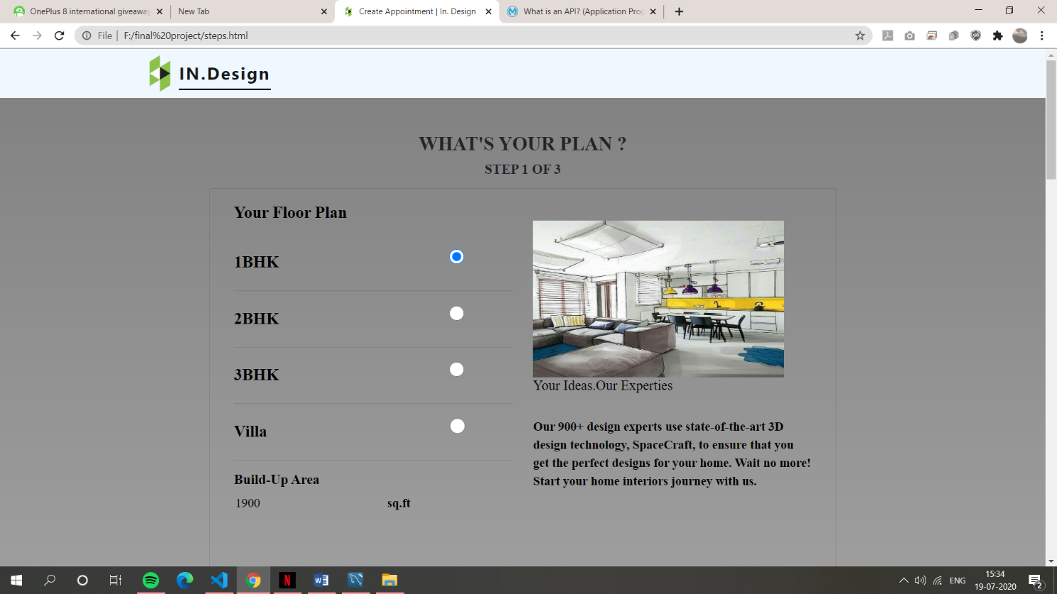

Figure 8.4.1) Create Appointment Page screenshot 1

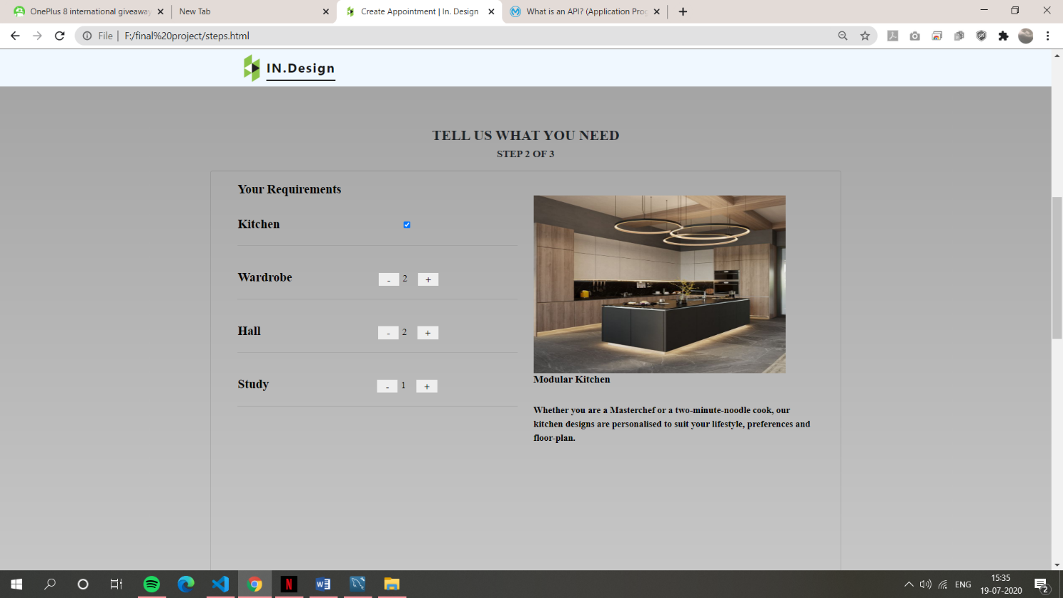

Figure 8.4.2) Create Appointment Page screenshot 2

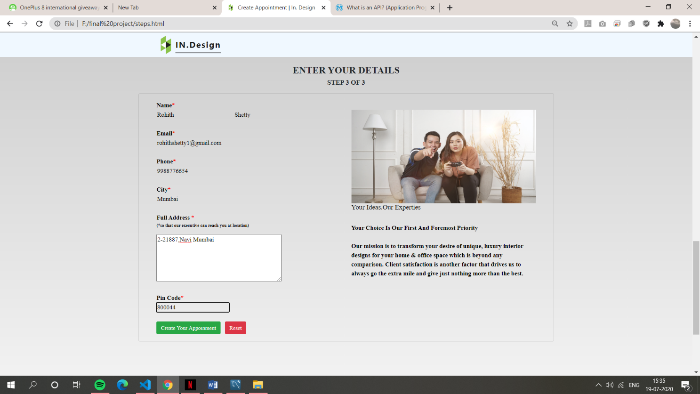

Figure 8.4.3) Create Appointment Page screenshot 3

* If the user passes all the clint side validations, then the success alert is displayed like this

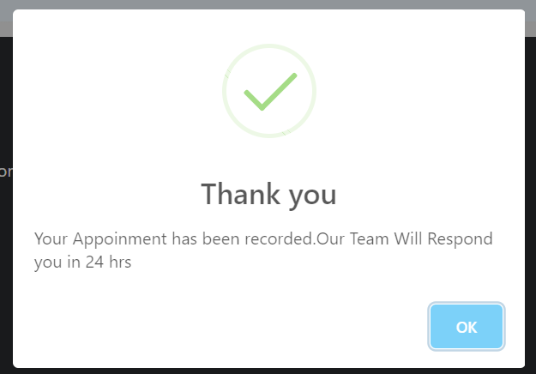

Figure 8.4.4) Success Alert After receiving Input

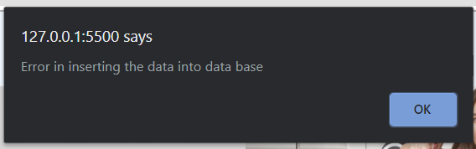

Figure 8.4.5) Error Alert if the data is not is inserted into table

* If the server is running ,then the user is created in the database or else error alert is displayed in above screenshot.

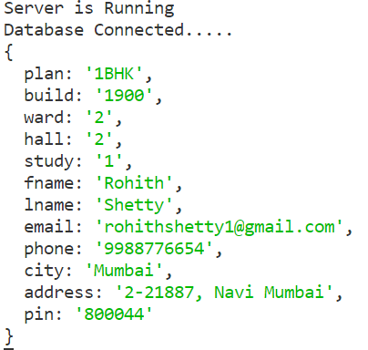

Figure 8.4.6) Created User status in command prompt.

* Here you can see the user is created in the table as shown in the below screenshot.

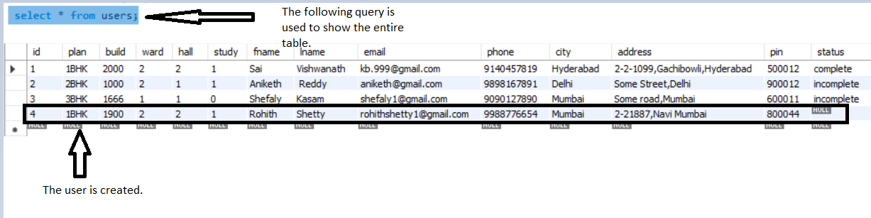

Figure 8.4.7) Select Query and data insertion in the table

* Coming to status , The admin can change the status either to complete or incomplete bu using update command .

For example, The created user with a Rohith shetty status is incomplete. So by using update command we can update his status to incomplete.

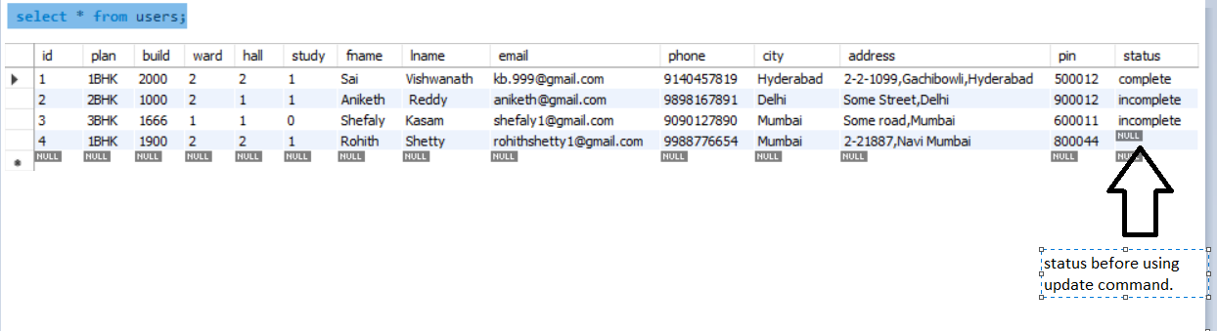

Figure 8.4.8) Status of user before update command

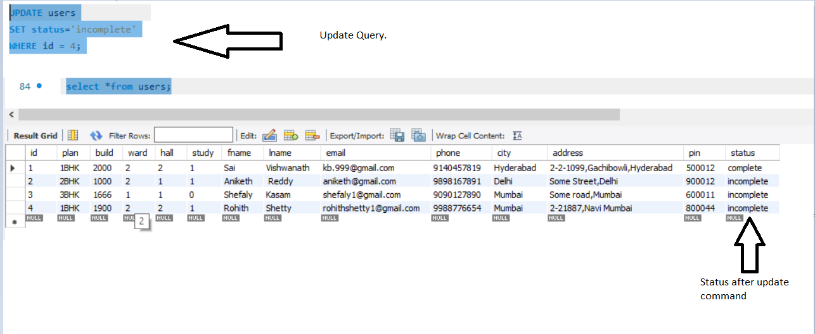

Figure 8.4.9) Update command and Status of user after update command

**API Codes:**

**Server.js:**

var express = require('express');

var mysql = require('mysql');

var bodyparser = require('body-parser');

var app = express();

app.use(bodyparser.urlencoded({extended:true}));

app.use(bodyparser.json());

app.use(function(req,res,next){

    res.header("Access-Control-Allow-Origin","*");

    res.header("Access-Control-Allow-Headers","Origin,x-Requested-With,Content-Type,Accept");

    next();

});

var connection = mysql.createConnection({

    host: "localhost",

    user: "root",

    password: "sai@123",

    database: "db2"

});

connection.connect(function(err){

    if(!err){

        console.log("Database Connected.....");

    }

    else{

        console.log("Error in connecting database.........");

    }

});

app.listen(4013,()=>{

    console.log("Server is Running");

});

app.get('/',function(req,res){

    res.json({msg:"Welcome to Node.js API"});

});

//Route for Insert Data

app.post('/createapp',(req,res) =>{

    let data = req.body;

    //To see the data in console

    console.log(data);

    connection.query('insert into createapp set ? ',data,function(error,results,fields){

        if(error){

            res.send({

                "code":400,

                "failed":"Error Occured"

            });

        }

        else{

            res.send({

                "code":200,

                "Success":"User Registeration Completed"

            });

        }

    });

});

**AJAX Code:**

 var data={};

      data.plan= $(".radio:checked").val();

      data.build=$("#ba").val();

      data.ward= $("#war").val();

      data.hall= $("#war1").val();

      data.study= $("#war2").val();

      data.fname= $("#fn").val();

      data.lname= $("#ln").val();

      data.email= $("#em").val();

      data.phone=$("#phone").val();

      data.city=$("#cit").val();

      data.address=$("#area").val();

      data.pin=$("#pincode").val();

                    $.ajax({

                        type:"POST",

                        url:"http://localhost:4013/createapp/",

                        data:JSON.stringify(data),

                        contentType:"application/json; charset=utf-8",

                        dataType:"json",

                        success:function(d){

                          swal(

                            "Thank you",

                            "Your Appoinment has been recorded.Our Team Will Respond you in 24 hrs",

                            "success"

                          );

                        },

                        error:function(jqxhr){

                            alert('Error in inserting the data into data base');

                        }

                    })

**Check Appointments page:**

* Here the user can check his appointment status after creating his appointment in create appointment page.
* Here the user inputs his phone number in the HTML page.

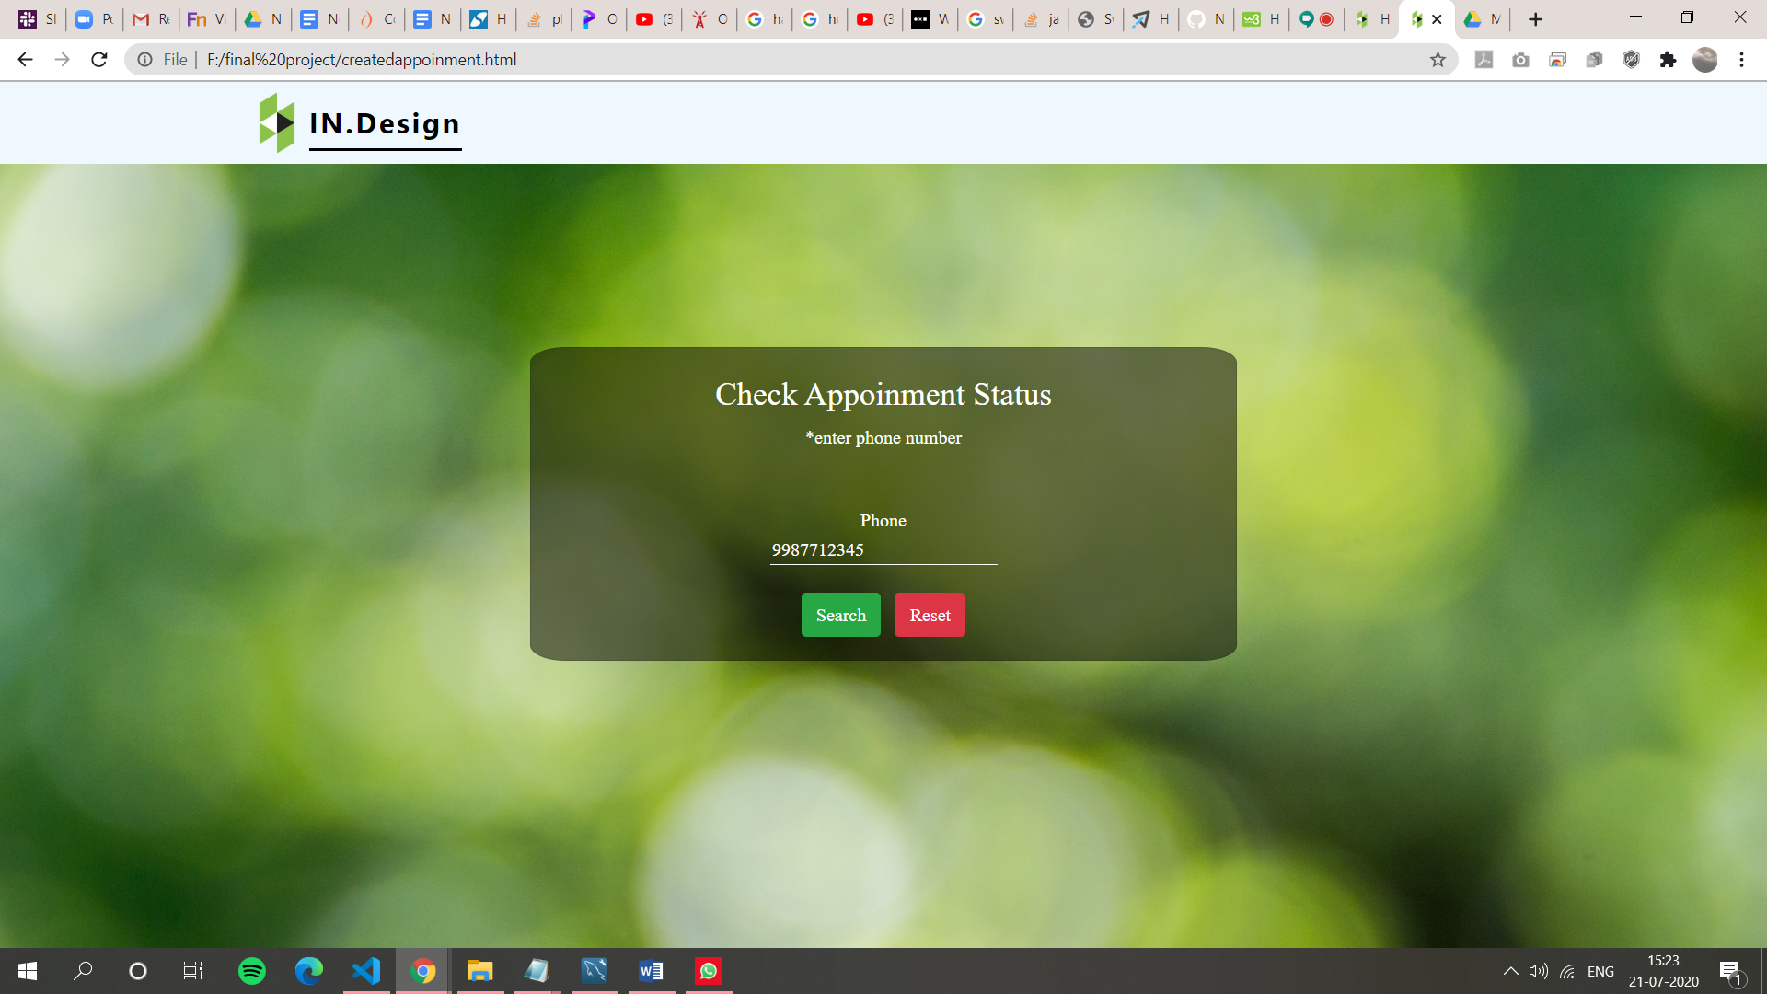

Figure 8.4.10) Check Appointment page Screenshot.

* Then the input is searched in the phone column of create appointment table and after searching there are three different type of outputs they are:

1. If the phone number is found in the table and if its status is complete then the following alert is given as shown in below screenshots.
2. If the phone number is found in the table and if its status is incomplete then the following alert is given as shown in below screenshots.
3. If the phone number is not found in the table, then the following alert is given as shown in the below screenshot.

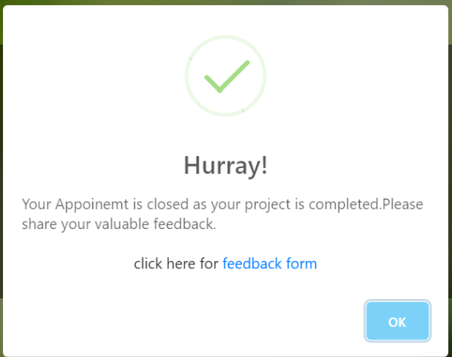

Figure 8.4.11) Phone number found and status is complete alert

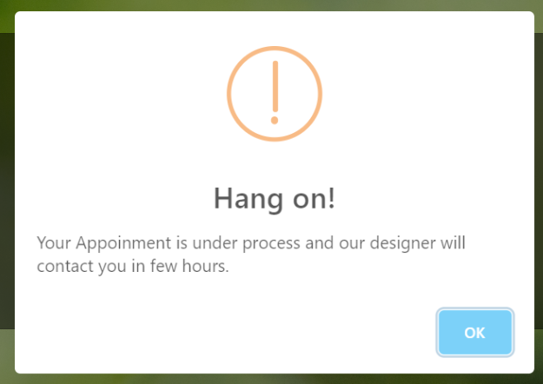

Figure 8.4.12) Phone number found and status is incomplete alert

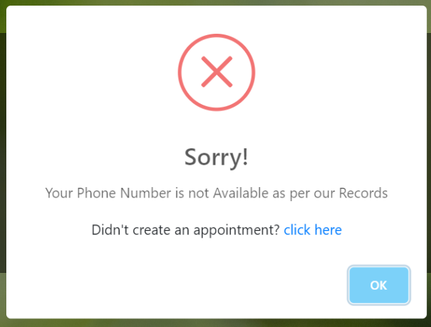

Figure 8.4.13) Phone number not found alert

* Status is also returned in command prompt if the phone number is found in the table and if the phone number is not found in the table then can't find the phone number is returned.

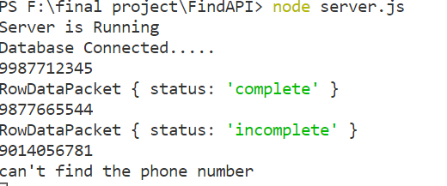

Figure 8.4.14) Command prompt return values after inputting phone numbers

**API Codes:**

**Server.js:**

var express = require('express');

var mysql = require('mysql');

var bodyparser = require('body-parser');

var app = express();

app.use(bodyparser.urlencoded({extended:true}));

app.use(bodyparser.json());

app.use(function(req,res,next){

    res.header("Access-Control-Allow-Origin","*");

    res.header("Access-Control-Allow-Headers","Origin,x-Requested-With,Content-Type,Accept");

    next();

});

var connection = mysql.createConnection({

    host: "localhost",

    user: "root",

    password: "sai@123",

    database: "db2"

});

connection.connect(function(err){

    if(!err){

        console.log("Database Connected.....");

    }

    else{

        console.log("Error in connecting database.........");

    }

});

app.listen(4014,()=>{

    console.log("Server is Running");

});

app.get('/',function(req,res){

    res.json({msg:"Welcome to Node.js API"});

});

app.post('/find',(req,res)=>{

    let phone=req.body.phone;

    console.log(phone);

    connection.query('select status from createapp where phone=?',[phone],function(error,results,fields){

        var x = JSON.stringify(results);

        if(x == "[]"){

            res.send({

                "code":400,

                "failed":console.log("can't find the phone number")

            });

        }

        else{

            res.send({

            "success":console.log(results[0]),

            "code":200,

            "display":results[0],

            });

        }

    });

});

**AJAX code:**

var data={};

      data.phone=$("#phone").val();

      $.ajax({

                        type:"POST",

                        url:"http://localhost:4014/find/",

                        data:JSON.stringify(data),

                        contentType:"application/json; charset=utf-8",

                        dataType:"json",

                        success:function(d){

                          if(d.code==400){

                          const el = document.createElement('div')

                          el.innerHTML =  "Didn't create an appointment?<a href='steps.html'> click here</a>"

                            swal({

                           title: "Sorry!",

                           text:"Your Phone Number is not Available as per our Records",

                           content: el,

                            icon:"error",

                             } );

                            return false;

                          }

                           else if(d.code==200)

                           {

                             if(Object.values(d.display)=="incomplete")

                           {swal(

                            "Hang on!",

                            "Your Appoinment is under process and our designer will contact you in few hours.",

                            "warning"

                          );

                           }

                           else

                           {

                            const el = document.createElement('div')

                            el.innerHTML =  "click here for<a href='feedback.html'> feedback form </a>"

                           swal({

                            title:"Hurray!",

                            text:"Your Appoinemt is closed as your project is completed.Please share your valuable feedback.",

                            content: el,

                            icon:"success"

                            });

                           }

                           }

                          },

                        error:function(jqxhr){

                        const el = document.createElement('div')

                        el.innerHTML ="Didn't create an appointment?<a href='steps.html'> click here</a>"

                            swal({

                           title: "Sorry!",

                           text:"Your Phone Number is not Available as per our Records",

                           content: el,

                            icon:"error",

                             } );

                        }

                    })

**Package.json** is also used and it is extracted to initialize the node.js application.

And also Install the modules **express,mysql and body-parser**.

Express module : Express is a minimal and flexible Node.js web application framework that provides a robust set of features to develop web and mobile applications. It facilitates the rapid development of Node based Web applications.

MySQL module: MySQL module is useful to bind the node JS and MySQL.

Body-parser module: Body-parser is the Node.js body parsing middleware. It is responsible for parsing the incoming request bodies in a middleware before you handle it.

The following modules are installed by using the command npm install express mysql body-parser –save.

**CHAPTER-9**

### **MAINTENANCE**

The maintenance phase involves making changes to hardware, software, and documentation to support its operational effectiveness. It includes making changes to improve a system’s performance, correct problems, enhance security, or address user requirements. To ensure modifications do not disrupt operations or degrade a system’s performance or security, organizations should establish appropriate change management standards and procedures.

Routine changes are not as complex as major modifications and can usually be implemented in the normal course of business. Routine change controls should include procedures for requesting, evaluating, approving, testing, installing, and documenting website modifications. Maintaining accurate, up-to-date hardware and software inventories is a critical part of all change management processes. Management should carefully document all modifications to ensure accurate system inventories. Management should coordinate all technology related changes through an oversight committee and assign an appropriate party responsibility for administering software patch management programs. Quality assurance, security, audit, regulatory compliance, network, and end-user personnel should be appropriately included in change management processes. Risk and security review should be done whenever a system modification is implemented to ensure controls remain in place.

For maintenance of the website:

1. The database has to be updated regularly according to new available information.\
2. Redundant and false information must be removed from the database.
3. Newer version of NODEJS and MYSQL can be used for up gradation of website and to improve the overall performance of the system.

**CHAPTER-10**

### **FUTURE SCOPE & FUTURE ENHANCEMENT**

##### PROJECT NAME: INTERIOR DESIGNER SITE.

1. Interior design would help each and every person to find the best designs to make your home and workplace beautiful and lovely.

2. End-to-End home interior solution to suit customer’s budget and lifestyle.

3. We provide quality and strong furniture.

4. We communicate with customers about their needs and requirements to design their home/workplace.

5. The following websites is useful in showcasing the work and

**CHAPTER-11**

### **CONCLUSION**

We have successfully implemented the site ‘In. Design’ (interior design Company). With the help of various links and tools, we have been able to provide a site which will be live soon and running on the web. We have been successful in our attempt to take care of the needs of both the user as well as the administrator. Finally, we hope that this will go a long way in popularizing.

**BIBLIOGRAPHY**

1. [www.javatutpoint.com](http://www.javatutpoint.com/)
2. [www.w3schools.com](http://www.w3schools.com/)
3. [www.getbootstrap.com](http://www.getbootstrap.com/)
4. [www.codeigniter.com](http://www.codeigniter.com/)
5. [www.stackoverflow.com](http://www.stackoverflow.com/)
6. [www.fontawesome.io](http://www.fontawesome.io/)
7. www.unsplash.com
8. Wikipedia
9. www.youtube.com
10. www.w3resource.com
11. https://javascript.info
12. https://sweetalert.js.org/